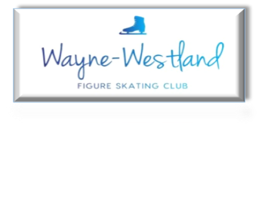

**Wayne Westland Figure Skating Club Minutes**

**March 25, 2025**

**Call to Order:** Shaun Taft 7:02PM

**Present:** Shaun T., Sara E., Bill G., Sharon M., Rachael A., Rana S., Abby S., Courtney O.

**Absent with notice:** Renee B., Pam L.

**Minutes:** Sharon moved to approve, Rachael seconded. Motion passed.

**Treasurer’s Report:** Presented

**MMIA Report:** Figure skaters may use extra ice after Learn to Skate finishes.

**Future Club Activities:** No report

**Committee Reports**

* **Delegate’s Report:** Bill will not go to Governing Council. Joann Eastman will be our proxy.

Shaun will be contact for Synchro Nationals volunteer and procurement.

* **Membership:** No report
* **Competition:** No report
* **Ice Show:** Tracking documents presented
* **Media**: No report
* **Skater’s Advisory:** Planning an 80’s party for first Saturday/Sunday ice show practice.
* **Fundraising:** Schwartz will need to be delivered by March 31. Delivery by following week.
* **Testing:** 2.28.25 15 tests

Registration fees $669

USFS Registration fee $150

USFS Processing fee $7.50

Judge Gift Cards $100

GC processing fee $4.75

Total Club Profit $406.75

3.14.25 3 skaters

Registration fees $154

USFS Fee $30 and $1

Processing fee $31

Gift Cards for Judges $30

Club Profit $93

* **Nomination:** Slate presented. Voting by Google Form before April meeting.

**Old Business**: Footlight status stalled. Contacting Dave about lift.

Rachael sent link for Spirit Wear.

May have someone build a recognition case.

Information from Farmington FSC about 501c (3) sent to a few Board members to look over. Shaun will ask her accountant co-worker Paul for advice.

**New Business**:none

**Adjournment**: Tess moved and Sharon seconded at 8:09PM.

**Next meeting:** Board - April 22, 2025 at 7PM

Club – summer 2025