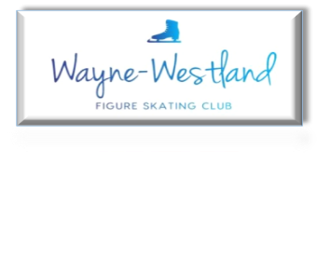

**Wayne Westland Figure Skating Club Minutes**

**December 23, 2024**

**Call to Order:** Shaun Taft at 7:02PM

**Present:** Shaun T., Rana S., Courtney O., Pam L., Rachael A., Tess K., Sharon M.

**Minutes:** Motion to approve by Rachael, seconded by Rana.

**Treasurer’s Report:** Presented

**MMIA Report:** Ice show will be May 2-4, 2025

Been reaching out to the mayor for some events.

**Future Club Activities:** Should an event prior to ice show practices be planned? 80’s dance party idea in late February/early March.

**Committee Reports**

* **Delegate’s Report:** no report
* **Competition:** no report
* **Ice Show:** Holiday show – members received gift cards; items and monetary donations were given to Alternatives for Girls

Spring Ice Show – Special parts videos are due January 15, 2025; Shaun explained determinants for special parts distribution

* **Membership:** Some skaters with 2nd Club interest reached out to Shaun.
* **Media**: Website – no report

Social Media – Keona M. and Keegan D. are interested in supporting the committee

* **Skater’s Advisory:** no report
* **Fundraising:** Little Caesars Pizza Kit fundraiser begins January 1, 2025. Skaters will receive credit of $6/kit sold

December 8th Make and Take Fundraiser made $150 plus a $50 donation from a local hockey player.

Members are asked to start saving items for a planned summer rummage sale.

* **Testing:** 14 Registered Skaters19 TestsTotal Registration Fees $823

USFS Register Test Scores $190 + processing fee $7.50 = $197.50

Judges Gift Cards $145

TOTAL Club Profit $480.50

Next session is January 24, 2025

* **Nomination:** Will begin in January.

**Old Business**: Followed up on 501c(3) status and footlights.

Rachael updated on spirit wear status.

Some volunteers will be needed for Synchro Nationals. More information needed.

Sharon looking further into banners to celebrate members.

**New Business**:Ideas discussed on where in MMIA we can showcase members’ accomplishments.

**Adjournment**: Tess moved, Rachael 2nd at 7:39PM

**Next meeting:** Ice show meeting in January.

Board meeting – January 28, 2025

