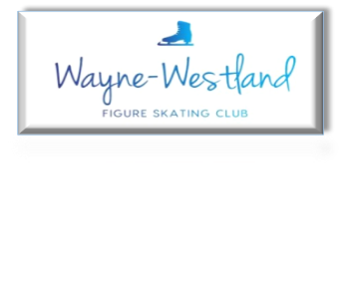

**Wayne Westland Figure Skating Club Minutes**

**November 28, 2023 7PM**

**Call to Order:** Shaun Taft 7:02PM

**Present:** Bill Goen, Rachael Alholinna-Kovacs, Pam Larsen, Sharon Mattioli, Tess Kuehne, Amy Harris, Abby Sitarski, Renee Brown

**Minutes:** Motion to accept by Sharon and seconded by Rachael.

**Treasurer’s Report:** Presented

Ask for an income/expense report from competition.

Courtney will follow up with competition vendors about their experience.

**MMIA Report:** Schoolcraft will skate at MMIA next season.

Need to pick a day to clean up upstairs. Discussion about what to tell Joe. Perhaps clean up during Winter Break. Specific day TBD.

Competition date perhaps October 26, 2024.

**Future Club Activities:** Craft night on December 8, 6-8PM in the community room to make ornaments for the tree.

**Committee Reports**

* **Delegate’s Report** Lydia Wallenchuk passed away in October. Requested to donate toward skater’s fund through Detroit Metro Council. Motion by Tess and second by Rachael to donate $50 to the fund. Passed.
* **Competition:** Discussed feedback.
* **Ice Show:** Holiday show has 18 programs and 4 LTS groups (~40 skaters). Motion by Renee and second by Sharon to budget $100 for refreshments. Passed. Entertainment committee (Pam, Abby, and Jessica West) will plan the holiday party within budget.

Motion by Pam and seconded by Amy to gift $10 Target gift cards for WWFSC skaters.

Discussion about ice show registration as emailed by Tess.

Motion by Amy and seconded by Rachael to raise group number fees by $5. Passed.

Ice show theme is about emotions.

* **Media**: Website gets updated upon request. Weekly emails sent out. Good job Courtney on Facebook. Photos in lobby are updated.
* **Skater’s Advisory:** Looking for ideas for group outing. Checking out Town’n’Country Bowling.
* **Fundraising:** Next fundraiser is Little Caesar’s virtual fundraiser January 1-31, 2024.

Sneaker fundraiser is still going. Future fundraisers include Swartz gift cards. Looking for gift cards for a holiday wreath. Will circulate a couple of fliers for individual fundraising.

* **Testing:** 11.10.23 Reconciliation Test Revenue $315

USFS 9 tests x 8 = $72 and $3 fee

Judges Gift Cards $70

Club Profit $170

12.8.23 Next Virtual

* **Nomination:** No Report

**Old Business**: Marquee needs addressing.

**New Business**:LTS coach’s meeting (over Winter Break?)

Tess has packet of coaches with credentials to give to students looking for privates.

Coach of the Month (like Mingo of the Month)

Meet Our Coaches(?)

**Adjournment**: 8:29PM Motion by Rachael and second by Tess.

**Next meeting:** Member – After Holiday Show

Board – January 23, 2024 7PM

