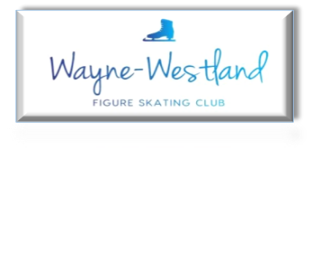

**Wayne Westland Figure Skating Club Minutes**

**May 29, 2024**

**Call to Order:** Shaun Taft 7:02PM

**Present:** Shaun T., Courtney O., Rana S., Renee B., Sharon M., Bill G., Rachael A., Sara E., Tess K.

**Absent with notice:** Pam L.

**Minutes:** Sharon moved and Rachael seconded to accept minutes with corrections.

**Treasurer’s Report:** Presented (see below)

**MMIA Report:** Rink is currently closed

**Future Club Activities:** Summer activities list was presented.

**Committee Reports**

* **Delegate’s Report** Tri-State meeting will be virtual on June 8th.

Tess gave an update on Governing Council.

Council bid for 2026 Synchro Sectionals is still pending.

* **Competition:** Planning for October 26th. Will need a confirmation from Joe.
* **Ice Show:** Tracking document was summarized.

Unpaid volunteers will be marked as members not in good standing.

* **Membership:** Renee will send out membership renewals.
* **Media**: (Website) Virtual test dates given to be posted.

(Facebook/Instagram) Feedback given. Looking into “commercial”.

* **Skater’s Advisory:** Summer activities presented for Club outing.
* **Fundraising:** Back to School Movie Night in Goudy Park (Wayne, MI). Have Tess and Addie promoted as members of Team USA.

Courtney will sign the Club up for the Wayne Road Car Cruise vendor event at the Westland Historic Society.

* **Testing: 5**.17.24 Test Breakdown

17 tests

$640 Test Payments

$130 Judge Gift Cards

$136 USFS Registration Fee

$7.50 USFS Processing Fee

$366.50 TOTAL PROFIT

Summer test dates given out.

* **Nomination:** Courtney, Rana, and Abby Sitarski have been nominated. Election will be on the June meeting.

**Old Business**: Old medals still need to be disposed of.

Discussion of 501(c)3 vs. 501(c)7

**New Business**:See if the footlights still work.

Need to figure out a standard process for Club banners.

Renee needs to re-share the Club accounts and passwords.

**Adjournment**: Motion by Tess, second by Renee at 8:02PM

**Next meeting:** Board: June 27th, 7PM

Club: September Welcome Back Celebration

