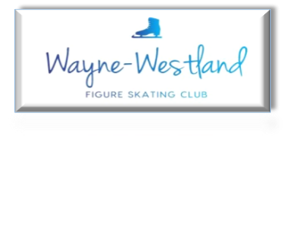

**Wayne Westland Figure Skating Club Minutes**

**June 25, 2024**

**Call to Order:** 8:02PM

**Present:** Shaun T., Bill G., Courtney O., Amy H., Renee B., Sharon M., Pam L., Abby S., Tess K, Rana S.

**Absent with notice:** Rachael A.

**Minutes:** Motion to accept with corrections by Renee and second by Sharon.

**Treasurer’s Report:** Presented (see below)

**MMIA Report:** No report

**Future Club Activities:** Give poll a few more days then pick a date for summer outing.

**Committee Reports**

* **Delegate’s Report:** Detroit Metro Council bid is still pending. New U.S. Figure Skating music policy was sent out to coaches.
* **Competition:** Announcement template is not ready. Reached out to referees, music, accountant, and judges. Waiting on responses.
* **Ice Show:** No report
* **Membership:** Reconciled who we had. Still had some missing renewals/contacts. Need to process current/new members by tomorrow.
* **Media**: Looking at Go Daddy for website. Thinking about possible coach shout outs on social media.
* **Skater’s Advisory:** No report
* **Fundraising:** Schwartz Fall Mum fundraiser information was received.

Timeline of other fundraisers was received.

Possible “experience” fundraisers using the community room discussed.

Idea on a rummage sale at the ice rink while the ice is out for summer 2025.

* **Testing:** 6.14.24 Test Breakdown

16 tests

$713 Test Payments

$100 Judge Gift Cards

$120 USFS Registration Fee

$7.50 USFS Processing Fee

TOTAL PROFIT $485.50

Additional Summer test session July 12th, August 23rd

* **Nomination:** See election below.

**Old Business**: If honoring team/synchro skaters from other clubs as Team USA with banners, would have to backlog to the 1990’s. Banner policy still pending.

Medals still need to be disposed of.

Reached out for 501(c)3 information. Discussion followed.

**New Business**:Review of the by-laws. Changes were sent out for review.

Invite the Westland mayor to club engagements and possible commercial.

Meeting turned over to Nomination Chair Courtney Ozog for conduction of the election.

**Election:** Results of the 2024-2025 Officers are as follows:

President – Shaun Taft

Vice President – Rachael Alholinna-Kovacs

Recording Secretary – Courtney Ozog

Treasurer – Rana Safah

**Follow up:** 501(c)3 vote will be conducted by email.

**Adjournment**: Motion by Renee and seconded by Tess at 9:20PM.

**Next meeting:** No July meeting. Next meeting August 27, 2024 at 7PM.

