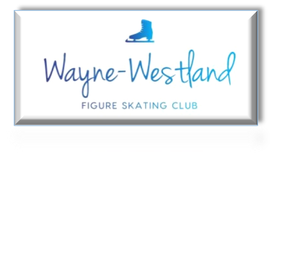
6210 N. Wildwood Street Westland, MI 48185
734.729.4560 WWFSC.org

April 2019

To all WWFSC Members.

The current USFS season comes to an end June 30, 2019. Attached is the membership application and contract for the upcoming year. Please complete both and return with payment to:
WWFSC club box in the coaches’ room by May 2, 2019 (Attn: Membership)
Applications will be renewed before the June 30th deadline. WWFSC will pay the processing fee to USFS for all applications received by May 2, 2019; late applications should include an additional $5/member to process their membership. Please consult your coach to determine which membership is best for your skater.
Former Wayne Club skaters who have had their membership prepaid for the season owe no money at this time, just the completed application, contract and $5/skater late fee if applicable.
Thank you
WWFSC, Membership Chair

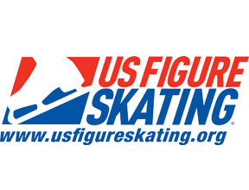

Wayne-Westland Figure Skating Club Membership Form
Parent Name Birthdate__________________
Skater Name Birthdate
Additional Skater _____
Address
City State Zip
Phone Cell
Email
Skater’s Private Coach (if applicable):
Please return forms and payment by 5-2-19. Make checks payable to ‘WWFSC’ and place in the Wayne-Westland FSC Drop box located in the coaches’ room, Attn: Membership Chair
Cell: 313-330-5473

Type of Membership- Please Check

Full Membership $115

Second Club Membership $40

Introductory Membership $65

Basic Club Membership $25

Coaching Membership $60.00

Adult Membership $60.00

Collegiate Membership $ 80.00

$

Wayne-Westland FSC
2019-2020 Club Contract

MEMBERSHIP DESCRIPTIONS

Full Membership:
Includes skater and parent US membership for one-year. Full US testing membership for the skater, voting eligibility for the parent, Board of Directors eligibility for the parent. Skater may participate in all competitions representing WWFSC and the annual ice show. Skater must skate at least 1-hour/week at Mike Modano Ice Arena while the arena is open for the parent/guardian to remain eligible to vote and serve on the Board of Directors.
Additional Skater Membership:
Includes additional skater(s) residing at the same address as parent and skater who have a full membership. Skater privileges are the same as those of first skater listed under Full Membership.
Introductory Membership:
One-time only skater US membership for one-year. Full US testing membership for the skater, voting eligibility for the parent. Skater may participate in all competitions representing WWFSC and the annual ice show. Skater must skate at least 1-hour/week at Mike Modano Ice Arena while the arena is open for the parent/guardian to remain eligible to vote in annual election of the Board of Directors.
Basic Club Membership:
Includes skater Basic Club Membership for one-year. This is not a testing membership. Skater may participate in all competitions representing WWFSC and the annual ice show.
Coaching Membership:
Includes full US membership for one year, voting and Board of Directors eligibility.
Adult Membership:
Includes full US testing membership for one year, voting and Board of Directors eligibility. Skater may participate in all competitions representing WWFSC and the annual ice show.
Collegiate Membership:
Includes full US testing membership for four-years, voting and Board of Directors eligibility. Skater may participate in all competitions representing WWFSC and the annual ice show.

Wayne-Westland FSC
2019-2020 Club Contract

PARENT AND SKATER BEHAVIOR

The Wayne-Westland Figure Skating Club has zero tolerance for parent or skater misconduct. Inappropriate language, social media posts or creating an environment of hostility will not be tolerated and may result in removal from the club and club activities without a refund of previously paid fees. Please refer to the USFS parent and skater Code of Ethics for full details (Club Bylaws and copies of the USFS ‘Code of Ethics” will be available in the lobby for review).

VOLUNTEERING
You must volunteer at least one (1) shift at the USFS competition in November. There is a $75 fee for non-compliance. Participation in the annual ice show is not required for club membership but it is encouraged and additional volunteer hours must be completed; please see ice show contract for details and obligations.

I have read and understand the above conditions and agree to abide by the rules set forth by the coaches and the members of the Wayne-Westland Figure Skating Club Board of Directors. Skaters and parents are expected to behave in a manner consistent with the policies, bylaws, and Code of Conduct of the Wayne-Westland Figure Skating Club, USFS and ISI.

I further recognize and understand that this contract is an agreement between our family and Wayne-Westland Figure Skating Club for the skating season that begins July 1, 2019 and ends June 30, 2020.

_________________________________________________
Skater’s Name
_________________________________________________ __________________________
Skater’s Signature Date
__________________________________________________ __________________________
Parent’s Signature Date
WWFSC.membership.edited

