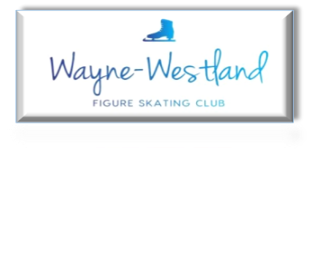

**Wayne Westland Figure Skating Club Minutes**

**October 22, 2024**

**Call to Order:** 7:02PM

**Present:** Shaun T., Courtney O., Rachael A., Pam L., Abby S., Sharon M., Rana S.

**Absent with notice:** Renee B.

**Minutes:** Rachael move to accept, Rana seconded.

**Treasurer’s Report:** Presented. Feedback given on payments and competition registration using Sk8stuff.

**MMIA Report:** No report

**Future Club Activities:** No report

**Committee Reports**

* **Delegate’s Report:** No report
* **Competition:** Outstanding task list presented
* **Ice Show:** No report
* **Media**: No report
* **Skater’s Advisory:** No report
* **Fundraising:** Better Made arrived. Sold 91 cases. Skaters received $5 per case for their ice show account.
* **Testing:** No report
* **Nomination:** No report

**Old Business**: None

**New Business**:Bill G. was sent a “Get Well” basket.

**Adjournment**: Sharon move and Rana seconded at 8:01pm.

**Next meeting:** November 26, 2024 at 7pm