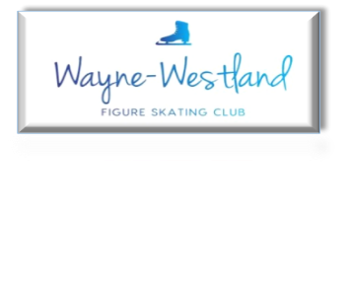

**Wayne Westland Figure Skating Club Minutes**

**April 22, 2025**

**Call to Order:** Shaun Taft 7:03PM

**Present:** Shaun T., Bill G., Rachael A., Rana S., Abby S., Courtney O., Tess K., Renee B., Sharon M.

**Absent with notice:**

**Minutes:** Will email to approve.

**Treasurer’s Report:** Presented

**MMIA Report:** Wednesday will be a late set up for ice show.

**Future Club Activities:** Ice Show

**Committee Reports**

* **Delegate’s Report:** Proposed Governing Council business presented.

Synchro Nationals volunteers need two point people to chair Procurement and Volunteers. Tess will head Volunteer and Shaun will head Procurement.

* **Membership:** Will go out next week for renewal.
* **Competition:** No report
* **Ice Show:** Reviewed tracking document
* **Media**: Ice show updates on the website. Keiona Mayo is heading the ice show social media posts.
* **Skater’s Advisory:** Themed days planned for ice show week.

Abby and Kailey looking into venue and date for end of season party before July 1st.

* **Fundraising:** Schwartz – 272 cards sold ($1,088 profit), 10 opt outs. Total will be $1688.
* **Testing: 4.4.25**

Registrations 4 skaters, 4 Tests =$186

US Registration $40 (4 tests x $10)

US Processing Fee $3

Judge Gift Cards 2 @ $15 Amazon = $30, 1 @ $15 Visa + $2.95 processing fee = $17.95

Club Profit $95.05

**4.18.25**

Registration 4 skaters/7 tests $279

USFS Registration $70 ($10x7)

Processing Fee $3.00

Judges Gift Cards 2 Amazon at $15 each = $30 2 Visa at $15 each $30 + $5.90 processing fee = $35.90

Club Profit = $140.10

* **Nomination:** 2025-2028 Board Elections results top three – Sharon Mattioli, Pamela Larson, and Karen Carpentier

**Old Business**: Rana met with a non-profit organizer for 501c (3). Motion by Tess to move forward with Trey Smith with $500 payment for 501c (3) status with an extra $1000 for any possible need. Seconded by Sharon. Motion passed.

**New Business**:none

**Adjournment**: Tess moved and Sharon seconded at 8:18 PM.

**Next meeting:** Board - May 27, 2025 at 7PM

Club – summer 2025