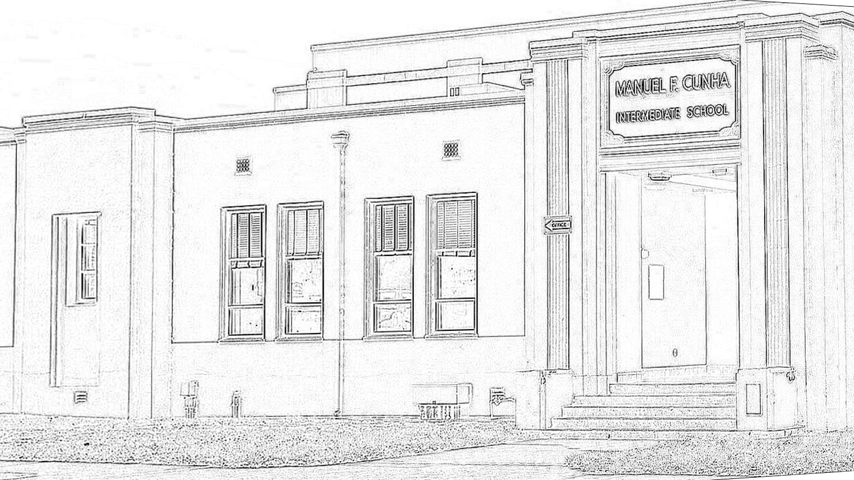
CUNHA PTO MARCH MEETING Tuesday March 17 6 pm Room D1
MINUTES
Cunha PTO
600 Church Street
Half Moon Bay California 94019
CunhaPTO@gmail.com
CunhaPTO.org
Tax ID #71-0909516

I. Call to Order 6:00pm

II. Welcome and Introductions
Victor Guzman (Cunha Principal), Britney Hooker (Cunha Vice Principal), Julia McPherson (PTO Secretary), Megan Wilson (PTO Treasurer), Kendra Holland (PTO President), Angela Eckberg, Amber Stariha

III. Vote
Previous Meeting Minutes (January 2026)
VOTE: Motion to approve January’s minutes
The Mover - Megan Wilson
The Seconder - Amber Stariha PASSED

IV. Voice of the Community
Staff
Community Members

V. Administration Report: Mr. Guzman, Cunha Intermediate School Principal
- 8th grade cal academy - need 10 more chaperones
- ELD fieldtrip on 4/8 - SF State and local community college
- ELAC is Tue 3/24
- Staff/student basketball game 4/10 (Fri before spring break)

VI. General Business
March Dance Sign-Up
- Link and email to be resent for parent sign-up (chaperone and food/drinks)
March Teacher Appreciation Sign-Up
Old Yearbook Fundraiser
- Yearbook fundraiser - Ms. Grover (Librarian) - giveaway old yearbooks (PTO agrees no to selling them)

Staff Appreciation Ideas
- Budget recommendation is $1400 and $1500-1600 for the rest of the year in Teacher Appreciation expenses
- Asking for volunteers, no other events BUT T.A. for the rest of the year
- Tres amigos, breakfast burritos and coffee, cookie trays (order for 50-55)

2026-2027 Board Positions

VII. Financial Report: Megan Wilson, Cunha PTO Treasurer
Teacher Appreciation Budget
- Financial - deep dive into years past, actual spend, put "extra" into budget
- In past - PTO did 2 days (Tue/Thur) and admin did 2 days (Mon/Wed), maybe ELAC takes 1 day?? (Jasmine to coordinate with families)

VOTE: Motion to increase Teacher Appreciation budget from $1200 TO $1500 AND Staff Appreciation from $1000 TO $1500
The Mover - Angela Eckberg
The Seconder - Kendra Holland. PASSED

Science Department Thank You Note
- Those at the meeting signed the card

VIII. Adjournment 6:28pm

Next Meeting:
Tuesday, April 21 6 pm, Room D1

Tentative Cunha PTO Meeting Schedule (third Tuesday of the month, 6 pm, Room D1)
April 21
May 19

