**TUNING GUIDE**

**TOWN CLASS**

**15 August 2020**

**W Key**

**General Comments**

Tuning a sail boat has many meanings to different folks. An aluminum mast by manufacture is straight and stiff so that “tuning” is essentially an exercise in ensuring that the mast is in the correct fore/aft and thwartship position with the proper tension on the stays and shrouds.

While Town Class sailboats have a similar requirement for the fore/aft, thwartship position and rig tension, these characteristics vary with the opinion of the Skipper. In addition, a Town Class Sailboat mast is very flexible and must be “tuned” to keep it straight in column i.e. no wiggles or curves.

As in any functional process in which the opinion of the Skipper, there is no set solution and the process is iterative i.e. changing with observation, so keeping a record of mast position and rig tensions is essential to determine what is fast and slow. Continually change the mast position and rig tension until you can extract the maximum boat speed against other boats. Establish and maintain a record of the following as seen in Figure One below:

1. Mast butt distance from the forward side of the centerboard box to the aft side of the mast
2. Masthead distance from the outside edge of the transom at the center
3. Rig tension with no sails hoisted. Use time categories: very loose, loose, medium, and tight or more advanced notes should include lower shrouds (aft chain plate), upper shrouds (forward chain plate) and headstay.

**Basic Tuning**

**Mast**

1. Athwartship (goal is to have the mast be equal port to starboard and be straight with no curves)
2. Take the boom off the mast.
3. Slack the forward shrouds (uppers).
4. Using the halyard and a piece of line tied onto the end of the aft end of the halyard where the sail would normally be attached, measure from side to side to the deck edge aft of the after (lowers) shrouds.
5. Adjust the turnbuckles until the measurement from side to side is within 1/8”. This will set the lower section of the mast vertical thwartship in the boat.
6. Lie on your back on the bow deck with a cushion between you and the cockpit combing and sight up the mast track. Be sure that you can reach the nearest forward shroud with your hand when lying on your back. Loop a short piece of line around the opposite forward shroud and lead it over so that it can be pulled on when you are lying on your back.
7. Straightness
8. Sight up the track and note the bend in the mast above the aft shroud attachment point. Pull gently on one forward shroud or the other to determine the effect on the mast bend. The goal is to get the mast as straight as possible’
9. Once the effect on mast straightness can be determined by pulling on the forward shrouds, adjust the turnbuckles to set the mast straightness. Once close to straight, go slowly backing off on one turnbuckle one turn and taking up the opposite turnbuckle
10. Do not be discouraged, this process may take 10-15 minutes, but once set correctly, your boat will thank you with better speed.

**Advanced Tuning**

**Comments**

The Town Class was designed in the 1930s when the trend was to have exceptionally large mains and small jibs, with the addition of the jib as probably as an improvement on a catboat. When sail boats are designed, there is a separation between the Center of Underwater Effort and the Center of the Sail Area, designated as “lead” and this separation is intended to balance the boat so that she doesn’t want to head into the wind.

Any attempt to round up into the wind must be countered with the rudder and is called weather helm.

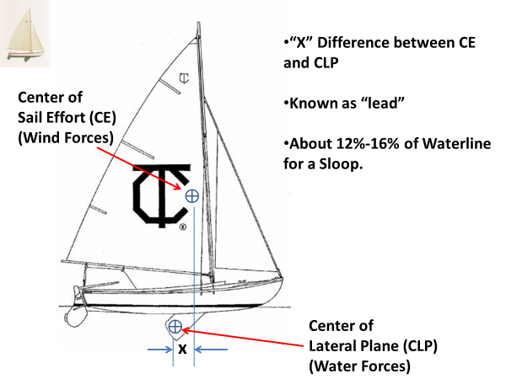

Weather helm on Townies, because of the short, fat rudder, works like a water brake and stops the boat very effectively, so that to sail fast, the boat needs to be rigged so that is minimal weather helm. Townies have serious weather helm issues which is the basis for carrying two tillers, break one and have a spare. Cure the weather helm and eliminate the need for a spare tiller.

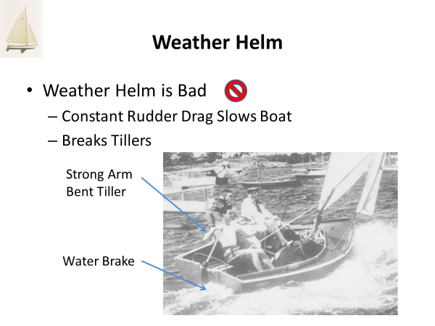

Excerpt from 2016 Seminar

This weather helm results from the use of incorrect “lead” and with a Townie, this incorrect “lead” probably resulted from the full bow which requires a larger “lead”. The weather helm can be cured by moving the Centerboard aft or the Rig forward. The CB is fixed in the boat, so moving the Rig forward is the procedure. Refer to moving the Rig to reduce or eliminate weather helm as “Advanced Tuning” of the mast.

**Advanced Tuning Procedure**

1. Using latest sailing experience/reference material, see figure one, select the initial mast position and rake.
2. Position and rake the mast as desired.
3. Use the basic tuning instructions to ensure the mast is straight and vertical side to side
4. Record the values for masthead to transom and mast butt to CB box for reference. See figure One.
5. Sail and make note of weather helm in various wind speeds and racing conditions
6. Adjust mast position accordingly.

**Rig Tuning Dimensions V03 April 2021**

|  |  |  |  |  |  |  |
| --- | --- | --- | --- | --- | --- | --- |
| Boat | Owner | Rake | CB Bx front face to aft side of mast | Mast Fwd face at Deck to Stem | Masthead to aft edge of transom | Rig Tension |
|  |  |  |  |  |  |  |
| 2047 | Cooke | Vertical |  |  | 24’ 10” | Medium |
| 2065 | Cann | Forward++ | 9” |  | 25’2” |  |
| 2074 | Solstad | Forward |  |  | 24’ 10” | Loose |
| 2086 | Howes | Slight Aft | 11” | 61 1/16” | 24’ 7” | Medium |
| 2093 | Key | More Aft | 12" | 60 15/16” | 24’ 0” | tight |
|  |  |  |  |  |  |  |

Figure One Tuning Record

Note 1 On 2047 and 2074 the masthead to transom distance was the same because of the forward movement of the mast butt on 2047. No dimensions available for CB Bx to mast for these boats.

Note 2 #2093 has the mast raked aft and can achieve that by moving the mast butt forward, cutting out the deck aperture (partners) and raking aft

Mast Fwd Face to Stem Fwd Face Measurement #2087

61 1/16”

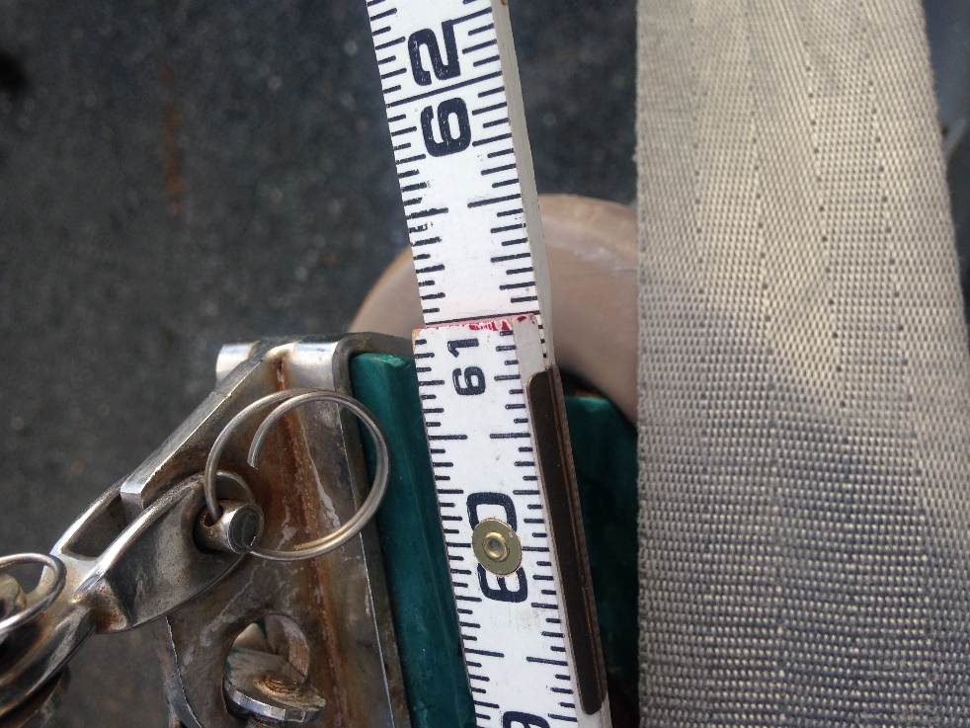

Mast Fwd Face to Stem 2093

60 15/16”