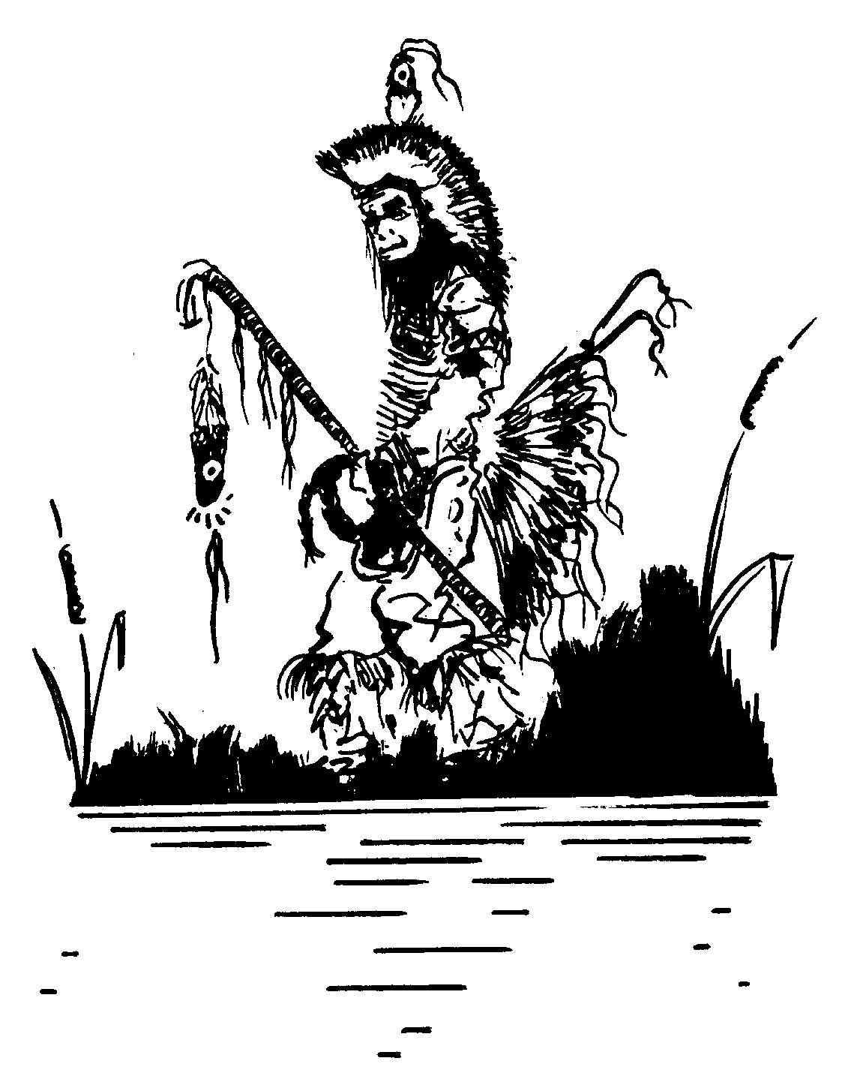
PERRY MCLEOD-SHABOGESIC

17 Charles St.
Garden Village, Ont.
P2B 3K3
(705) 753-3725
(705) 507-8535
anzoked@yahoo.ca
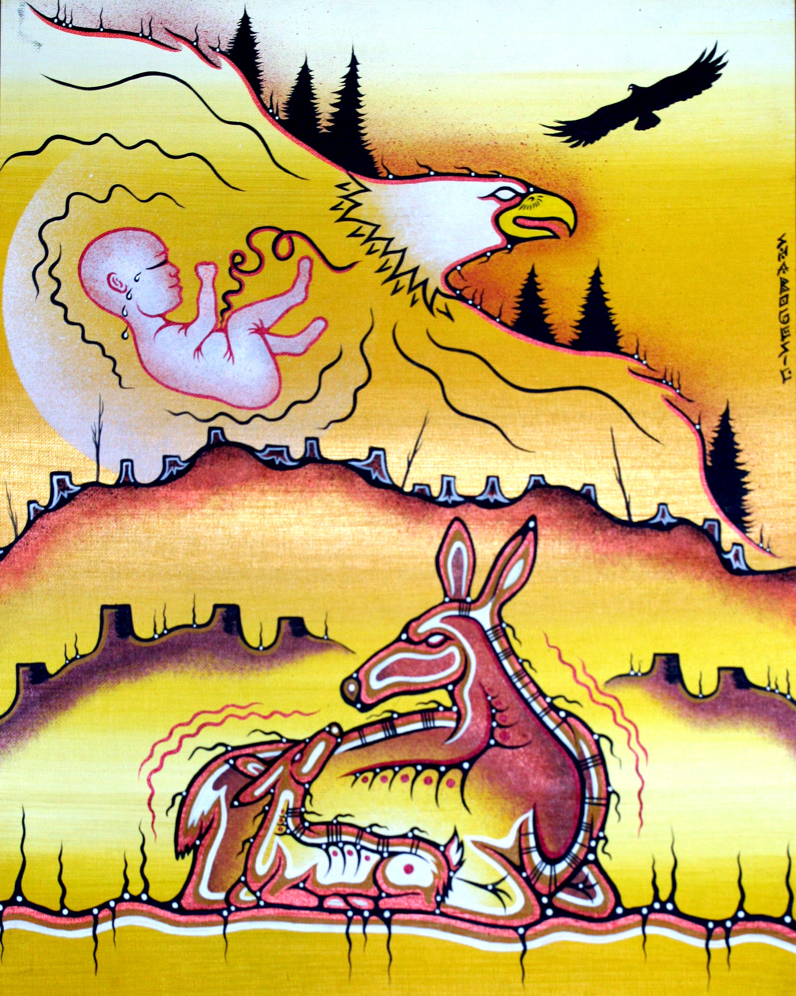
Perry McLeod-Shabogesic of the "Crane Clan" is an Ojibway Anishinabe from N'biising (Nipissing) First Nation (NFN). The Ojibway people are a tribe within the larger Anishinabek Nation whose territory spans largely around the central Great Lakes of North America. NFN is located on the north shores of Lake Nipissing in Northern Ontario, Canada.

Perry has been a artist, cartoonist, writer, traditional helper, medicine harvester and cultural resource person in and around his community for many years. Perry's spirit name is "Aandzooked", which means "Teller of sacred stories" in Ojibway.

Shabogesic has worked within the school system for over 25 years visiting classrooms across Ontario sharing his artistic gifts with children.
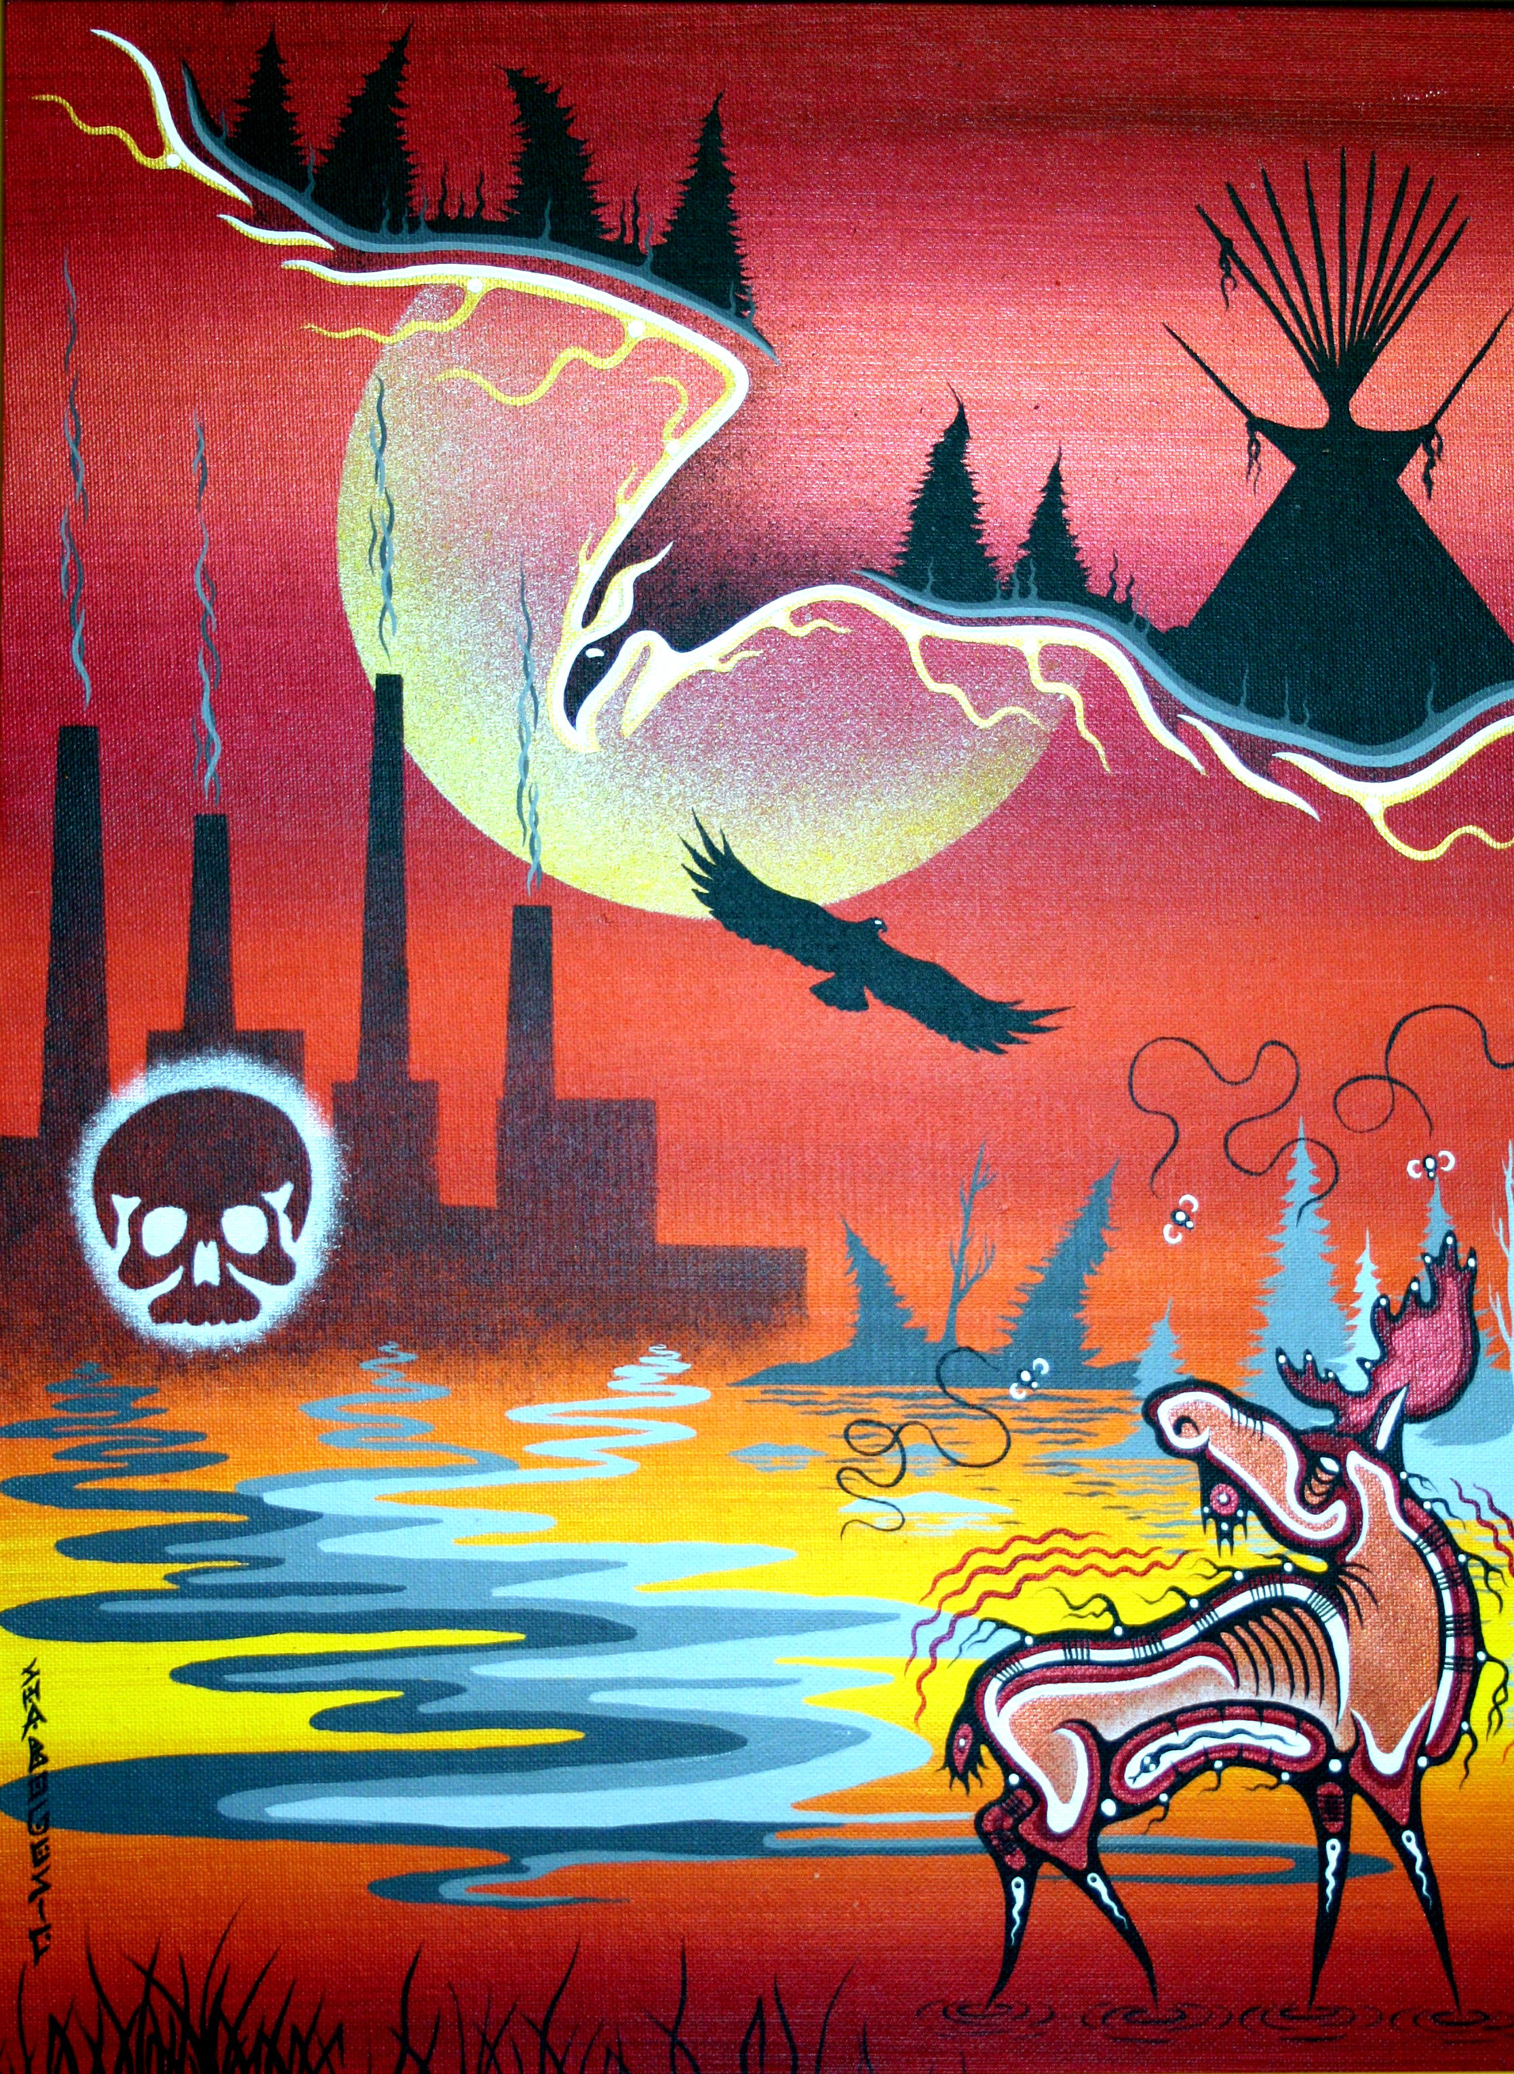
“Where are the Trees?” Acrylic on Canvas

Using art as a way to teach about local culture, history and self-expression Perry has and continues to work with Aboriginal youth to celebrate art.

McLeod-Shabogesic has sat on the OAC as a juror many times as well as accessed funding to facilitate a number of “Artist in the Classroom” and Artist in Residence” projects over the years including recent projects as a member of Aanmitaagzi.

Today, Perry continues to visit classrooms today celebrating art with students. He has also worked for his people in the areas of health, social services, education and culture.

“Poison Water” Acrylic on Canvas

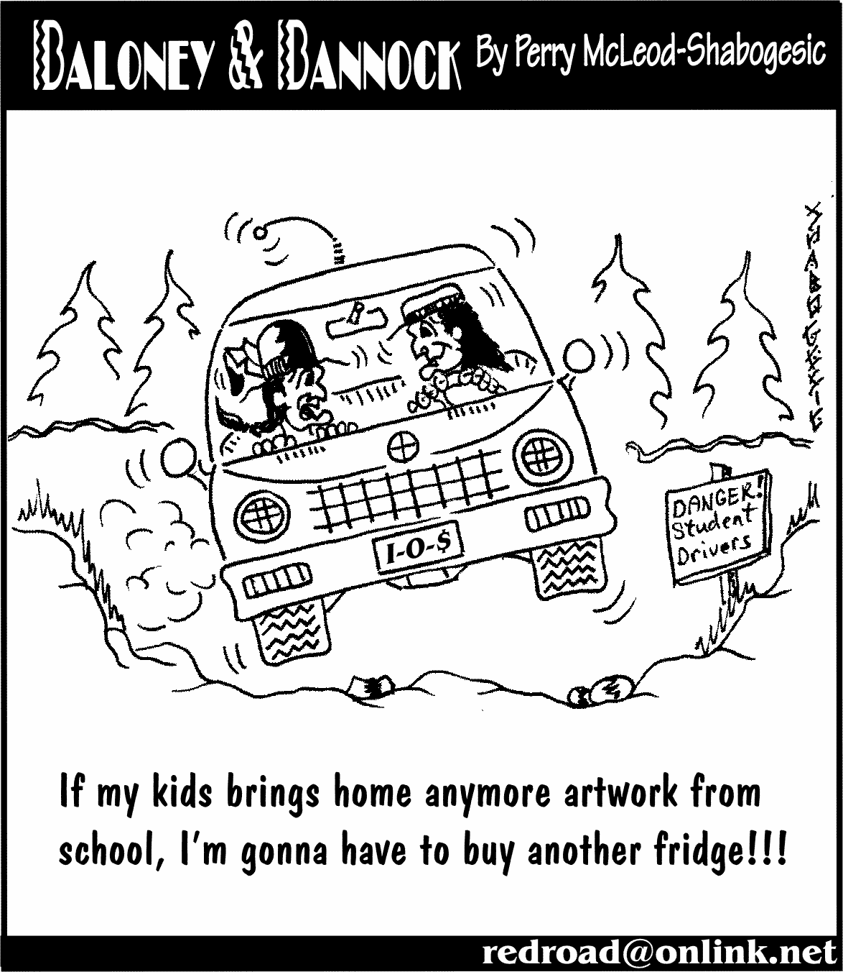
About 20 years ago, Perry also developed a comic strip called "Baloney & Bannock". Since then, it has slowly become a cult favorite amongst many of the Anishinabek communities.

Recently he has worked closely with world renown cartoonist Lynn Johnston (For Better or For Worse) helping her develop story lines for her strip as well as improving his own techniques.

From politics to culture he loves to poke fun. His sense of humor has even caused him to get into a little controversy along the way. On this matter Perry says "If you can't laugh at yourself and the world around you, then I'm more than willing to help ya!!!

Perry’s other artwork includes logos and fine art using acrylic and mixed media. He has developed his artistic style from the traditional woodland images and rock paintings. He has often been asked to speak on many aboriginal issues by aboriginal and non-Aboriginal organizations across Ontario, Canada and the United States.

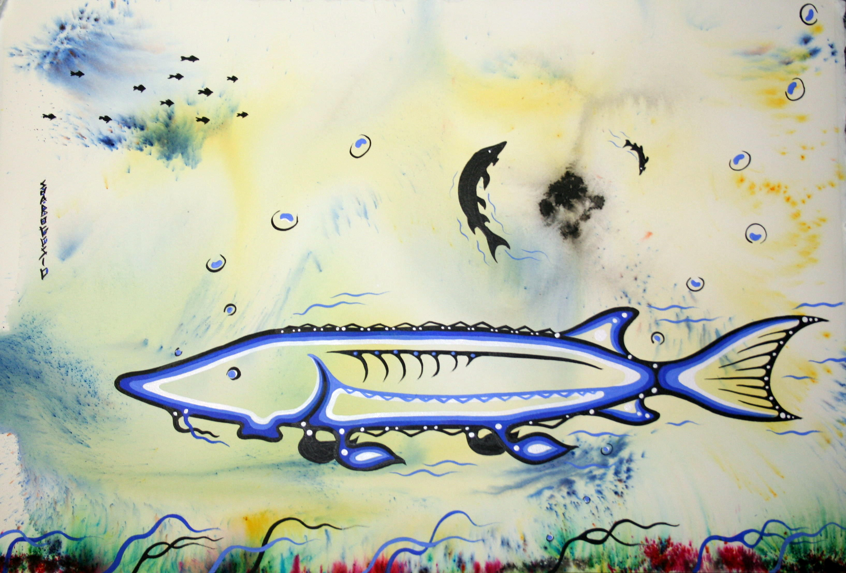

“The Great Sturgeon” mixed media on paper

CORPORATE LOGOS:

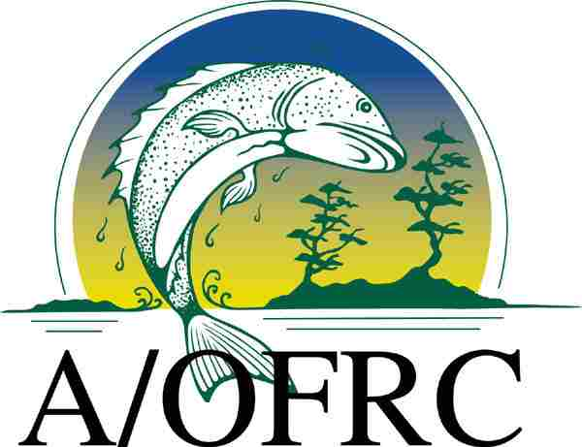 Anishinabek/Ontario Fisheries Resource Center logo

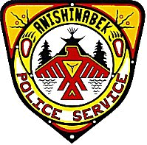 Anishinabek Police Services logo

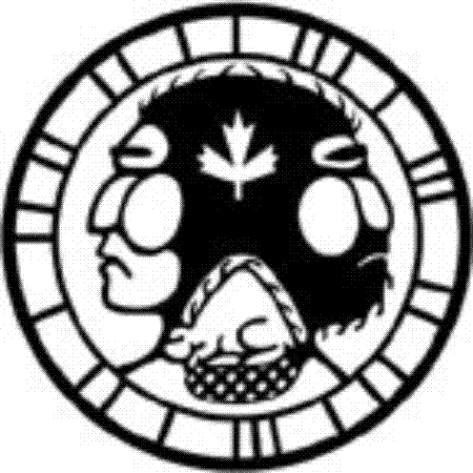 Fur Harvesters logo

