

Thank you for choosing the **Crescent Dental Clinic** as your dental practice. This leaflet tells you about our practice. Should you have any further questions, please speak to Abhijeet Kulkarni, Practice Principal on 01423 531863 or email [Crescentdentalharrogate@gmail.com](mailto:Crescentdentalharrogate@gmail.com) The practice undertakes to provide high quality dental care by appropriately trained staff and ensure that you are involved in decisions about your care.

We provide a full range of treatment on a private basis, including **White and Cosmetic Fillings, Inlays, Onlays, Crowns and Bridges, Root Canal Treatments, Dentures, Veneers, Bonded restorations for Smile Design, Teeth Whitening and an extensive range of Cosmetic Dentistry**. We offer detailed **Dental Examination, Scaling (Oral Hygiene) and Convenient Dental Payment Plans**. For further information, please speak to our dentists or visit our website [www.dentallyyours.uk](http://www.dentallyyours.uk)

Please contact the practice if you would like to make an appointment at a time that is convenient for you, by calling 01423 531863 or email: [crescentdentalreception@gmail.com](mailto:crescentdentalreception@gmail.com) (if sending an email, please provide your full name, contact telephone number and preferred dates and timings. We will call or email to offer you the most suitable appointment options and **will only confirm the appointment after your approval. Alternatively you could request an appointment via our website** [www.dentallyyours.uk](http://www.dentallyyours.uk)

## Our team

**Dr. Abhijeet Kulkarni,** BDS, MJDF (RCS) Eng. (GDC Registration No 145758)

Abhijeet joined the practice in April 2018, as the Principal Dentist. Abhijeet qualified in 2000, and has since worked in Hospital and General Dental practices. He gained his MJDF Diploma and Membership to the Royal Colleges in 2013. He also has a certificate in facilitating Healthcare Learning from UCLAN. Abhijeet enjoys general dentistry and has special interest in Conservative and Cosmetic Dentistry. Abhijeet works at the practice on Mondays, Wednesdays and Fridays.

**Dr. Alan Aungier,** B.Dent.Sc, MSc (Periodontology)(GDC Registration No 59563 Alan started and has worked as principal dentist at Crescent Dental Clinic since 1993 until April 2018, when he became an Associate dentist. Alan qualified in Dublin in 1984 and has since gained Master degree in Periodontology from the Universityof London. He is interested in all aspects of general dental care. Alan works at the practice in Tuesdays, Thursdays and Fridays.

*Crescent Dental Clinic is owned by Dentally Yours Limited, registered with companies house. (Company registration number 10617374) The registered trading address for the company in 12 Cambridge Crescent, Harrogate, HG1 1PE.*

Our dentists are supported by **our committed team:**

**Annette Ward** (Registered Dental Nurse and Receptionist)(GDC Reg.No 129043)

Annette has 24 years experience in dental nursing, having gained the National certificate in Dental Nursing in 1995. Annette also has a NVQ in Customer Services. Annette has been with the practice for the past 6 years, and is always happy to provide you with all the support you need during your patient journey

**Chloe Hill (**Apprentice Dental Nurse)

We are delighted to welcome Chloe to the team. Chloe joined us in May 2019 and works at the practice Monday to Friday, except Thursdays, when she attends dental nursing training classes. Chloe is very keen to help you during your patient journey at the practice.

## Opening hours

We are open during the following times:

|  |  |  |
| --- | --- | --- |
| Monday | 9:00am | 6:00pm |
| Tuesday | 9:00am | 5:00pm |
| Wednesday | 9:00am | 5:00pm |
| Thursday | 9:00am | 5:00pm |
| Friday | 9:00am | 5:00pm |
| Saturday | By appointment |  |
| Sunday | Closed |  |

The practice is closed for lunch from *1pm* to *2pm*

Should you have a dental emergency outside of the practice opening hours, please call 01423 531863 where you will find the details for Out Of Hours cover. If the arrangements are not accessible or suitable, you could alternatively call 111 (NHS 111) to seek help. For all life threatening emergencies, call 999.

## Complaints procedure

If you have any concerns or comments about your experience of our practice, please contact Abhijeet Kulkarni on 01423 531863 or **Crescentdentalharrogate@gmail.com** who will explain our complaints procedure. A copy of the complaints policy is also available from reception.

## Patient confidentiality

We take patient confidentiality extremely seriously and have systems in place to protect all personal information. All patient records are stored securely. We do not release information to a third party without your express permission, unless the information is required by law. A copy of the practice confidentiality policy is available at reception. You can also request information about your rights to view your records.

## Methods of payment

We accept the following methods of payment at the practice: Cash, Cheque (made payable to Dentally Yours Limited) and all major Credit and Debit Cards. We can also accept payment by Bank Transfer. Please ask reception for details.

## Other information

We will aim to ensure that you are cared for by your preferred dentist. Where this is not possible, we will explain the reasons. We encourage our patients to receive regular dental care to achieve and maintain good oral health. We will undertake a dental care assessment during your first appointment to assess and agree your treatment needs. A detailed Treatment Price List is displayed at the practice reception desk.

Unfortunately, our treatment areas CANNOT be accessed by wheelchair users. If you do have any disability that you think we need to know about, please give us a call before your appointment and we will do our best to put suitable arrangements in place to accommodate your needs.

Missed appointments result in wasted time that could be used by other patients. We ask that if you are unable to attend your appointment, you let the practice know and give as much notice as possible and, at least 24 hours. Missed appointments or cancellations at short notice may result in a charge being made. We will of course take any special circumstances into account.

## Our contact details

*Crescent Dental Clinic, 12 Cambridge Crescent, Harrogate, HG1 1PE*

*Tel: 01423 531863*

*Email:* [*Crescentdentalharrogate@gmail.com*](mailto:Crescentdentalharrogate@gmail.com) *; Website:* [*www.dentallyyours.uk*](http://www.dentallyyours.uk)

Like / follow us on **Facebook**: [www.facebook.com/harrogatedentalclinic](http://www.facebook.com/harrogatedentalclinic)

Follow us on twitter@dentally_yours

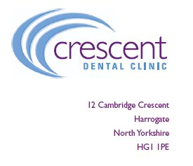

Practice information leaflet

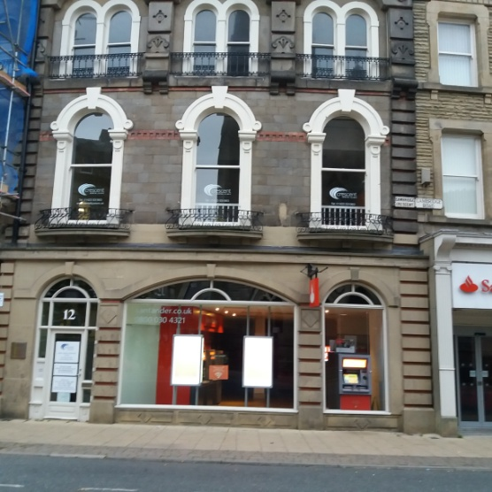 

* There are several free (Disc parking) (5mins) and Charged car parking spaces (1min) around the practice.
* The practice is located on the First floor above Santander Bank
* The practice is easy walking distance from Bus stop – War Memorial (1 min) and Harrogate Train station (Station Parade) (3 mins)
* Google Maps plus code XFV5+79 Harrogate