Topic: Meaningful Work & Wealth

Message 1

Graphic

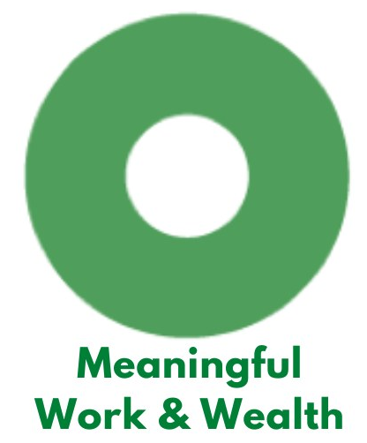

Text

Vital Condition Spotlight: Meaningful Work & Wealth: Personal, family, and community wealth provides the means for healthy, secure lives. That includes good-paying, fulfilling jobs and careers, and financial security that extends across the life span. People’s lives and self-worth flourish when doing productive, rewarding work. The ability to accumulate adequate wealth shapes the living standards not only for individual families and communities, but also for generations to come. Even beyond the immediate importance of earning a paycheck, meaningful work lifts up entire families and communities, creating a vibrant community. #VitalConditions #MeaningfulWork #ThrivingTogether #Delaware #NetDE #Equity @HealthyCommunitiesDE

Message 2

Graphic

Text

Vital Condition Spotlight: Meaningful Work & Wealth: Fulfilling jobs that pay a living wage and facilitate economic mobility contribute to healthy, secure lives and financial security that extends across the lifespan. Productive, rewarding work also contributes to happiness and has a positive impact on families and communities — and financial security is critical for well-being. #VitalConditions #MeaningfulWork #ThrivingTogether #Delaware #NetDE #Equity @HealthyCommunitiesDE

Message 3

Graphic

Text

Vital Condition Spotlight: Meaningful Work & Wealth: Increasing access to banking and financial resources — especially for people with lower incomes and people from under-represented racial and ethnic groups — helps convert the value of work into savings that support resilience and build generational wealth. Further, removing systemic inequities will provide more paths to small-business ownership, access to capital, and other knowledge supports, contributing to equitable opportunity for careers and individual and community wealth that enable inclusive thriving. #VitalConditions #MeaningfulWork #ThrivingTogether #Delaware #NetDE #Equity @HealthyCommunitiesDE

Message 4

Text

Vital Conditions Spotlight: Meaningful Work & Wealth: Did you know? According to United States Department of Health and Human Services, 28 million people in the United States work in occupations that don’t pay a living wage. #VitalConditions #MeaningfulWork #ThrivingTogether #Delaware #NetDE #Equity @HealthyCommunitiesDE

Topic: Get Involved (New Year’s 2023)

Message 1
Graphic

Text
It’s a fresh new year. Let’s make a resolution to make [community name] a place where everyone has the chance to be happy, healthy, and thriving. [insert call to action- see options below] #VitalConditions #ThrivingTogether #Delaware #NetDE #Equity #HappyNewYear2023 @HealthyCommunitiesDE

Sample calls to action:
- Share your ideas about what you’d like to see in our community! [insert info about upcoming meeting or contact info for community engagement specialist]
- Want to be a part? Join us [insert info about volunteer opportunities or contact info for community engagement specialist]

Message 2

Graphic:

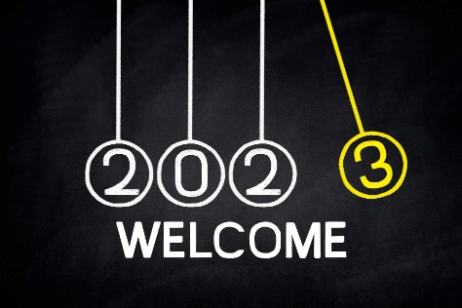

Text:
It’s a new year! Make a resolution to get involved in improving our community. What improvements would you like to see happen in the next year? [insert call to action- see options below] #VitalConditions #ThrivingTogether #Delaware #NetDE #Equity #HappyNewYear2023 @HealthyCommunitiesDE

Sample calls to action:
- Share your ideas about what you’d like to see in our community! [insert info about upcoming meeting or contact info for community engagement specialist]
- Let’s work together to make things happen. Check out these opportunities to participate - [insert info about volunteer opportunities or contact info for community engagement specialist]

Topic: Our Collective Progress

Graphic:

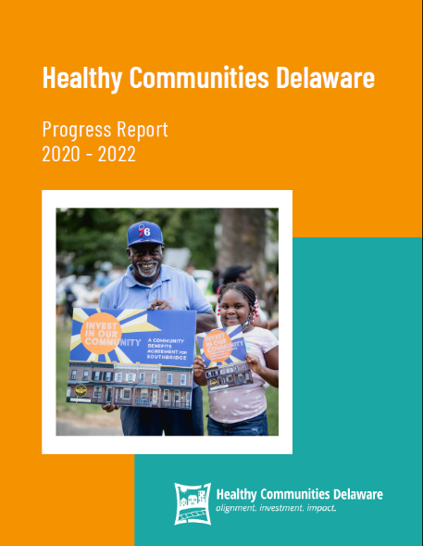 (link image to report)

[ORGANIZATION NAME] is part of the Healthy Communities Delaware Network, which began in 2020 with investments in 9 communities and 14 community based organizations. From June 2020 to June 2022, take a look at our progress and collective impact here: LINK TO REPORT #VitalConditions #ThrivingTogether #Delaware #NetDE #Equity @HealthyCommunitiesDE

Topic: Our Community is Part of Something Bigger

Graphic:

(link image to report)

Text
Did you know that [community name] is part of the Healthy Communities Delaware statewide collaborative network? It’s a group of 14 neighborhoods across the state, all working to improve vital conditions like housing, safety, and social connection so that EVERYONE has the opportunity to be well and thrive, no exceptions. Visit Healthy Communities Delaware and view our Progress Report: [REPORT LINK ON WEBSITE| [insert call to action- see options below] #VitalConditions #ThrivingTogether #Delaware #NetDE #Equity @HealthyCommunitiesDE

Sample calls to action:
- Find out what’s happening in [community name], and in communities across the state. [link to report]
- Learn more about how [CBO name] is working to improve community conditions in [community name]. [add link to your website, video, or event]
- Join us in working to make [community name] a great place to live. [add link to your website or
- event/meeting or giving campaign]

