**Topic: Humane Housing – Vital Condition of the Month**

**Message 1  
Graphic:**

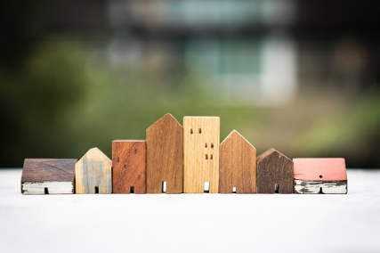

**Text:**Everyone needs a safe, warm place to live. But in Delaware, there simply aren’t enough affordable and available homes – in fact, there is a shortage of 18,000 housing units. [insert call to action- see options below] #VitalConditions #HumaneHousing #ThrivingTogether #Delaware #NetDE #Equity @HealthyCommunitiesDE @housingalliancede

**Sample calls to action:**

* Learn more in the [2022 Housing and Homelessness Report](https://www.housingalliancede.org/_files/ugd/9b0471_322d16c2158c4ab09743a897dc12aa6d.pdf) from Housing Alliance Delaware.
* Learn more about how [CBO name] is working to increase affordable housing in [community name]. [add link to your website, video, or event]

(Facts/statistics from [2022 Housing and Homelessness Report](https://www.housingalliancede.org/_files/ugd/9b0471_322d16c2158c4ab09743a897dc12aa6d.pdf) from Housing Alliance Delaware)

**Message 2**

**Graphic:**

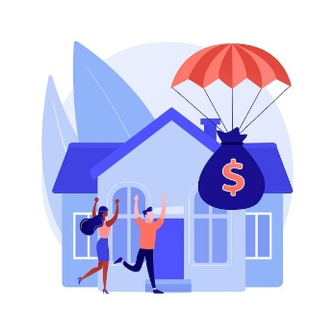

[Image by vectorjuice on Freepik](%3ca%20href=%22https:/www.freepik.com/free-vector/mortgage-relief-program-abstract-concept_12084855.htm#query=home%20cost&position=8&from_view=search&track=sph">Image by vectorjuice</a> on Freepik)

**Text:**

Housing is the biggest monthly expense for most Americans, but for some, rent is simply out of reach. In Delaware, a worker earning minimum wage would have to work 71 hours each week (almost 2 full-time jobs) to afford a one-bedroom rental unit. [insert call to action- see options below] #VitalConditions #HumaneHousing #ThrivingTogether #Delaware #NetDE #Equity @HealthyCommunitiesDE @housingalliancede

**Sample calls to action:**

* Learn more in the [2022 Housing and Homelessness Report](https://www.housingalliancede.org/_files/ugd/9b0471_322d16c2158c4ab09743a897dc12aa6d.pdf) from Housing Alliance Delaware.
* Learn more about how [CBO name] is working to increase affordable housing in [community name]. [link to your website, video, or event]
* Join us in helping to increase affordable housing in [community name]. [link to your website or event/meeting or giving campaign]

(Facts/statistics from [2022 Housing and Homelessness Report](https://www.housingalliancede.org/_files/ugd/9b0471_322d16c2158c4ab09743a897dc12aa6d.pdf) from Housing Alliance Delaware)

**Message 3**

**Graphic:**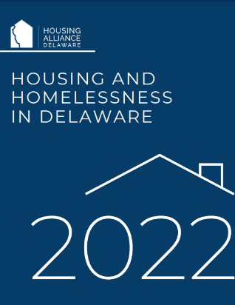

**Text:**Housing is the foundation for our lives. Take a minute to imagine - what would be different about your life if you didn’t have a home? Where would you take a bath? Keep your clothes? Eat a meal? What address would you use on a job application? Or for your child’s school enrollment? In February 2022, homelessness was a reality for over 2,000 Delawareans, one-third of whom were children. [insert call to action- see options below] #VitalConditions #HumaneHousing #ThrivingTogether #Delaware #NetDE #Equity @HealthyCommunitiesDE @housingalliancede

**Sample calls to action:**

* Learn more in the [2022 Housing and Homelessness Report](https://www.housingalliancede.org/_files/ugd/9b0471_322d16c2158c4ab09743a897dc12aa6d.pdf) from Housing Alliance Delaware.
* Learn more about how [CBO name] is working to end homelessness in [community name]. [link to website, video, or event]
* Join us in working to end homelessness in [community name]. [link to website or event/meeting or giving campaign]

(Facts/statistics from [2022 Housing and Homelessness Report](https://www.housingalliancede.org/_files/ugd/9b0471_322d16c2158c4ab09743a897dc12aa6d.pdf) from Housing Alliance Delaware)

**Topic: Impact of Community Vital Conditions on Health**

**Message 1**

**Graphic:**

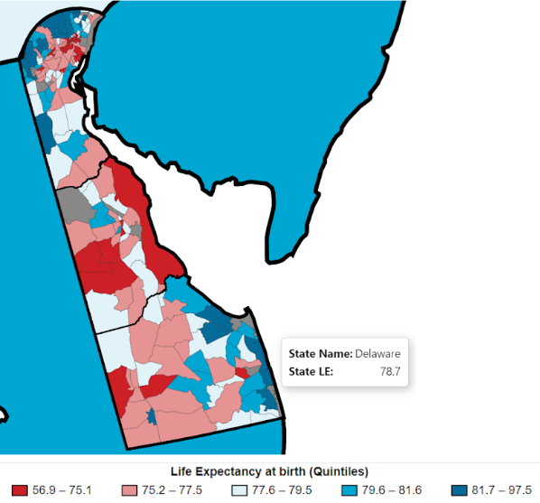

**Text:**When it comes to health and well-being, where you live matters. In one census tract in Delaware, residents live an average of 86 years. In some others, the average is only 68 years – a staggering 18-year difference. Why? Because of differences in community conditions like housing, transportation, safety, air quality, opportunities for learning and working, and social connectedness. [insert call to action- see options below] #VitalConditions #ThrivingTogether #Delaware #NetDE #Equity @HealthyCommunitiesDE

**Sample calls to action:**

* Find out more about these vital conditions in your community at <https://myhealthycommunity.dhss.delaware.gov/portals/ecdc/locations/state>.
* Learn more about how [CBO name] is working to improve community conditions in [community name]. [add link to your website, video, or event]
* Join us in working to improve community conditions in [community name]. [add link to your website or event/meeting or giving campaign]

(Facts/statistics from National Center for Health Statistics Data Visualization Gallery - <https://www.cdc.gov/nchs/data-visualization/life-expectancy/index.html>)