Pre-Approved Sample Social Media Post (Vital Conditions, General):

Graphic:
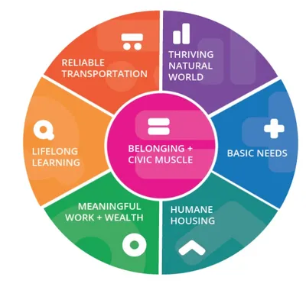

Text:

Our ability to thrive as individuals depends on having a consistent set of community Vital Conditions, such as clean air, fair pay, humane housing, early education, routine health care, and other basic necessities. Personal experiences may rise and fall from birth to death. However, vital conditions persist over generations. They shape the exposures, choices, opportunities, and adversities that we each encounter throughout our lives. [Name Of Organization] works to improve the vital conditions for individuals and families living in our community so that all people have the ability to thrive! #VitalConditions #ThrivingTogether #Delaware #NetDE #Equity @HealthyCommunitiesDE

Pre-Approved Sample Social Media Post (Vital Conditions , Lifelong Learning).

Graphic:

Text:

The Vital Conditions for Well-Being are the things that all people need all the time to be healthy and well. Lifelong Learning is one of these Vital Conditions--it is about the opportunity for a good education that ensures all people, regardless of age, background, or ability, are set up for success, and have the supports needed to reach their full potential. It’s about an education that launches people into meaningful careers, with ongoing opportunities to learn and grow. #VitalConditions #LifelongLearning #ThrivingTogether #Delaware #NetDE #Equity @HealthyCommunitiesDE

Pre-Approved Sample Social Media Post (Vital Conditions, Basic Needs for Health & Safety):

Graphic:

Text:

The Vital Conditions for Well-Being are the things that all people need all the time to be healthy and well. Physical and mental well-being starts with Basic Needs for Health & Safety such as access to fresh air and water, nutritious food, and the security of a stable home. People also need healthy relationships - with freedom to express gender and sexuality - and a life free from violence, injury, and toxic stress. Access to routine and critical health care is also an important factor for maintaining health and well-being. #VitalConditions #BasicNeeds #Health #Safety #ThrivingTogether #Delaware #NetDE #Equity @HealthyCommunitiesDE

Pre-Approved Sample Social Media Post (Vital Conditions, Thriving Natural World):

Graphic:

Text:

The Vital Conditions for Well-Being are the things that all people need all the time to be healthy and well. Thriving Natural World is about having clean air, clean water, clean land, and well-functioning ecosystems. A healthy environment is one that is free from environmental hazards, one that is resilient to future changes and threats, and one that fulfills our needs to connect with nature. #VitalConditions #ThrivingNaturalWorld #ThrivingTogether #Delaware #NetDE #Equity @HealthyCommunitiesDE

Pre-Approved Sample Social Media Post (Vital Conditions, Meaningful Work & Wealth):

Graphic:

Text:

Personal, family, and community wealth provides the means for healthy, secure lives. That includes good-paying, fulfilling jobs and careers, and financial security that extends across the life span. People’s lives and self-worth flourish when doing productive, rewarding work. The ability to accumulate adequate wealth shapes the living standards not only for individual families and communities, but for generations to come. Even beyond the immediate importance of earning a paycheck, meaningful work lifts up entire families and communities, creating a vibrant community. #VitalConditions #MeaningfulWork #ThrivingTogether #Delaware #NetDE #Equity @HealthyCommunitiesDE

Pre-Approved Sample Social Media Post (Vital Conditions, Humane Housing):

Graphic:

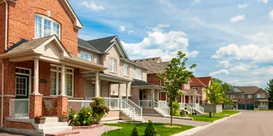

Text:

Humane Housing is an indispensible vital condition that we all depend on for our health and well-being. We are able to thrive when we have secure, consistent places to live; when our homes and neighborhoods are safe from hazards; and when our neighborhoods provide what we need for our lives and livelihoods. Housing is the biggest expense for most Americans, and thus housing affordability is a significant factor in financial well-being. Homeownership has long been at the center of the American Dream helping build family wealth, and stable diverse communities. #VitalConditions #HumaneHousing #ThrivingTogether #Delaware #NetDE #Equity @HealthyCommunitiesDE

Pre-Approved Sample Social Media Post (Vital Conditions, Reliable Transportation):

Graphic:

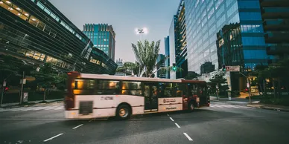

Text:

Reliable Transportation is about moving between home, work, school, stores—and more—in daily life. Transportation options influence access to jobs, social mobility, and our health. Active transportation—walking, biking, and transit use—helps us incorporate physical activity into our daily lives. Designing compact communities and sustainable transportation systems ensure people are able to get where they need to go no matter a person’s means, mode, or ability. Access to transportation is a major driver of health and well-being. #VitalConditions #ReliableTransportation #ThrivingTogether #Delaware #NetDE #Equity @HealthyCommunitiesDE

Pre-Approved Sample Social Media Post (Vital Conditions, Belonging & Civic Muscle):

Graphic:

Text:

Belonging and Civic Muscle is about having fulfilling relationships and social support that people need to thrive. It’s about being part of a community and contributing to its vibrancy. Social support through friends, family, and other networks contributes to our practical and emotional needs, enhances mental well-being, helps us navigate the challenges of life, and reinforces healthy behaviors. People with a stronger sense of belonging, social connectedness, and power to effect change tend to live healthier, happier lives. As people in a community feel valued and cared for, they become more confident and willing to participate in the community, contributing to its vibrancy and affecting change. #VitalConditions #Belonging #Civic Muscle #ThrivingTogether #Delaware #NetDE #Equity @HealthyCommunitiesDE

