Tentative 2.5 DIESEL 4X4 TRUCKS

The rules promulgated in these rules are intended as guidelines for the sport of Street Licensed Diesel 4×4 truck pulling. These rules have been adopted by Northwest Pa Pullers, for the 2020 season. Nothing herein should be construed as a guarantee against injury or death to participants, crewmen, family members, bystanders or spectators. Each participant at a Full Pull Productions’ pulling event must assure that their equipment and replacement equipment throughout the season meets the requirements for this class.
This is Diesel only fuel class is designed for pickup trucks with a wide variety of performance upgrades that may be driven or hauled to the pull
Credentials: Valid DOT registration and license plates are mandatory. A NWPA Member is exempt from this rule as long as the truck has the full contingent of safety equipment as specified in the 3.0sb Diesel class. The vehicle may be two or four-wheel drive. Pulling vehicles may be held for post competition tech inspection. Failure to abide may result in a DQ
Weight: 8000 lbs. Maximum, with driver.
REGULATIONS:
Ballast: Ballast is permitted. Hanging weights may not extend more than 60 inches from the centerline of the front axle. Weight boxes are prohibited. Final decisions rest with the technical department. Weights and brackets must be removable by hand. No Ballast/added weight in the cab area.
Batteries: The batteries must be securely mounted. They may not be located in the driver compartment or forward of the radiator core support.
Body: The body must be an OEM truck body, including the full bed floor. The body and truck bed must retain full factory sheet metal. Metal aftermarket hoods are permitted. Fiberglass is prohibited. The hood must be closed and securely latched while the vehicle is hooked to the sled. The complete OEM firewall and complete OEM floor pan is mandatory. Front bumpers are mandatory; Ranch hand style and others are permitted. Rear Bumpers mandatory; Rear roll pans are allowed.
Brakes: Four-wheel fully operational O.E.M. hydraulic brakes are mandatory.
Chassis: The OEM chassis is mandatory. The engine must be in the OEM location for the body used. The vehicle must retain the full OEM chassis. Wheel tubs, back-half conversions, tube chassis, etc., are prohibited.
Cooling System: Radiators must be functioning and in the vicinity of the stock location and be of at least stock size.
Credentials: All drivers must have a valid state driver’s license.
Driveline: An OEM transmission and transfer case is mandatory. They must have been an option on a one-ton or smaller pickup.
Driver Restraint System: The OEM restraint system is mandatory and must be worn.
Driveshaft Loops: All trucks running for points must have a minimum of six-inch wide u-joint shields around the rear u-joint constructed of at least 1/4 inch steel or 3/8 inch aluminum that will safely contain the u-joint and the end of the rear shaft.
Engine: The engine block must have been available as a factory option on a one-ton or smaller pickup truck. Block and Head must circulate coolant freely. No hard filled blocks/heads. Water pumps may be factory or electric powered. All factory belt driven accessories, excluding the air conditioning compressor, must be retained and powered via the crankshaft by a standard serpentine “V” belt. Electric cooling fans are permitted. Aftermarket radiator assemblies are permitted, but must be securely mounted in the same area as the OEM unit. ** A sled- and driver- operated spring loaded emergency air shut off is mandatory for all vehicles running for points and/or any vehicle running over Factory O.E.M. Specs. The cable must terminate into a two inch diameter steel ring.
NITROUS OXIDE is prohibited along with other oxygen extenders and the use of PROPANE is also prohibited. All system components MUST be removed.
Exhaust: All vehicles must be equipped to exit exhaust rearward of the driver’s compartment. Stacks exiting through the fender well and hood are prohibited. Two (2) 3/8 inch diameter bolts must be installed through exhaust pipe in a cross pattern within one (1) inch of each other and as close to the turbo as possible.
Fire Extinguisher: A fire extinguisher (minimum 2.5 pound dry-powder type) is required and must be in working order with gauge fully charged. Fire extinguisher must be within reach of the driver.
Fire Extinguisher System: A properly installed fire extinguisher system is permitted.
Fuel: The fuel must be pump #1/#2 diesel only. Soy/Bio-diesel fuel is permitted. Off-road diesel fuel is prohibited. Fuel tank must be in O.E.M location or an approved racing type fuel cell mounted properly in the bed.
Fuel Injection Pump: The fuel injection pump is limited to a stock-appearing, OEM engine make-specific pump only. Dual high-pressure common-rail fuel pumps or HPOPs are permitted.
Harmonic Balancer: All engines turning 4500 RPM and higher must be equipped with a harmonic balancer or damper meeting SFI Spec 18.1
Hitch: The hitch must be a receiver-style hitch; reinforcements are permitted. Any hitch attachments /bracing must be from frame down not from axle up. Reinforcements must not extend forward of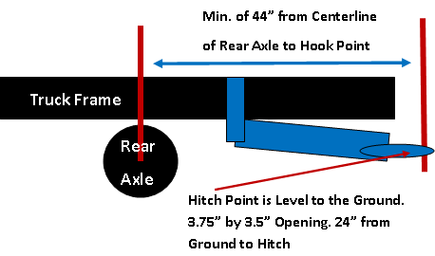 the centerline of the rear axle. Reinforcing materials will all be below the plane of the frame rails. Trick hitches are prohibited. Hitch must be a minimum of 44” measured form the centerline of the rear axle to the hooking point. The hitch must be horizontal to the ground and stationary in all directions. Bumpers may be notched or 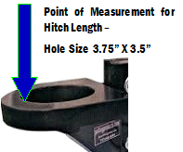removed. The hitch’s height from the ground may not exceed 24” inches on 4wd units and 28” inches on 2wd units. The hooking point must have a minimum 3.750-inch inside diameter opening for the sled hook. The hooking point will be measured to the rear of the opening in the clevis/hook loop. Hooking point (i.e. where the hook drops) must be parallel to the ground. Final decision of legality of all hitches resides with the head tech official.
Intercoolers: Factory style or aftermarket air to air replacement only in stock location. **Water to air coolers are prohibited.** Any means of cooling the air before the engine, except the air to air cooler is prohibited. **NO USE OF ICE OR WATER OR COOLED GAS/VAPOR**
Interior: A complete interior, including dashboard, door panels, headliner, etc., is mandatory. Two matching OEM front seats are mandatory. Must have full back and head rests on seats. All factory controls (lights, signals, horn, windows, wipers, etc.) must be retained and operative.
Rear End: Non-OEM rear-end housings are prohibited. The rear end must have been an option on a 1-ton or smaller truck. Rear axle bolts to be covered by a cap or shield.
Steering: The vehicle must retain the full, original OEM steering gear. The vehicle must retain the original OEM power steering assistance, if it was so equipped. Additional stabilizers are permitted.
Street Equipment: Complete headlight and taillight assemblies (all) are mandatory and must be operative in OEM locations. Complete OEM windshield and windows are mandatory. Windows must be operative per factory specifications; that is, they must open and close via OEM electrical or mechanical means. Driver’s window must be completely rolled up while competing. Other windows on truck may be lowered.
Suspension, Front: The factory suspension configuration must be retained. The upper mounting point for strut assemblies must be in the factory location. Adjustable caster/camber pillow ball mounts are permitted. The lower control arm may be strengthened provided factory-mounting points to chassis are maintained. The lower mounting point for the strut assembly may be modified for improved caster or camber. Strut tower braces, lower tie bars, sway bars, and limit straps are permitted. Traction bars and devices are permitted.
Suspension, Rear: An OEM-style suspension is mandatory. Traction bars and devices are permitted; they must be bolt on only; welds are permitted for attachment to frame or axle housing. Control arms may be strengthened or replaced, provided all original mounting points are retained. Strut tower braces, lower tie bars, sway bars, limit straps, and camber kits are permitted. All rear suspensions must use at least one working shock absorber and leaf spring per wheel. Airbag spring assistance is permitted; airbag compressors must be disconnected. A truck may run a solid suspension with a 24” hitch height.
Tires: The tires must be DOT street tires. Cut tires are prohibited. Use of dirt deflectors is prohibited. Rear Dual Tires permitted with OEM appropriate bed. Flatbeds with or without rear duals may be permitted with prior Competition Director and or/Board approval. Max ground contact patch of 18” Per Side for Trucks running dual wheels. Use of dirt deflectors is prohibited.
Throttle: OEM style foot throttle only with two springs on the fuel injection pump. No Hand Throttles.
Transfer Case: Non-OEM transfer cases are prohibited. It must have been an option on a one-ton or smaller pick-up truck.
Transmission, Automatic: Non-OEM transmissions are prohibited. Aftermarket torque converters, valve bodies and internal components are permitted. Transmission brakes are prohibited. Any non-OEM floor-mounted automatic transmission shifter must be equipped with a spring-loaded positive reverse lockout device to prevent the shifter from accidentally being put into reverse gear. A functional neutral safety switch is mandatory. All transmission lines must be metallic or high-pressure-type hose. All vehicles with engines running 4500 RPM or more and using an automatic transmission must be equipped with a transmission shield meeting SFI Spec 4.1 and must be labeled accordingly. A blanket-type shield is permitted; it must be appropriately labeled as meeting SFI Spec 4.1 and it must extend from the rear of the block to the front of tail housing with a minimum six-inch overlap where it is fastened. All non-blanket-type shields must incorporate two (or one, per manufacturer’s instructions) 3/4 inch by 1/8 inch straps that bolt to the shield on each side and pass under the transmission pan unless the transmission pan is labeled as meeting SFI Spec 4.1. All vehicles with engines running 4500 RPM or more and using an automatic transmission must be equipped with a flex plate meeting a Minimum SFI Spec 29.1 and be covered by a flex plate shield meeting SFI Spec 30.1
Transmission, Manual: Non-OEM transmissions are prohibited. Aftermarket internal components are permitted. A clutch meeting minimum SFI Spec 1.1 or 1.2 is mandatory on all vehicles with engines running 4500 RPM or more. All manual transmissions must be clutch assisted. Sequential shifters are prohibited. All vehicles with engines running 4500 RPM or more and equipped with a manual transmission must have a flywheel shield labeled as meeting minimum SFI Spec 6.3 or greater. Applications for which an SFI Spec flywheel shield is not available may use a properly attached SFI 4.1 or 4.2 blanket that completely covers the bell housing; it must be attached to the block and extend rearward to the transmission with a minimum six inch overlap where it is fastened.
Turbocharger:
The vehicle is limited to a single turbo with a compressor inducer of 2.5″ as specified below. A true Smooth Bore 2.6 permitted on a trial basis in 2020. Competitors must make provisions at tech officials’ request to allow complete inspection of the compressor wheel and housing. Failure to comply with the request will result in disqualification and banishment until the turbo is re-inspected
** 6.4 liter Powerstroke engines may utilize the factory twin-turbo configuration with no alterations/modifications to bore/housing or wheel. 6.4 Powerstrokes will be permitted to run modified turbos, as long as the atmosphere turbo does not exceed the OEM straight bore dimension. (2.59”) No TAPERED COVERS will be permitted
**SEE NEXT PAGE FOR DETAILED TURBO SPECS**
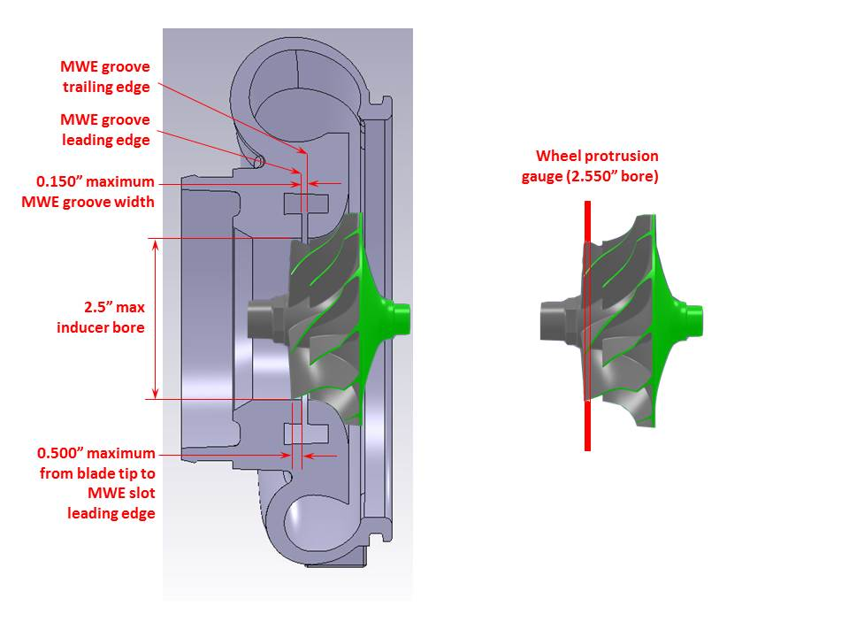

Turbo Specs: A single turbocharger with a single compression stage is permitted. The intent of this rule is to limit turbochargers to OEM-style wheel and cover geometries with minimal modifications. Owners are required to make the compressor wheel and cover accessible to FPP techs for inspection at any time.
- The compressor cover inducer bore is limited to 2.50” diameter and will be checked with a 2.550” plug. Bore may not be ovaled or otherwise distorted from a true circular shape to allow stoppage of the plug, but allow additional airflow to the wheel.
- The compressor wheel must protrude into the inducer bore by visual inspection and by using a ring gauge on the compressor wheel. The ring gauge used will be made from 16 ga. Sheet metal with a fully radiused 2.55” bore (see diagram). The wheel tips must protrude through the gauge to be legal.
- The compressor wheel and compressor cover contours must be parallel within normal OEM clearances <0.030″ per side) and will be checked visually or with a wire gauge if needed. No cuts, ledges, steps, tapers or any other features may be machined into the wheel or cover contour to allow additional airflow. Removable bushings are not permitted
- A single MWE groove is limited to 0.150” wide at all locations around the inducer bore and will be checked with ball diameter at 0.155″ on a pick or by other means. The ball must not pass through the groove. No additional features or structures are permitted in the slot that would prevent passage of the ball. 2.5” bore both before and after the MWE. Where the groove intersects the inducer bore, no radiusing or contouring is allowed; only sharp corners with minimal chamfers/edge rounding is legal. Air may only enter the compressor wheel via the specified inducer and MWE aag Q1 1` groove. No Forward Facing MWE
- Any type of adjustable compressor inlet on the turbo must be welded into place.
- The MWE leading and trailing edges are defined in the diagram. The MWE trailing edge must be behind the wheel tips. The MWE leading edge must be within 0.500” of the wheel tips and will be measured with a hook-style pick or by other means with a 0.500” mark on it. Excessive clipping or back-beveling of the wheel tips to move the MWE further up the contour is not permitted.
- **All interpretation of these rules lie with the Northwest pullers Techs and their decision is final.
- Water Injection: Water injection is prohibited. All system components must be removed from the truck.
- Wheelbase: The vehicle must retain the original unaltered factory wheelbase and track width. Front dual-wheel spacers may be used only with accompanying positive-offset dually style wheels.

