8500 Open Street Diesel

This is an open street legal 4 x 4 truck class available to owners of trucks that are legal for highway use. If your truck is street legal and is built to the rules set forth herein, you can enter this class. Your registration papers are required to prove that the truck is licensed for street use in the state where licensed. A license plate with a current sticker tag is required to be affixed to the truck. Registration paper, license plate and sticker tag must match. Trucks may be hauled to the pull.

1. Motor changes that increase horsepower over and above the factory rated horsepower or that increase RPMs over and above the factory rated range will be limited to changing of chips, air intake system (K & N and others) and exhaust systems. Only O.E.M. injection pumps allowed.
2. No studded tires, tire chains or any tire not specifically intended for street use are permitted. All tires must carry a D.O.T. number on the sidewall. No cut, altered or sharpened tires. Trucks with dual rear wheels (2wd or 4wd) may enter and run in this class.
3. Front bumpers must be UNALTERED if factory stock. No hanging weighted front devices are permitted but homemade bumpers, brush guards and winch brackets and brackets for snow plow frames are permitted so long as no modifications that would add weight are determined. Homemade bumpers and brush guards must be HOLLOW. A truck is permitted to compete without any front bumper.
4. The hitch point will be from the rear bumper only or from a “REESE TYPE” Hitch on a level plane with the point of attachment to the truck’s frame behind the pumpkin of the rear end. No other types of hitches are permitted. No angled, lever, pivot, axis or other types of ‘TRICK’ hitches are allowed and the hitch must be stationary in all directions. The hook point must be the furthest point to the back of the truck. Hook point must be past the bed of the truck if there is no bumper, or past the end of the bumper. Each truck driver must supply a twisted clevis that will accommodate a minimum of 3.5 inches across the opening to accept sled hook.   
   Hitch height will be determined by turbo size
5. No aluminum engine blocks are permitted unless O.E.M. No open headers will be allowed. Pump diesel is the only fuel permitted. Absolutely no alcohol, nitrous oxide propane or other oxygen extenders. Headers are approved. Cross Bolts – PPL Specs – (nearest to the charger) are required if no muffler is used. NO superchargers are allowed. Exhaust may not exit to the side of the vehicles (towards the grandstand area). Engine swaps between manufacturers are not permitted. Duallies using gasoline as fuel may enter this class. Street legal gasoline trucks (unable to make weight for the 6200 lbs. class) may enter with permission of officials.
6. No solid suspensions are permitted. Suspension must have a minimum of two inches of movement at all times. No blocks are allowed between axle housing and truck frame THAT WOULD RESTRICT the necessary two inches of movement. Lift kits are acceptable.
7. Truck must be stock in appearance. Floor in bed must be solid. The wheelbase must not be changed from original manufacturer. Wooden flatbeds are permitted.
8. The transmission and transfer case must be O.E.M and available in one ton (or smaller) pick up trucks.

Turbocharger-

The vehicle is limited to a single 2.6 smooth bore turbo charger. Competitors must make provisions at tech officials’ request to allow complete inspection of the compressor wheel and housing.  Failure to comply with the request will result in disqualification and banishment until the turbo is re-inspected

** 6.4 liter Powerstroke engines may utilize the factory twin-turbo configuration with no alterations/modifications to bore/housing or wheel. 6.4 Power strokes will be permitted to run modified turbos, as long as the atmosphere turbo does not exceed the OEM straight bore dimension. (2.59”) No TAPERED COVERS will be permitted

***\*\*SEE NEXT PAGE FOR DETAILED TURBO SPECS\*\****

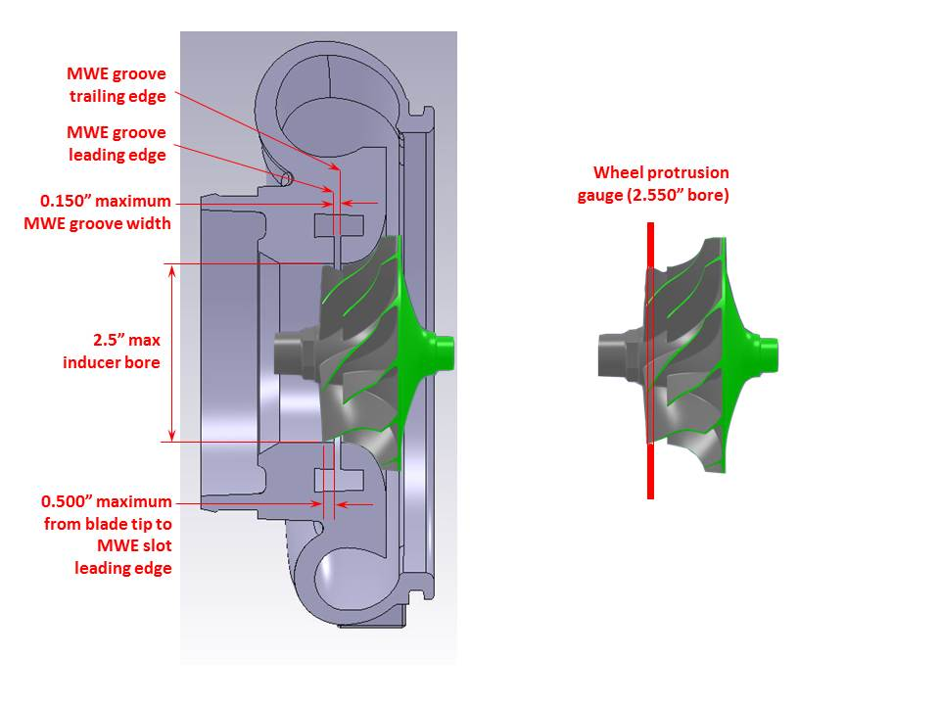

**Turbo Specs:** A single turbocharger with a single compression stage is permitted. The intent of this rule is to limit turbochargers to OEM-style wheel and cover geometries with minimal modifications. Owners are required to make the compressor wheel and cover accessible to Northwest Truck & Tractor Pullers techs for inspection at any time.

* The compressor cover inducer bore is limited to 2.50” diameter and will be checked with a 2.550” plug. Bore may not be ovaled or otherwise distorted from a true circular shape to allow stoppage of the plug, but allow additional airflow to the wheel.
* The compressor wheel must protrude into the inducer bore by visual inspection and by using a ring gauge on the compressor wheel. The ring gauge used will be made from 16 gauge. Sheet metal with a fully radiused 2.55” bore (see diagram). The wheel tips must protrude through the gauge to be legal.
* The compressor wheel and compressor cover contours must be parallel within normal OEM clearances <0.030″ per side) and will be checked visually or with a wire gauge if needed. No cuts, ledges, steps, tapers or any other features may be machined into the wheel or cover contour to allow additional airflow. Removable bushings are not permitted
* A single MWE groove is limited to 0.150” wide at all locations around the inducer bore and will be checked with ball diameter at 0.155″ on a pick or by other means. The ball must not pass through the groove. No additional features or structures are permitted in the slot that would prevent passage of the ball. 2.5” bore both before and after the MWE. Where the groove intersects the inducer bore, no radiusing or contouring is allowed; only sharp corners with minimal chamfers/edge rounding is legal. Air may only enter the compressor wheel via the specified inducer and MWE aag Q1 1` groove. No Forward Facing MWE
* Any type of adjustable compressor inlet on the turbo must be welded into place.
* The MWE leading and trailing edges are defined in the diagram. The MWE trailing edge must be behind the wheel tips. The MWE leading edge must be within 0.500” of the wheel tips and will be measured with a hook-style pick or by other means with a 0.500” mark on it. Excessive clipping or back-beveling of the wheel tips to move the MWE further up the contour is not permitted.
* **All interpretation of these rules lie with the Northwest pullers Techs and their **decision is final.**
* **Water Injection:** Water injection is prohibited. All system components must be removed from the truck.