October 21, 2026
The Link between Sugar, Obesity and Cancer

How a Diet High in Sugar Can Contribute to Obesity and Cancer
Sugar is a source of energy for the body. Your brain, muscles, and other organs use sugar in the form of glucose to function properly. The problem is not that sugar exists in our diet. The problem is what can happen when we regularly consume more added sugar than our bodies need.
Eating a diet high in added sugar, particularly sugary drinks, candy, desserts, and heavily processed foods, can contribute to weight gain, changes in the way the body regulates blood sugar, and other health problems. Over time, some of these changes can increase the risk of developing certain types of cancer.
It is important to understand that sugar does not automatically cause cancer, and eating sugar does not mean that you will develop cancer. The relationship is more complicated. Let's look at how sugar can affect the body in everyday language.

Part 1: How a Diet High in Sugar Can Contribute to Obesity



1. Sugar Can Give You More Calories Than Your Body Needs
Think of calories as units of energy that fuel your body. You need calories to breathe, walk, think, maintain your body temperature, and carry out everyday activities.
When you consume more calories than your body uses over time, the extra energy can be stored as body fat.
Foods and drinks high in added sugar can make it easy to consume more calories than you realize. For example, you might drink a large sweet tea or soda and take in a substantial amount of energy without feeling as full as you would after eating a balanced meal.
If this happens regularly, those extra calories can contribute to weight gain and eventually obesity.

2. Sugary Drinks May Not Make You Feel Full
Imagine eating a meal that contains chicken, vegetables, beans, and brown rice. The protein and fiber help you feel satisfied.
Now imagine drinking a sugary beverage that contains a similar amount of calories. Because liquids often provide less lasting fullness than solid foods, you may still feel hungry and eat your usual meal afterward.
This means you can consume extra calories without feeling that you have eaten much more.
Over time, this pattern can contribute to excess body fat.

3. Excess Sugar Can Affect How the Body Stores Energy
When you eat carbohydrates, your body breaks them down into glucose. Your pancreas releases insulin, which helps your cells use that glucose for energy.
When you regularly consume more energy than your body needs, your body stores some of the excess energy as fat. Your liver can also convert excess carbohydrate into fat, particularly when energy intake remains excessive.
It is important to clarify that insulin is not a bad hormone, and it does not automatically make you obese. Your body needs insulin to function. Obesity develops through a combination of energy intake, appetite regulation, genetics, activity levels, sleep, medications, and other factors.

4. Excess Body Fat Can Change the Way Your Body Works
This is where the problem can become more serious.
Fat tissue is not simply a place where your body stores extra energy. It is active tissue that produces chemical signals affecting hormones, inflammation, and metabolism.
When a person develops excess body fat, especially around the abdomen, several changes can occur:
- The body's cells may become less responsive to insulin.
- The body may develop ongoing, low-level inflammation.
- Hormone levels may change.
- The risk of developing type 2 diabetes and other metabolic problems may increase.
These changes can affect long-term health, including the risk of certain cancers.

Part 2: How Excess Body Fat Can Increase the Risk of Cancer
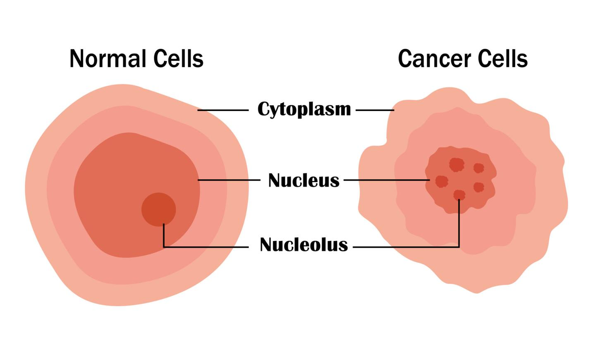
Cancer develops when abnormal cells begin growing and dividing in an uncontrolled way. Many things can contribute to this process, including inherited genes, tobacco, certain infections, environmental exposures, age, and lifestyle factors.
One important connection between diet, obesity, and cancer is that excess body fat can change the body's hormones, insulin levels, and inflammatory processes in ways that may help cancer develop.

NCI
+1
Let's break this down.

1. Excess Body Fat Can Cause Ongoing Inflammation
Inflammation is the body's natural response to injury or infection. For example, if you cut your finger, inflammation helps your body begin healing.
But inflammation that continues for a long time is different. When a person carries excess body fat, especially over many years, the body's fat tissue can release substances that keep the immune system in a state of ongoing, low-level inflammation.
Think of it like a fire that never completely goes out. Instead of helping with a short-term repair, the inflammatory response continues to affect the surrounding environment.
Over time, chronic inflammation can damage cells and influence the signals that control cell growth and survival. These changes may create conditions that favor the development or progression of cancer.
This does not mean that every person with obesity will develop cancer. It means that obesity is an established risk factor for several types of cancer.
NCI
+1

2. Higher Insulin Levels Can Affect Cell Growth
Remember that insulin is the hormone your pancreas releases to help regulate blood sugar.
When someone develops insulin resistance, the pancreas may produce extra insulin to compensate. This can result in higher-than-normal insulin levels in the blood.
Insulin and a related substance called insulin-like growth factor 1 (IGF-1) are involved in regulating how cells grow and divide. When these growth signals are elevated, they may encourage certain cells to multiply and may affect how abnormal cells survive.
In simple terms, some of the same changes that occur with insulin resistance and obesity can create a body environment that is more favorable to cancer development. Researchers consider these pathways among the possible explanations for the relationship between obesity and certain cancers.
NCI
+1

3. Body Fat Can Change Hormone Levels
Fat tissue does more than store energy. It also affects hormone production.
For example, excess body fat can increase estrogen levels. Estrogen is an important hormone, but prolonged exposure to higher levels can increase the risk of certain hormone-sensitive cancers.
This is one reason obesity is associated with an increased risk of endometrial cancer (cancer of the lining of the uterus) and breast cancer after menopause.
Excess body fat is also associated with several other cancers, including cancers of the colon and rectum, kidneys, liver, pancreas, and esophagus. The reasons vary by cancer type and can involve several biological processes at once.
NCI
+1

Part 3: Does Sugar Feed Cancer?
You may have heard people say, "Sugar feeds cancer." There is an important distinction to understand.
All cells in your body, including healthy cells, use glucose for energy. Cancer cells also use glucose, and some cancer cells consume it at unusually high rates.
However, eating sugar does not selectively feed cancer cells, and eliminating sugar from your diet has not been shown to make cancer shrink or disappear. Your body can continue supplying glucose to cells even when you stop eating sugary foods because it can make glucose from other nutrients.
NCI
+1
So why should we limit added sugar?
The concern is primarily about the overall effects of a high-sugar diet, especially when it contributes to excess body weight and metabolic problems.
Consider this chain of events:
Frequent excess added sugar
Especially from sugary drinks and calorie-dense processed foods
Excess calorie intake and possible weight gain
Possible insulin resistance, hormonal changes, and chronic inflammation
Increased risk of certain cancers over time
This is a possible pathway, not an inevitable outcome. Sugar intake does not guarantee weight gain or cancer.
Research strongly supports the link between excess body fat and increased risk of certain cancers. The evidence that added sugar itself directly causes cancer is much less conclusive.

American Cancer Society
+1

Part 4: Which Cancers Are Associated With Obesity?
The Centers for Disease Control and Prevention identifies 13 types of cancer associated with overweight and obesity.

CDC
These include:
- Breast cancer in women after menopause.
- Colorectal cancer.
- Endometrial cancer.
- Kidney cancer.
- Liver cancer.
- Pancreatic cancer.
- Ovarian cancer.
- Gallbladder cancer.
- Esophageal adenocarcinoma.
- Certain cancers of the stomach, thyroid, and other tissues.
These associations do not mean that sugar directly causes each of these cancers. Rather, excess body fat is one established risk factor, and a diet high in added sugar can contribute to obesity in some people.
Cancer risk is influenced by many factors, and maintaining a healthy weight is one way to help reduce risk.

Part 5: How Can You Reduce Your Risk?
You do not need to eliminate every carbohydrate or avoid all foods that taste sweet. Instead, focus on building a balanced eating pattern that limits added sugar and supports a healthy weight.

1. Replace sugary drinks with water.
Soda, sweet tea, energy drinks, and sweetened coffee can add substantial calories. Water and unsweetened beverages are better everyday choices.

2. Choose whole fruit instead of sweets more often.
Whole fruit provides fiber, vitamins, and minerals. You generally do not need to avoid fruit because it contains natural sugar.
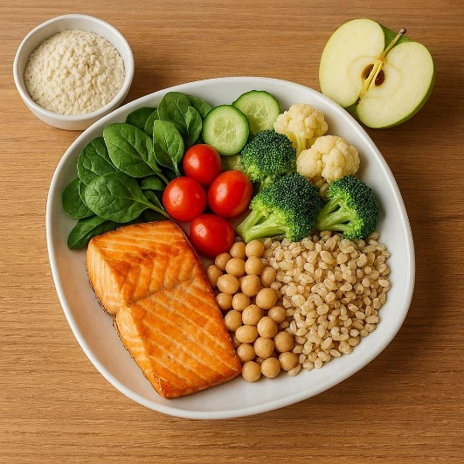
3. Eat more fiber-rich foods.
Vegetables, beans, lentils, whole grains, and fruit can help you feel satisfied and support digestive health.

4. Move your body regularly.
Walking and other physical activities help regulate blood sugar, support weight management, and contribute to overall health.

5. Make whole or minimally processed foods the foundation of your diet.
Limit foods that are high in added sugar and calories but low in fiber and essential nutrients. This leaves more room for nutritious foods that support long-term health.
These habits are consistent with recommendations from the American Cancer Society and the World Cancer Research Fund for maintaining a healthy weight and reducing cancer risk.
American Cancer Society
+1

The Bottom Line
A diet high in added sugar can contribute to obesity by making it easier to consume more calories than your body needs. As excess body fat accumulates, it can change hormone levels, increase inflammation, and contribute to insulin resistance. These changes can increase the risk of certain cancers.
The important distinction is that sugar's strongest established connection to cancer is indirect, through its contribution to excess body weight and related metabolic changes, rather than proof that sugar directly causes cancer.
You cannot control every cancer risk factor, but you can make choices that support your health. Reducing added sugar, eating more vegetables and fiber-rich foods, staying physically active, and maintaining a healthy weight can help lower your risk of obesity-related disease and support your overall well-being.

