November 12, 2020

The Honourable Scott Moe Premier of Saskatchewan 226 Legislative Building Regina, SK S4S 0B3
Dear Premier Moe, Minister Merriman, and Dr. Shahab, Re: Response to a call for leadership open letter
A public plea has recently been made to “act with suﬃcient force to reverse the rising daily case counts” of COVID-19 by a number of Saskatchewan physicians. I believe many in Saskatchewan share a concern that we closely monitor and assess the number of ICU hospitalizations and deaths from COVID-19 in the province as we head into winter - i.e., what is typically cold and flu season in Canada. Obviously the province of Saskatchewan has a responsibility to provide supports for the health and safety of its residents.

However, as the authors of the Great Barrington Declaration, its many subsequent co-signers, Premier of Alberta Jason Kenney, and Manitoba’s former Chief Public Health Oﬃcer Dr. Joel Kettner have asserted, the harms caused by lockdown interventions to COVID-19 have to be weighed against the deaths caused by COVID-19. Increased depression and suicides, increases in domestic, child, and sexual abuse (with less external opportunities for detection), an increase in drug overdoses, and the extreme financial hardships caused by businesses forced to close have all been documented in regions that have entered COVID-19 lockdowns. A comparison of the deaths caused by COVID-19 to the increase in deaths from causes related to lockdown measures highlights the need to balance a potential increase in cases*, many of which are asymptomatic, with the social, economic, and mental health benefits of limiting COVID-19 restrictions.

If we restrict businesses again, many more Saskatchewan businesses will be forced to permanently close their doors (in addition to the many which have already done so). The number of suicides and negative health consequences associated with the subsequent increase in poverty caused by lockdown measures is also significant. If the physical activity and social interactions of Saskatchewan youth are further restricted - beyond the mask mandates, cancelled school-provided extra-curricular activities and social distancing measures already in place in most Saskatchewan schools - we are knowingly causing harms with unprecedented physical and mental health consequences. We likely will not fully realize these consequences for many years - and we have given youth no voice in this discourse.

We too ask for your leadership: to reject calls for further lockdown measures in order to protect all of your residents from all of the harms associated with the COVID-19 pandemic.
Sincerely,
Concerned business owners, parents, and general public

*Current case and hospitalization data as of November 11, 2020 follow

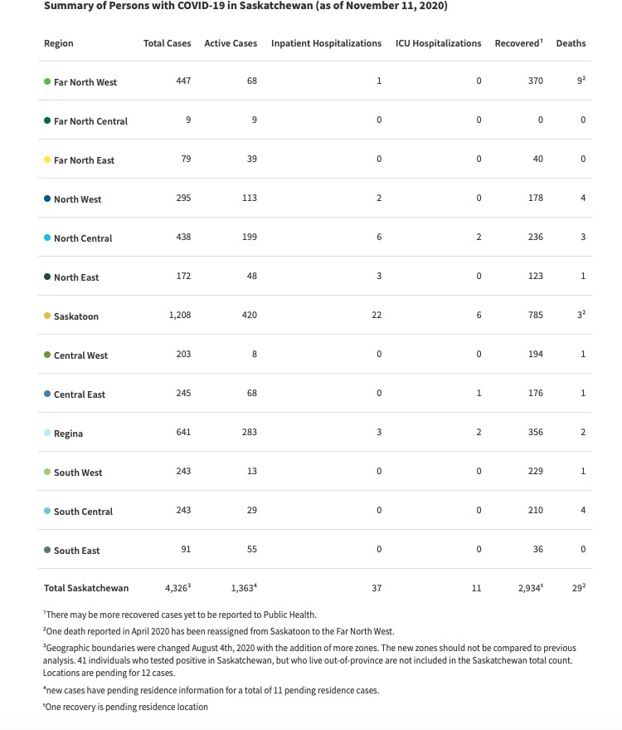

Source: https://dashboard.saskatchewan.ca/health-wellness/covid-19/cases

Signatures to November 12th response to a call for leadership open letter:

Signature Date |  | Signature Date

