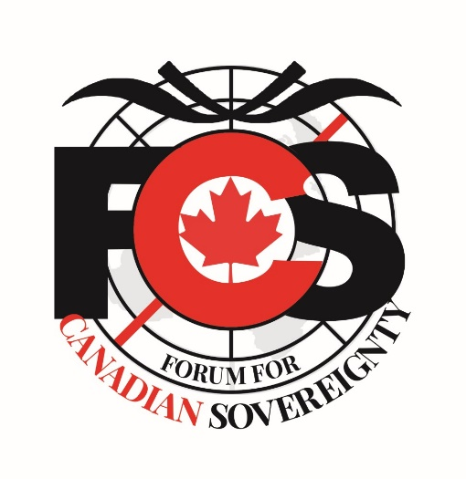

Canada,
The Sustainable Development
Agenda,
&
You

Since WW2 there has been a coordinated effort of the global elite to manage the worlds problems from a centralized, globalist perspective. In the late 60’s, a group still operating today, called The Club of Rome, sponsored by the Rothchild family, along with the Rockefeller family and others, conceptualized a globalist agenda. An agenda to govern the global masses, destroy capitalism and denounce free market principles, bring down the industrialized world, denounce the Nation State, and ultimately eliminate western civilization as we know it. Addressing issues of population control, food shortages, climate change, consumption, production, resources, culture, land usage and rights, property rights, and health through centralized global governance and redistribution of wealth. Essentially the communist manifesto with a convergence of crony capitalism or fascism. Hence, the New World Order (Their words not ours)
From those original meetings and discussions, the Sustainable Development Agenda was born. It’s first incarnation came out of the Rio Declaration in 1992. Agenda 21. The Governing Progressive Conservative Party, under Brian Mulroney, was the first Canadian government to sign on to this agenda. It has evolved over time from fewer, smaller goals, to what it is today. A 17 goal agenda with 169 targets and 248 indicators. Both the PC’s, now the CPC, and the Liberal Party have endorsed and committed to this agenda since inception, up to the existing agreement signed by Stephen Harper on September 27th, 2015, called Sustainable Development Agenda – Transforming Our World. One month before the election of Justin Trudeau. Within the first week of taking power, Justin Trudeau referred to Canada as a Post Nation State. Essentially ceding Canadian Sovereignty to the UN and it’s Global Governance model.
Climate Change and Covid19 are simply mechanisms the globalists use to forward, promote, and achieve their goals through fear, social engineering, perception over reality, and manipulation, with the enormous help of the mainstream media. Mainstream media has simply become the propaganda arm for the globalist agenda.
Given the enormity of this global transformation, please stop and think as to why they have never openly promoted this agenda until very recently. Not since inception of this agenda have they informed or educated the masses as to what this plans means or the consequences to everyday Canadians and our way of life.
For more information on this agenda and please go to www.ffcs.info
To help educate and inform fellow Canadians please share this!
To contact us or inquire as to how you can help please email: info@ffcs.info

The Forum for Canadian Sovereignty is Canada’s only NGO opposing this globalist agenda and defending the values we all cherish, the values of freedom, liberty, justice, sovereignty, prosperity, actual equality, tolerance, compassion, and responsibility.

