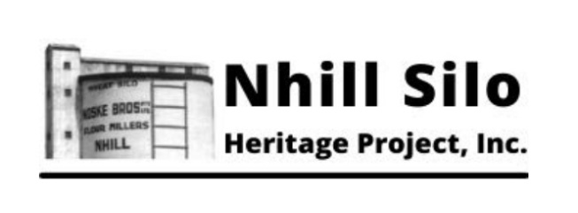
Nhill Silo Heritage Project Inc.
Annual General Meeting Summary
Reporting Period: 1st July 2024 – 30th June 2025
Date of AGM: 20th August 2025

President’s Overview
Over the past year, the Nhill Silo Heritage Project Inc. has continued to make steady progress towards the vision of transforming the historic Nhill Silo site into a meaningful community resource and visitor attraction.
Our dedicated volunteers and committee members have contributed countless hours toward restoration, planning, and administrative tasks. Significant milestones include continued interior works in Fry’s Hall, the preparation of our revised Master Plan, and key steps toward finalising the generous donation of the Mill and adjoining buildings by Ahrens.
While progress can sometimes feel slow, we are proud of the solid foundation that has been built over the past four years. With increased efforts in communication—including plans for more regular newsletters—we aim to engage our supporters and community more closely in the coming year.
Special thanks to our committee, volunteers, and particularly to our Secretary Amy Heath and Treasurer Shane Natt, for their ongoing commitment and enthusiasm.
— Peter Duperouzel, President

Financial Summary
Presented by Treasurer Shane Natt at the AGM
Total Income | $9,969.80
Total Expenditure | $8,668.67
The project remains in a sound financial position, with stable income from memberships and low overheads. The full financial report was accepted at the AGM.

Membership
As of the AGM, the project had received approximately 60 memberships for the 2025–2026 period, with additional renewals ongoing. Continued member support is vital to the sustainability of the project.

Key Projects and Activities (2024–2025)
Infrastructure and Restoration Works
- Ongoing work inside Fry’s Hall, including:
  - Installation of new windows
  - Door and frame preparation for painting
  - Progress on the main entrance door installation
- Post and Rail Fence: Timber ordered; installation to follow across the front of the silo site.
- Viewing Hole installed in the floor to showcase the original grain loading chute
- Repairs underway on roller door entry and associated display infrastructure
Planning and Governance
- Master Plan Review:
  - Draft prepared and under internal review
  - Member feedback phase to be launched before adoption at a special meeting
- Planning Permit granted with conditions
- Preliminary work on DGR (Deductible Gift Recipient) application has begun, but it will be a lengthy process due to the stringent application requirements.
External Partnerships and Donations
- The Ahrens donation of the Mill and adjoining buildings is still progressing.
- Investigation into the return of a rail wagon shunter from Sunshine, VIC for local display
- Hindmarsh Shire Grants opportunity identified
- The Nhill Silo Heritage Project is acting as the host for this year’s Nhill Heritage Weekend, to be held on October 25th & 26th. For further information, please visit our website.

Community and Engagement
- Discussion around organising a community working bee for volunteer involvement
- Plans to improve communication through regular newsletters

Committee and Governance
At the AGM, the following Office Bearers and Committee Members were elected unopposed:
Position | Name
President | Peter Duperouzel
Vice President | Daryl Meek
Secretary | Amy Heath
Treasurer | Shane Natt
Committee Member | Darrell Hall
Committee Member | Gary Hall
Committee Member | Rob Lynch
Committee Member | John Deckert was co-opted to this position at the September meeting.

Looking Ahead
Priorities for the 2025–2026 period include:
- Finalisation and adoption of the revised Master Plan
- Completion of the Ahrens property transfer
- Launch of a community volunteer event
- Continued infrastructure works and site development
- Strengthening member engagement and communications
The committee remains committed to restoring and repurposing the Nhill Silo precinct for both community use and cultural heritage preservation.

Prepared September 2025
Nhill Silo Heritage Project Inc. Committee
Email: nhillsilo@gmail.com | Website: nhillsiloheritageproject.org

