Toddler Portions and Meal Ideas

Here's a general guide for feeding your toddler:

* Each day, a child between ages 1 and 3 years needs about 40 calories for every inch of height. This means, for example, that a toddler who measures 32 inches should be taking in an average of about 1,300 calories a day, but the amount varies with each child's build and activity level.
* The child's serving size should be approximately one-quarter of an adult's.

Here's an average toddler-sized meal:

* One ounce of meat, or 2 to 3 tablespoons of beans
* One to 2 tablespoons of vegetable
* One to 2 tablespoons of fruit
* One-quarter slice of bread

Your toddler will get enough calories along with all the protein, vitamins, and minerals he or she needs from an average daily intake similar to the to the chart below.

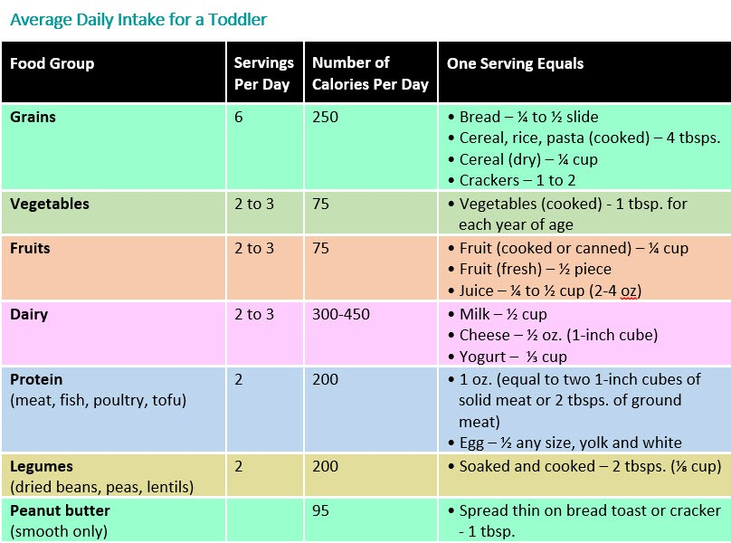A sample menu may look like:

# Breakfast

* ½ cup nonfat or low- fat milk
* ½ cup iron- fortified cereal or 1 egg
* 1⁄3 cup fruit (for example, banana, cantaloupe, or strawberries)
* ½ slice whole wheat toast
* ½ teaspoon margarine or butter or 1 teaspoon jelly

# Snack

* 4 crackers with cheese or hummus or ½ cup cut-up fruit or berries
* ½ cup water

# Lunch

* ½ cup low- fat or nonfat milk
* ½ sandwich—1 slice whole wheat bread, 1 ounce meat, slice of cheese, veggie (avocado, lettuce, or tomato)
* 2–3 carrot sticks (cut up) or 2 tablespoons other dark- yellow or dark-green vegetable
* ½ cup berries or 1 small (½ ounce) low-fat oatmeal cookie

# Snack

* ½ cup nonfat or low-fat milk
* ½ apple (sliced), 3 prunes, 1⁄3 cup grapes (cut up), or ½ orange

# Dinner

* ½ cup nonfat or low-fat milk
* 2 ounces meat
* 1⁄3 cup pasta, rice, or potato
* 2 tablespoons vegetable

Some snack ideas that could be incorporated into meals include:

## Fresh fruits

* Apples, bananas, peaches, nectarines, pears (thinly sliced for safety)
* Cherries, grapes, plums (sliced or smushed and pitted)
* Orange or grapefruit sections (cut into pieces)
* Strawberries

## Dried fruits

* Apples, apricots, peaches, pears (cut up)
* Dates, prunes (pitted, cut up)
* Raisins or cranberries

## Vegetables

* Carrots, green beans (well cooked, diced)
* Steamed cauliflower, broccoli
* Yams or sweet potatoes (cooked and diced)
* Peas (mashed for safety; a child can inhale whole peas)
* Steamed, pureed spinach or greens
* Avocado slices or small cubes

## Dairy products

* Cheese (grated or diced)
* Yogurt, fresh or frozen
* Milk, including non-dairy milk alternatives

## Breads and cereals

* Whole wheat bread
* Whole grain tortilla, pita, or bagels cut into small pieces
* Crackers (graham, whole grain)
* Whole grain dry cereals
* Rice cakes (for older toddlers)

## Lean proteins

* [Fish](https://www.healthychildren.org/English/news/Pages/AAP-Says-US-Children-Not-Eating-Enough-Seafood.aspx) (canned tuna, salmon, sardines, whitefish)
* [Peanut](https://www.healthychildren.org/English/health-issues/conditions/allergies-asthma/Pages/Peanut-Allergies-What-You-Should-Know-About-the-Latest-Research.aspx) butter or other nut butters (smooth, spread thinly on whole grain bread or crackers)
* Edamame beans or chickpeas (steamed or mashed) or hummus spreads
* Cooked tofu cubes or tofu dip
* Hard boiled eggs

For the full article and more information:

[https://www.healthychildren.org/English/ages-stages/toddler/nutrition/Pages/Serving-Sizes-for-T oddlers.aspx](https://www.healthychildren.org/English/ages-stages/toddler/nutrition/Pages/Serving-Sizes-for-Toddlers.aspx)