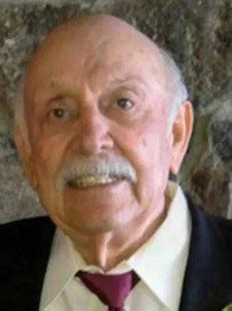

Albert ("Al") passed away on February 27, 2026, at the age of 90.
Al was born in Rawlins, Wyoming on February 4, 1936, to Edward Mohatt and Antoinette Mohatt Jones.
His welcoming smile and gentle laughter were engaging and delightful to all who knew him. Al leaves behind life lessons learned through love, acceptance, and understanding - a testament to how fully he lived them.
Al had a natural gift for problem-solving, whether it was mathematical equations or life's challenges. He was gentle in his approach, kind and caring, yet able to find answers to nearly every problem presented to him.
He graduated from Gabbs High School in Gabbs, Nevada and went on to earn his degree from the University of Nevada. Following his graduation from Nevada, Al purchased two Texaco stations in Reno. He worked for Kafoury Armstrong while earning his CPA certificate. He then spent 10 years with the City of Reno in both accounting and public works. He ultimately fulfilled his dream of opening his own CPA practice, eventually retiring from the work he loved.
As a member of Lambda Chi Alpha at the University of Nevada, Al was a gift to his fraternity. He took great pride in his role as President of the Sundowners. Al also cherished his membership with the Elks Club.
He was an avid Wolfpack fan - you could find him at every football and basketball game, from the Old Gym and the Coliseum to the Lawlor Event Center.
Together with his wife, Linda, and dear friends, Al traveled the world - by plane, train, ship, automobile, bike, and even elephant.
Al is survived by his wife, Linda, of 45 years; his daughter Rhonda Hoenstein (Clint); stepchildren Allan Renwick (Adrienne) and Todd Renwick (Tawnya); nine grandchildren; and four great-grandchildren. He was preceded in death by his parents; his son David Mohatt; his sisters Monica Ellette and Angela Engle; and his brother Edward Mohatt.
The family would like to extend their love and appreciation for the wonderful care at Love and Joy provided by Cynthia F. Wong, Arnel Enrique, and Bong Dimaano.
A Celebration of Life will be held at the Stadium Club at Mackay Stadium on Saturday, April 11th, from 3:00–5:30 p.m. Attendees may park on the 5th floor of the West Stadium parking garage.

