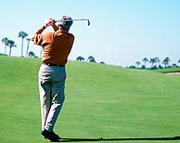
The Northern Nevada Seniors Golf Club
is open to men 50 years of age or older living in the Eastern Sierra
www.NNSGC.com PO Box 12596, Reno, NV 89510

NNSGC Membership Form 2026
Last Name: _
First Name: _ Middle initial: _
Mailing Address: _
City: _ State: _ Zip: _
E-Mail Address: _
☐ I agree to allow NNSGC the use of my email on their webpage (Check box if so)
Birthday: (Month/Year) _ / _
Home Phone: _ Cell Phone: _
Current GHIN # _ Current handicap _
Credits $$ to use (Leave blank if none): $ _
NOTES: _
_
New members will be given a temporary handicap after two rounds. If you have a GHIN we will use your established handicap less 10% as we have more relaxed rules and use our own handicap system. Mail completed application and an annual check for $55 to:
NNSGC, PO Box 12596, Reno NV 89510
THANK YOU for joining our great group of golfers!!

