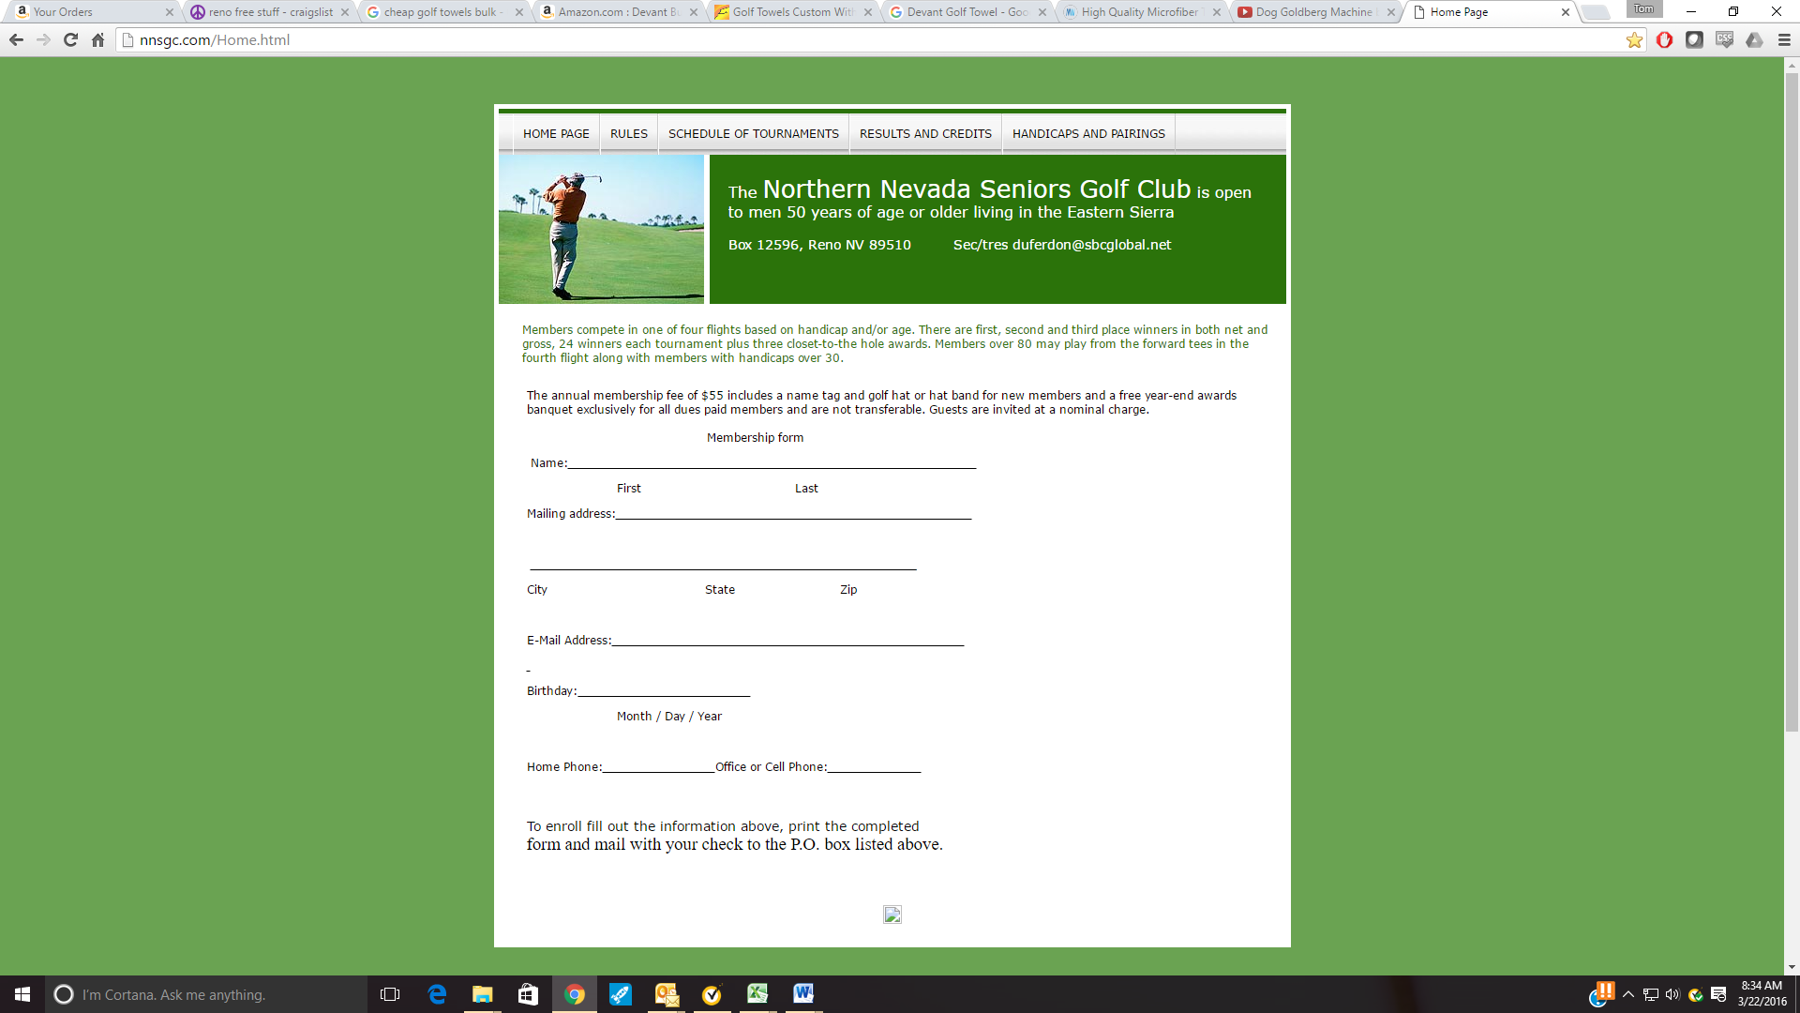The Northern Nevada Seniors Golf Club

[www.NNSGC.com](http://www.NNSGC.com) PO Box 12596, Reno, NV 89510

**NNSGC Tournaments Entry Form Year 2023**

**Member Name: _**

**Golf-Skins-Credit$**

**Lakeridge, Wed March 15th, 9:00, $67 (Duncans = $12), L&D, Morrin Memorial**

**Eagle Valley West, Wed March 29th, 9:00, $55 (Duncans = $27), L&D**

**Toiyabe, Wed April 12th, 9:00, $67 (Duncans = $12), L&D**

**Hidden Valley, Mon April 24th, 10:00, $79, NO GUESTS**

**Redhawk Lakes, Wed May 10th, 9:00, $72 (RH members = $12)**

**Wolf Run, Wednesday May 24th, 8:30, $67 (Duncans = $12), L&D**

**Grizzly Ranch, Tue & Wednesday, June 6-7, 9:30, $110**

**Whitehawk, June 21st, 8:30, $90, NO GUESTS**

**Redhawk Hills, Wed July 5th, 8:30, $75 (RH members = $12)**

**Genoa Lakes South, Wed July 19th, 8:30, $77**

**Sunridge, Wed August 2nd, 8:30, $70**

**Silver Oaks, Wed August 16th, 8:30, $62**

**Graeagle Monday August 28th, 8:30, $72**

**Sierra Sage, Wed September 13th, 8:00, $60, Breakfast**

**Dayton, Wed September 20th, 9:00, $60, L&D**

**Old Greenwood, MONDAY October 2nd, 10:30 Shotgun $115 NO GUESTS**

**Somersett, MONDAY October 9th, 11:00, $80 (S members = $12), NO GUESTS**

**Note: L&D stands for Lunch and Drinks**

**Membership or affiliation (enter ✔**)**: Duncan?  RedHawk?  Somersett?**

**SKINS NOTES: Separate from NNSGC game, paid in cash at the yearend Banquet**

**Include the $10/Tournament in payment check (Preferred) or pay at course.**

**TOTAL ENCLOSED: $ CREDITS Used: _________ CHECK # ____________**

**NOTE: Payment must accompany application *even for guests***

**Playing with:** ___________________________________ **Notes:** ______________________________

**REMINDER: Golfer(s) is/are responsible to the course for all caused cart damage**

**THANK YOU and PLAY WELL!!**