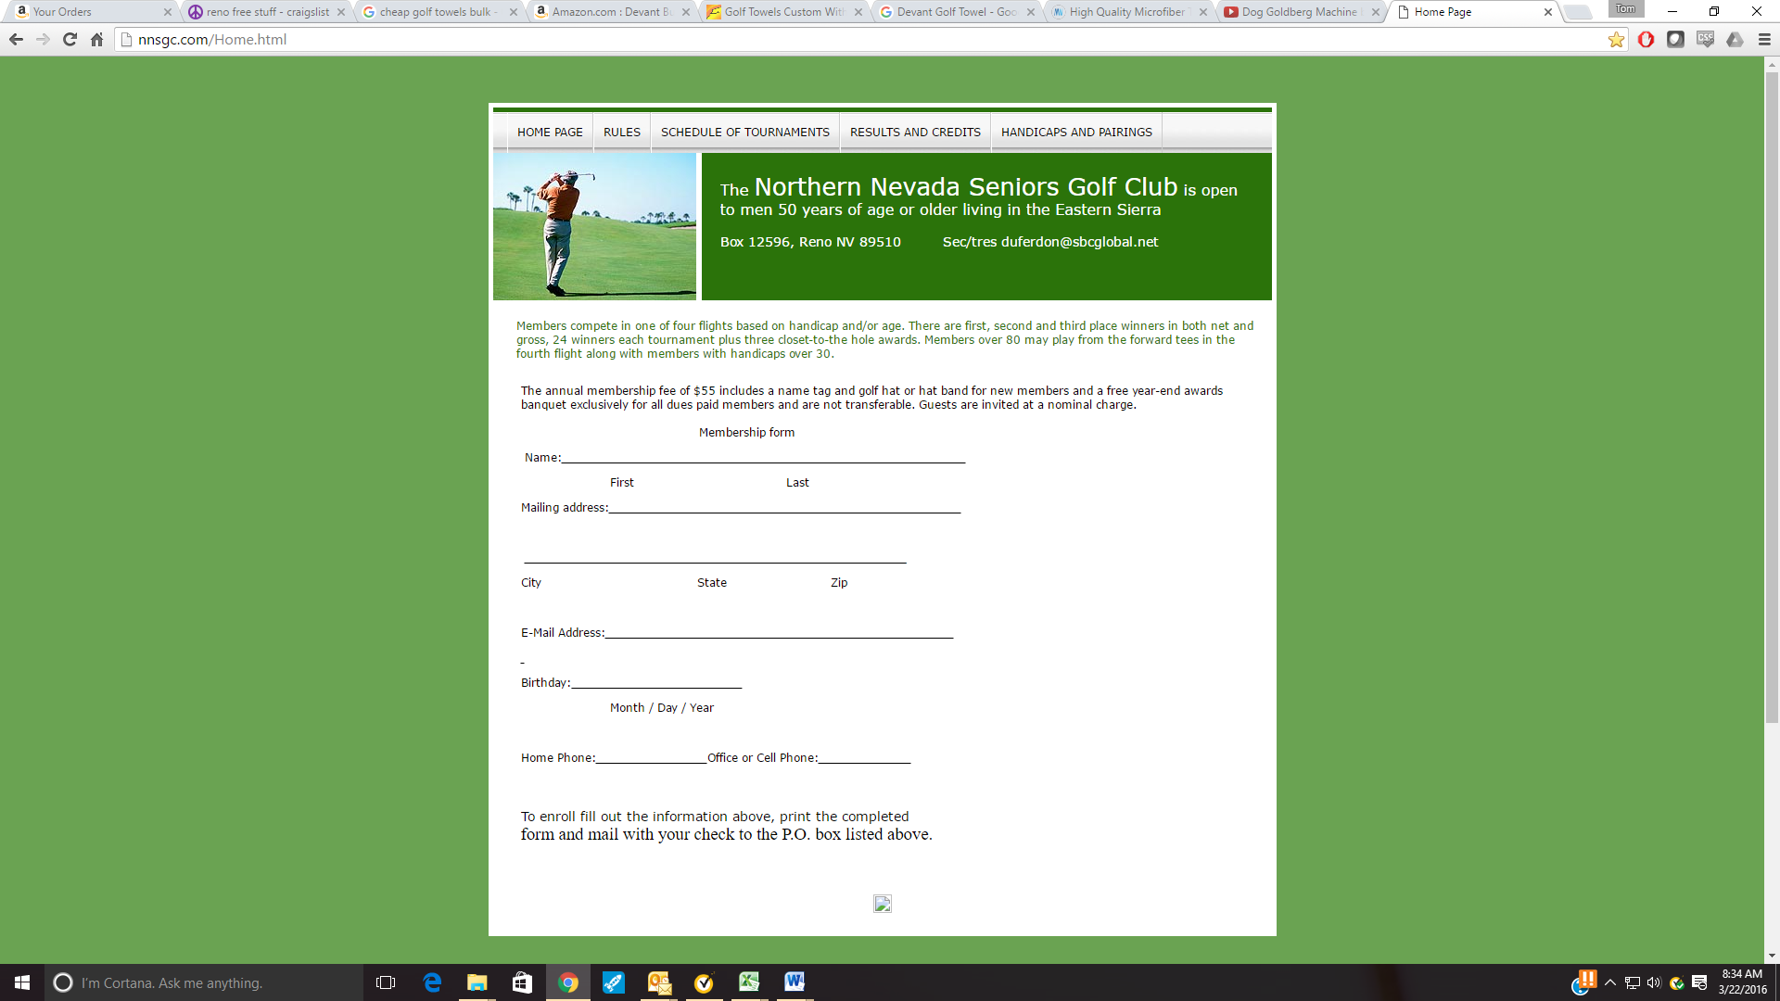The Northern Nevada Seniors Golf Club

is open to men 50 years of age or older living in the Eastern Sierra

[www.NNSGC.com](http://www.NNSGC.com) PO Box 12596, Reno, NV 89510

NNSGC Membership Form 2020

Name: (First) Click here to enter text. (Last) Click here to enter text.

Mailing Address: Click here to enter text., City: Click here to enter text. , State: Click here to enter text., Zip: Click here to enter text.

E-Mail Address: Click here to enter text.

Permission to post email address on NNSGC webpage (Yes or No) Click here to enter text.

Birthday: (Month/Year) Click here to enter text. / Click here to enter text.

Home Phone: Click here to enter text. Cell Phone: Click here to enter text.

Current GHIN # Click here to enter text. & current handicap Click here to enter text.

Credits Used: $ Click here to enter text.(List how much of Credits you are using)

NOTES : Click here to enter text.

New members will be given a temporary handicap after two rounds. If you have a GHIN we can use that less 10% as we have more relaxed the rules and use our own handicap system. Mail completed application and an annual check for **$55** to**: NNSGC, PO Box 12596, Reno NV 89510**