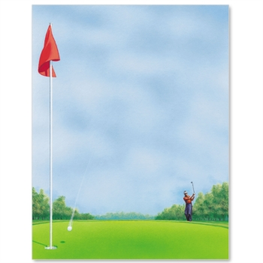
NNSGC
Northern Nevada Senior Golf Club
www.NNSGC.com PO Box 12596, Reno, NV 89510

NNSGC is a golfing club open to men age 50 and above who live in Northern Nevada. Members compete in one of (4) four flights based on handicap. The club pays at least 1st thru 4th places for net and gross in each flight plus closest-to-the holes and a longest putt in each tournament. We plan on 18 tournaments during the 2022 year. Since we usually have over to 100 golfers playing, the courses give us good rates and benefits which we pass on to our members. The max players are 144 on most courses but some courses limit us to 120. Guests will be allowed when space is available. Membership is ($55 annually) comes with a name tag, hat and a free year-end banquet. Visit www.NNSGC.com for additional information and a NNSGC application form, NNSGC rules and list of this year’s 2022 golf tournaments.
Lakeridge Golf Course $62 ---- March 9th
Eagle Valley West $47 ---- March 23rd
Toiyabe Golf Course $62 ---- April 6th
Redhawk Lakes Course $67 ---- April 20th
Hidden Valley CC $75 April 25th Monday (No Guests)
Wolf Run Golf Course $62 May 11th
Grizzly Ranch Golf Course $100--- May 24th and 25th
Redhawk Hills Course $75 June 1st
Whitehawk Golf Course $90 June 15th (No Guests)
Genoa Lake South, $47 June 29th
Eagle Valley East $47 July 13th
Silver Oaks Golf Course, $57 July 27th
Genoa Lakes North Golf Course $67 Aug 10th
Sierra Sage Golf Course, $52 Aug 24th
Dayton Valley Golf Course $52 Sept 7th
Plumas Pines GC, $62 Sept. 21st (No Guests)
Gray’s Crossing $105 – Wednesday Oct. 5th (No Guests)
Somersett GC $70 – Mon. Oct 10th (Limit 120)
Dates and Times and Rates may change check webpage!

Come out and join the NNSGC and have some fun and golf with some great guys. We are always looking for golfers of any skill level who just want to play golf and have fun. Visit www.NNSGC.com and join!

