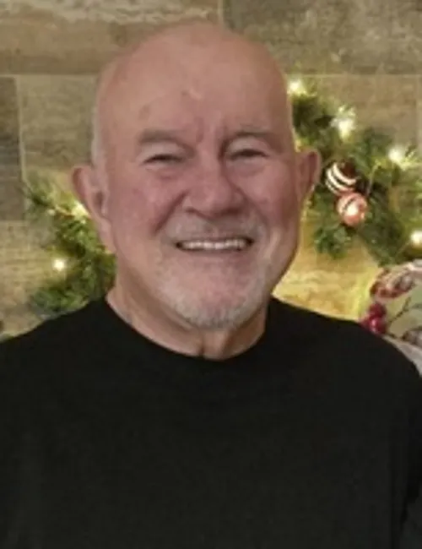
Charles Henry Sturgill Jr.
With great sadness, we announce the unexpected passing of Charles Henry Sturgill, Jr., 74, on Tuesday, February 17, 2026, at his home in Reno, Nevada.
Charles (Chuck) was born on February 13, 1952, in Nassawadox, Virginia, to Charles and Ellen (Johnson) Sturgill. He grew up in Accomac, Virginia, alongside his four siblings.
At the age of 17, Chuck joined the United States Marine Corps on March 30, 1970. He spent nearly a year deployed during the Vietnam War, serving as an aircraft mechanic. Rising to the rank of Sergeant (E-5), he was honorably discharged on March 29, 1974. Chuck was a proud Marine and patriot.
On November 17, 1972, Chuck met Jane Burke in Alameda, California. Their connection was instant and life-changing. They married on May 5, 1973, and were blessed with two children, Jennifer and Christopher. In 1979, the family moved to San Ramon, California, where they lived for 35 years. During this time, Chuck worked in manufacturing and became a beloved community figure. He coached youth baseball and football and was a mentor to many young athletes. He also enjoyed working on cars with his son and tackling home improvement projects.
In 2014, Chuck and Jane retired to Reno, Nevada. There he pursued his love of golf and joined a men’s softball league. Above all else, Chuck cherished his relationships with his children and grandchildren. Known as "PopPop," he held a special place in their hearts.
Chuck is survived by his devoted wife of nearly 53 years, Jane Sturgill; daughter Jennifer Collins (Matt); son Christopher Sturgill (Tami); five grandchildren: Joshua, Callie, Collin, Lyla, and Brody; sister Debbie West (Peter); brother Jimmy Sturgill (Cindy); sister-in-law Carol Burke; and numerous nieces and nephews. He was preceded in death by his parents and sisters Barbara Bastain and Gloria Faye Franklin.
In lieu of flowers, donations may be made in Chuck's honor to the Veterans Guest House at https://www.veteransguesthouse.org/. Chuck will forever be remembered for his generosity, warmth, humor, and unwavering love for his family.

