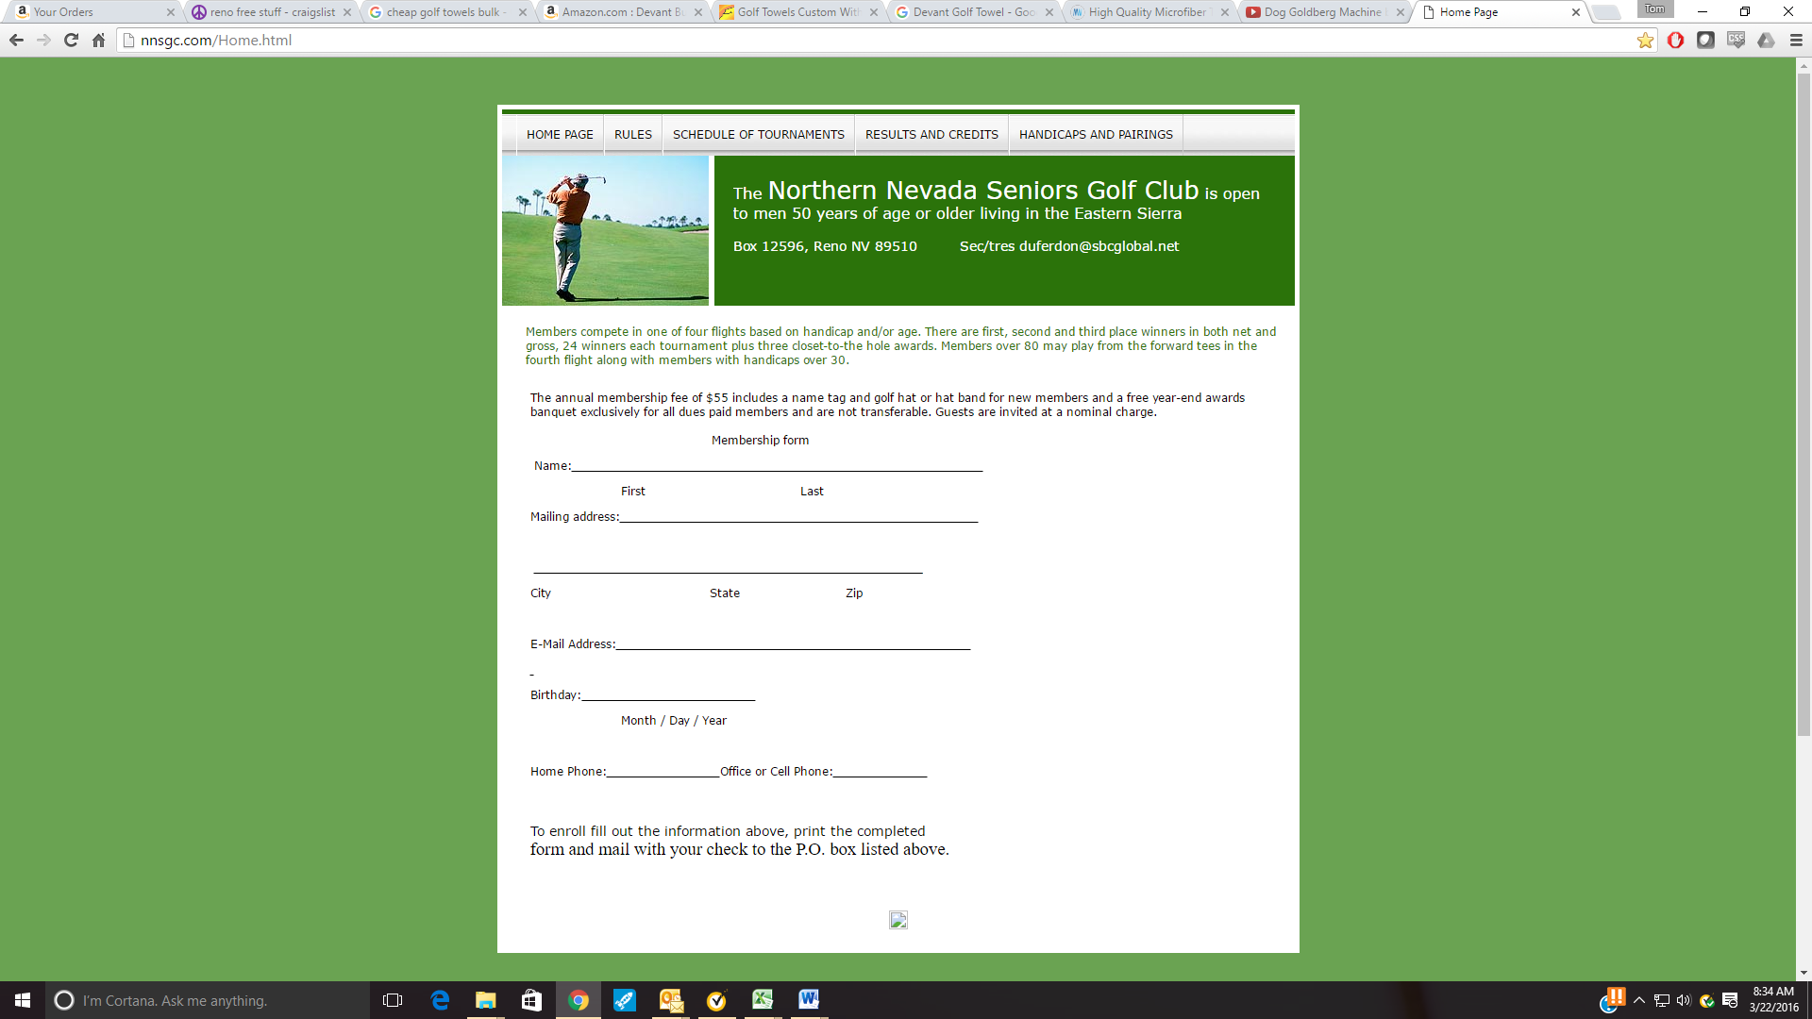The Northern Nevada Seniors Golf Club

[www.NNSGC.com](http://www.NNSGC.com) PO Box 12596, Reno, NV 89510

**NNSGC Tournaments Entry Form Year 2025**

**Member Name: _**

**In? Skins Extra Credit used $**

**Lakeridge, Wed. March 26, 9:00, $80, Mulligans Inc., (D = $12), L&D**

**Eagle Valley West, Wed April 2, 9:00, $55 (D = $27), L&D**

**Toiyabe, Wed April 16, 9:00, $75, L&D (D=$12)**

**Sunridge GC, Wed Apr 30, 9:00, $67, L&D**

**Redhawk Lakes, Wed May 7, 8:30, $84 (R = $12)**

**Redhawk Hills, Wed May 21, 8:30, $84 (R = $12)**

**Graeagle Meadows GC, Monday, June 2, 8:30, $82**

**Whitehawk, June 11, 8:30, $100, NO GUESTS**

**Wolf Run, Wed June 25, 8:00, $75 (D = $12), L&D**

**Sierra Sage, Wed July 9, 8:30, $67, (Breakfast Burritos) Team Game Inc.**

**Silver Oaks, Wed July 23, 8:30, $68, L&D**

**Genoa Lakes, Wed Aug. 6, 8:30, $92**

**Plumas Pines GC, Wed. Aug. 20, 8:30 $90**

**Eagle Valley East, Wed September 3, 8:30, $55 L&D (D=$27)**

**Arrowcreek, Wed September 17, 9:00, $125 Challenge Course**

**Dayton, Wed September 24, 9:00, $68, L&D, Team Game Inc.**

**Old Greenwood, Wednesday Oct 1, 10:30, $115, NO GUESTS**

**Somersett, MONDAY Oct 13, 10:30, $95 (S= $12), pizza, NO GUESTS**

**Enter ✔ here if you are member of: Duncan (D)  RedHawk (R)  Somersett (S)**

**- ALL starts are SHOTGUNS. L&D = Lunch & Drink**

**- SKINS/Extra Game NOTE: Separate from NNSGC game & paid cash at the yearend Banquet.**

**- Please include $10 for SKINS, +/or $6 for Extra Game in payment check or pay at course.**

**- 144 golfer limit/tournament except: Whitehawk, Graeagle, Somersett each at 120**

**TOTAL ENCLOSED: $ ____________ CHECK # ____________ & CREDITS Used: ____________**

**NOTE: Payment must accompany application *even for guests***

**Playing with:** ___________________________________ **Notes:** ______________________________

**REMINDER: Golfer(s) is/are responsible to the course for all caused cart damage**

**THANK YOU and PLAY WELL!!**