Contestant Application Mr./Ms. Alamo City Leather and Alamo City Bootblack 2023

May 13th, 2023

Location: Club Silver,1812 N. Main Ave, San Antonio, TX 78212

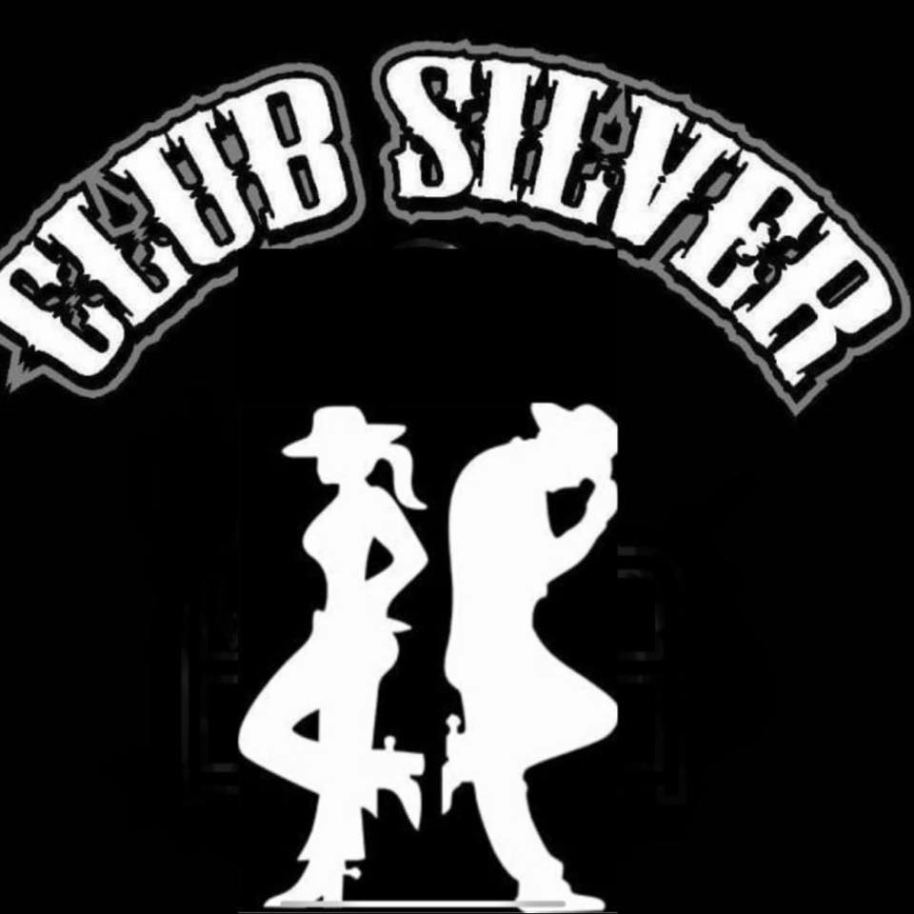

All applications are due by 11pm, April 28th, 2023
Please send completed applications to:
nlasa.official@gmail.com
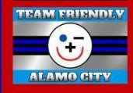


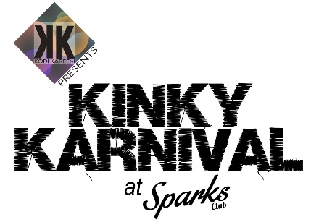

Contestant Information
(Please print clearly)
Legal Name _________________________________________________________
Gender Identity/Pronouns (optional)_________________________________________
Stage/Scene Name __________________________________________________________
Indicate the title you are competing for: Mr. Alamo City Leather__________
Ms. Alamo City Leather__________
Alamo City Bootblack____________
Street Address____________________________________________________________
City/State/Zip________________________________________________________
Country_____________________________________________________
Phone_____________________________
Email_____________________________________________________________
Birth Date__________________________
Height____________ Weight __________
Eye color_________________________
Hair color__________________________
Body modifications (Tattoos/piercings) _________________________________________________________________________________
Sponsor(s) (not required) ____________________________________________________________
Club/group/organization affiliations____________________________________________________
BDSM/leather or other fetishes ______________________________
List current/previous titles and years __________________________________________________
_____________________________________________________________________________________
List any publicly available adult-oriented or pornographic photos, videos, social media, or websites: ___________________________________________________________________________________
_____________________________________________________________________________________
List two (2) things that you have done in the community of which you are proud of:
_________________________________________________________________________________
_____________________________________________________________________________________
Why have you chosen to compete for an Alamo City Leather title?
__________________________________________________________________________________
If you are selected the winner, what are your goals for the coming year?
__________________________________________________________________________
Special medical or other needs_______________________________________________________
Do you need a language interpreter? (Check one) YES ____ NO ____
If yes, What language, including ASL? ____________________
Have you ever been arrested, convicted, or indicted of a felony or crime involving fraud, deception, or any criminal activity? (If yes, explain)_____________________________________________________
Any additional information you would like the judges to know? ____________________________________________________________________________________
_____________________________________________________________________________________
Disclaimer and Release of Liability:
In consideration of this contest entry to the owner (NLA-I San Antonio, or any of its producers) of the contest (Mr./Ms. Alamo City Leather and Alamo City Bootblack), I waive and release its owners and producers from any and all demands, actions, and claims of injury or damage to my person, property, reputation, cost, expense, attorney’s fees, or penalties that may arise either now or in the future in connection with my appearance in the Mr./Ms. Alamo City Leather and Alamo City Bootblack contest. I hereby grant permission to use my stage/scene name in connection with any publicity related to the Mr./Ms. Alamo City Leather and Alamo City Bootblack contest.
By my signature below, I hereby state that I have read and understand the above disclaimer.
I certify that:
a. All of the information that I have supplied on this application is true and correct;
b. I am 21 years of age or older;
c. I meet all of the qualifications specified in the attached contest requirements statement;
d. I agree to endeavor to meet all of the expectations of the contest in the attached expectations statement should I win;
e. I have read, signed, and attached the photographic release statement;
f. I have attached a photocopy of my driver’s license or passport showing my age and address.
Contestant signature __________________________________________________________________
Print Name: ___________________________________________________________
Date: ____________________________________________________

