

CAMP BLUE DIAMOND
Returning Staff
2025 SUMMER STAFF APPLICATION
Church of the Brethren
PO Box 240, Petersburg, PA, 16669
(814) 667-2355 info@campbluediamond.org
www.campbluediamond.org

(Please print legibly using black ink or type)

Name __________________________________________________ Email address __________________________________

Permanent address _________________________________________________________ Home Phone (____)____________

College address, if living on campus ________________________________________________________________________

Cell phone or number where you can most easily be reached (______) __________________  Male  Female

Please contact me by (Check all that apply) Call Email Text Message

Denomination and home congregation ______________________________________________________________________

Pastor’s Name ______________________________ Phone (_______) __________________________

Past and present church/district responsibilities and involvement: __________________________________________________
______________________________________________________________________________________________________

EDUCATION: Please list your high school/college experiences

What year of school are you presently in? __________  High School  College  Other ___________________

YEARS | SCHOOL | MAJOR OR EMPHASIS | DEGREE

EMPLOYMENT: Please list your employment experience beginning with the most recent
Dates | Employer | Address/Phone | Type of work | Supervisor | Reason for leaving

PERSONAL:

CURRENT CERTIFICATION: Please list certifications you hold, i.e., Basic First Aid, CPR, WSA, Life Saving, Other

Indicate specific certification and dates: ______________________________________________________________________
Date of birth: _____/_____/_____
Do you have a current driver’s license? Will you be 21 or over by June 5  Yes  No
REFERENCES: List 3 references including your pastor (or other adult if no church affiliation), a teacher (if in high school or college) and another adult. These people must be qualified to assess you contribution in a leadership role. Include each person’s email address and phone number. We are unable to process applications with incomplete information. Do not list relatives, present CBD staff, or persons currently serving on the Camp Board of Directors.

Name | Title | Email address

POSITION:
What staff position are you applying for? Please indicate 1st and 2nd choices.

PROGRAM POSITIONS:

__ Counselor __ Waterfront Director __ Naturalist __ Crafts Director __ Climbing Tower/Challenge Course
Director

SUPPORT STAFF POSITIONS:

___ Maintenance Staff ____ Kitchen Staff

INTERVIEW:
Interviews for program positions will be conducted by the Program Director over the phone. Responses will be taken to the Program Committee and reviewed. The Program Committee will have the final say in the rehiring process and return applicants should have an answer the week following the annual Camp Blue Diamond Board Retreat in January.

APPLICANT’S STATEMENT:
The information contained in this application is correct to the best of my knowledge. I authorize any references, past employees or pastors listed in this application to give information (including opinions) they may have regarding my character and fitness for working with children and youth in camp ministry. I release all such references from any liability for furnishing such evaluations to you, provided they do so in good faith and without malice. I waive any right that I may have to inspect references provided on my behalf. Should I be hired, I agree to be bound by the bylaws and policies of Camp Blue Diamond and to refrain from any unscriptural or unethical conduct in the performance of my services. I will assist to the best of my ability in maintaining and further developing the high ideals, Christian emphasis, academic standards and service requirements of Camp Blue Diamond.

Applicants Signature: _____________________________________________________ Date: ____________________

Returning Program Staff taking part in the Early Incentive Program must have applications in before December 13th.
Positions will be filled as applications are received as decided by the Program Committee, however, support staff positions will not be decided upon until after February 1.


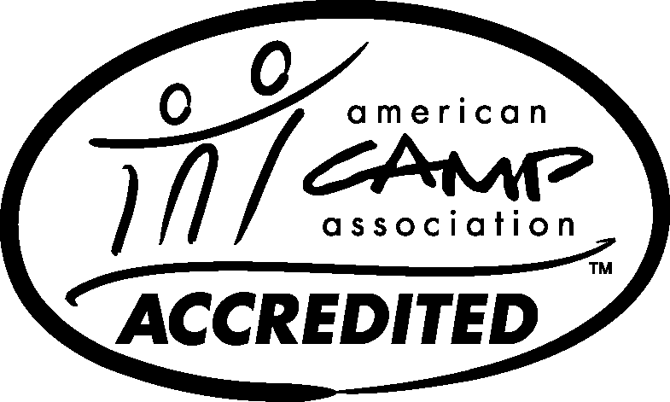
Return application to:

Camp Blue Diamond
Summer Staff Application

PO Box 240

Petersburg, PA 16669

or gimler@campbluediamond.org

