Application for Membership
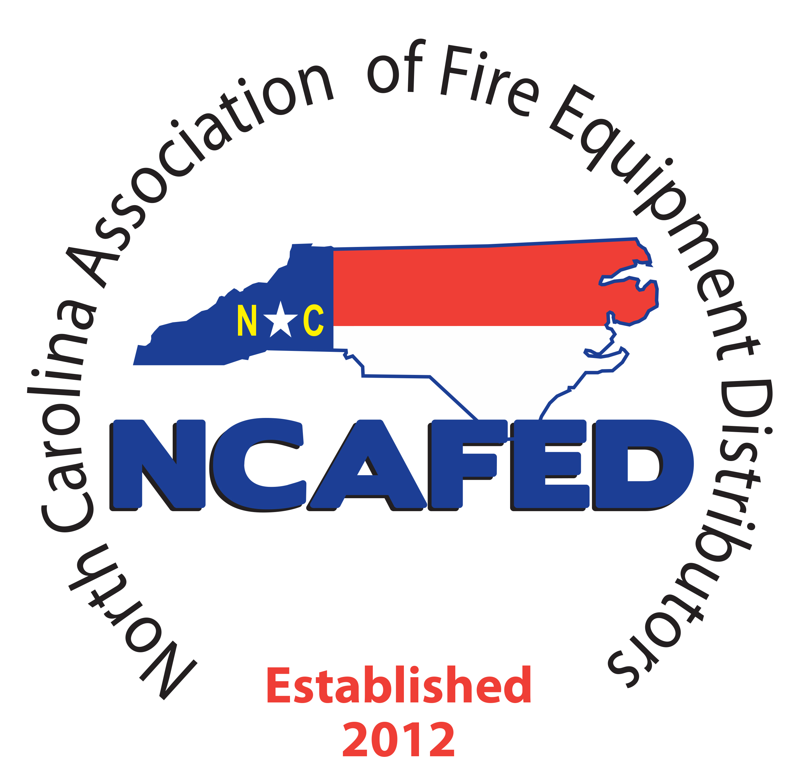

NORTH CAROLINA ASSOCIATION OF FIRE EQUIPMENT DISTRIBUTORS
If you have any questions, feel free to email or call any NCAFED Board Member (see directors page on website)

Membership type: select one

_________ Distributor: Firm or company actively engaged in sales, selling, distribution and servicing of portable fire extinguishers, fire protection equipment, or fire suppression systems other than water based Membership Annual Dues $225.00

__________ Distributor members with multiple locations in North Carolina actively engaged in sales, selling, distribution and servicing of portable fire extinguishers, fire protection equipment, or fire suppression systems other than water
Branch membership Annual Dues $75.00 per branch (please complete Branch Membership Form page 3 for all branch locations)

__________Associate: (Non-Voting) Individual, firm or company who shall provide manufacturer or supply products or services to Active or Associate Members of the Association Membership Annual Dues $550.00

__________Professional: (Non-Voting) individual, firm or company who shall provide professional services for the fire protection industry or governmental regulatory or training agencies.

Please fill in your company information.

Company Name/Organization Date / /

Legal Name of Business

Main Contact Person Title
(This person will receive all NCAFED mailings)
Mailing Address
Physical Address________________________________________________________________________________________

Telephone Fax

Email__________________________________________ Website

How long has your company been engaged in the sales, service, repair and maintenance of fire equipment?_____________

Businesses you are engaged in (please check all that apply)

Fire Extinguishers | ☐ | E Lights | ☐ | Fire Alarms | ☐ | Security Systems | ☐ | Backflow | ☐ | Fire Sprinklers | ☐
Kitchen Systems | ☐ | Pre-Engineered Industrial Systems | ☐ | Pre-Engineered Clean Agent Systems | ☐ | Vehicle Systems | ☐ | Engineered Systems | ☐ | Hood Cleaning | ☐

Other___________________________________________________________________________________________

As a member of NCAFED, your benefits include:

NCAFED Logo: Members in good standing can use the registered logo for marketing on vehicles, letterhead, uniforms, etc.

NCAFED Annual Conference and Trade Show featuring educational seminars, Vendor Trade Show. Members enjoy reduced registration fees.

Website- www.NCAFED.com featuring most current information about membership, continuing education, regulation as well as the current calendar of events and links to other industry websites. A special login “MEMBERS ONLY” section containing materials and information available only to NCAFED members in good standing.

Code of Ethics for Distributor Membership

We, as active members of the North Carolina Association of Fire Equipment Distributors, recognize that the products and services we provide have a significant impact on the quality of life for the entire public. As we perform our services, we will demonstrate the highest level of professionalism, personal integrity, and competence. Accordingly, we adhere to the NCAFED Code of Ethics, which states:

- We will fulfill our obligations to our clients in an efficient and competent manner and with complete honesty.
- We undertake to provide only those services for which we are competent by way of education, training, and experience.
- We strive to maintain our proficiency by a process of continually updating our knowledge and skills.
- We strive to adhere to all established codes and standards relevant to the products and services we provide.
- We do not attempt to misuse codes and standards or the process by which these codes and standards are created.
- We strive to follow all instructions established by the manufacturers of the equipment we provide or service.
- We will analyze the needs of our clients completely and professionally and make honest recommendations to fulfill those needs based on all available information.
- We strive to warn of any condition we notice that may affect the safety, health, and well-being of our clients, their property, and their employees.
- We will keep confidential and will not misuse the proprietary business information and trade secrets of our clients.
- We will conduct ourselves in a dignified and professional manner. We will admit and accept our own errors when proven wrong.
- We will not distort or alter the facts in an attempt to justify our decisions.
- We recognize that we are invited into our clients’ facilities and will conduct ourselves in a safe and professional manner.
- We will treat our clients’ goods and property with the highest regard.

If accepted for membership in the association, I acknowledge the responsibility inherent with the sale and maintenance of fire protection equipment industry. I pledge to perform the work, and to serve our customers with the highest degree of honesty, integrity, and skill.

I pledge that we will perform all work in strict accordance with legally applicable national, State, and local fire codes and that the violation of these codes may cause for termination from this association. Furthermore, I state that I have the authority to commit this firm or company to such precepts and principles.

My assignees and I also agree that any property of NCAFED will be returned to the association upon termination of membership.

I HEREBY CERTIFY THAT I HAVE READ THE CONTENTS OF THE APPLICATION AND THAT THE INFORMATION PROVIDED HEREIN IS TRUE AND CORRECT.

____________________________________________________ __________________
Signature of Authorized Representative Title Date___ /___/___

____________________________________________________ __________________
Company Officer Title Date___ /___/___

____________________________________________________
Company Owner Title_________________ Date___/___/___

Payment Methods

Check made payable to NCAFED
- Mail check and application to: NCAFED Membership Department 130 Wolfpack Lane, Durham, NC 27704

For Credit Card
- (MasterCard/Visa/American Express) Email your application to: admin@ncafed.com

*A full year’s membership fee must be included with your application.

For official use only: □ to comm. □ pending □ approved _______________ member # _____________

