June 2024

newsletter

ZEAL

**Zeal workers are currently based or have previously served in ministries across the following nations: Algeria, Egypt, Iraq, Lebanon, Libya, Sudan, Syria, Tunisia, Turkey, Morocco & Yemen. Below is their latest news.**

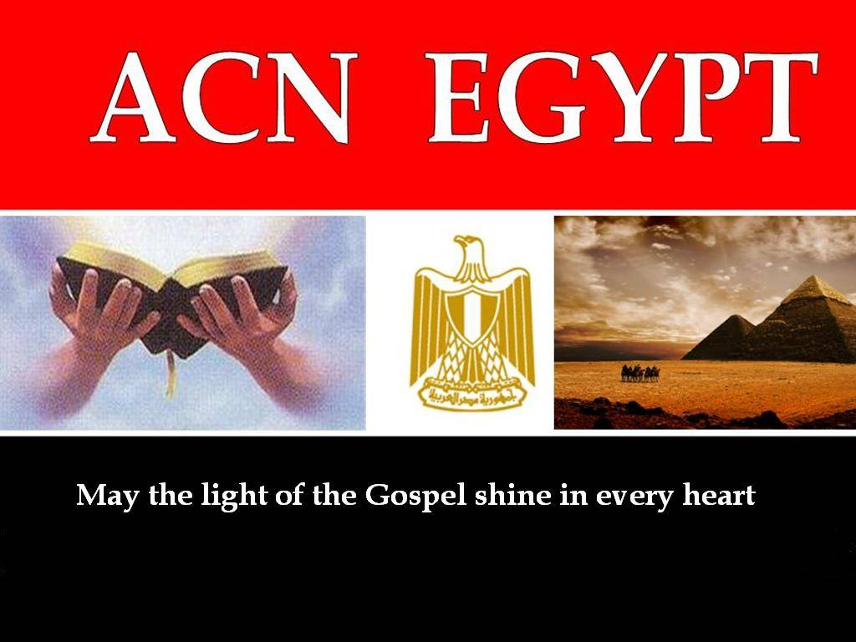

**EGYPT**

- I travelled with a team to the south of Egypt very close to the border with North Sudan. It was part of an evangelism campaign to share the Gospel with the thousands of Sudanese refugees coming into the country. We setup a tent where we provided medical help to those in need and gave out water supplies etc. The refugees were really touched by the love that we showed them and we were able to have amazing conversations about how much God loves them. Pray for the seeds of the Gospel planted in their hearts.

-One of our team members has been meeting and discipling a Muslim girl called Shireen. Shireen had very low self esteem because of all the negative things that her family were constantly telling her. Our team member shared the Gospel with her leading her to know that she is so precious that Jesus was willing to die for her. The Holy Spirit really touched her heart and she has surrendered her life to Christ in an amazing way. Shireen is now so thirsty to read the Bible, praise God,

-We were contacted by a Muslim man called Osman. Amazingly, he told us that he had rejected Islam because of all the violence that he saw as well as the

369993

**Egypt** (continued)

lack of love between the Muslims that he knew. Omar wanted to find out more about Christianity. I met with him several times to share the good news of Jesus Christ. Omar has now started reading the Bible regularly and the Holy Spirit is stirring up his heart. Please pray for him.

-Abdul was a Sudanese Muslim man who fled the war in his country. He went to Saudi Arabia and began to hate Islam because of the heavy burden it put on people. He came to Egypt and contacted us via our Christian website. We followed up with him and eventually met him face to face. He had many questions but we thank the Lord that after 3 months of discipling him, he surrendered his life to Jesus Christ and is now born again. Praise God for this new believer who is reading the Bible and growing in faith.

**“*Therefore go and make discip1es of all nations, baptizing them in the name of the Father and of the Son and of the H0ly Spirit, and teaching them to obey everything I have commanded you.***

***And surely I am with you always, to the very end of the age.*”**

**Matthew 28: 19, 20**

**Regular Prayer Request:**

* Protection for all the workers and staff of Zeal and their families.
* The new believers. That they will grow in their relationship with Christ and will draw others to our L0rd and Savior.

**Missions trip to Albania**

We thank God for the short missional training trip to Albania. This was done in partnership with another Christian organisation that has a training centre in the country. It was a real blessing to be involved in training up young people for mission.

Incredibly, the group was planning on going to Poland for their outreach trip however after prayer they felt that God was instead directing them to Turkey. In addition it turns out that they will be going to our home city in Turkey for 6 weeks. We were so touched to be able to train and send workers to our city in Turkey to shine the light of Christ there.   
***Then He said to His disciples, “The harvest truly is plentiful, but the laborers are few. lTherefore pray the Lord of the harvest to send out laborers into His harvest.”***

**Matthew 9:37,38**

**Would you please pray for them that God would use them to sow the seeds of the Gospel.**

**Country in Africa**

**(two of our Zeal workers went on separate evangelism trips to this Islamic country)**

* This is a strict Islamic country. Recently there was the case of a group of Muslims who had converted to Christianity. They were discovered and the courts sentenced them to death for apostasy. One of our Zeal workers raised the issue desperately with international humans rights organisations and pressure was put on the government. They were eventually released and told not to evangelise in the capital city.
* We held a meeting with the permission of the government to help families through a marriage seminar. Both Muslim and Christian families came. We were able to speak about marriage and Gods love from a Christian perspective but without officially using the Bible. The couples were every encouraged and the feedback from the local people was positive.
* We held another meeting for believers where we could disciple them and train them on church leadership. Praise God for all the seeds of the Gospel planted in this Islamic country of Africa.

|  |  |
| --- | --- |
| Chris Padaychee | Greg Harrison |
| International Director | President |
| Zeal | Zeal |

**Thank you for partnering with us, as we support native**

**Arab Chr1stians to share the G0spel across the Arab world.**

**This document contains highly sensitive information. Please be extremely careful with it. It should not be published or displayed publicly without first obtaining specific permission from Zeal.**