Date | Creative Activity  If you should require a space for Christmas Eve, 24th December 2020 or New Year’s Eve, 31st December 2020 please contact us as we will only open on these days if we have enough children to be able to run the club.  Christmas 2020 Holiday Club | Challenge of the day | Group Games | Science Experiments | Outdoor Play | Extra activities
Monday 21st December 2020 | Children will use their handprint to make Rudolf the red nose reindeer pictures | Who can build the biggest plastic cup Christmas tree | 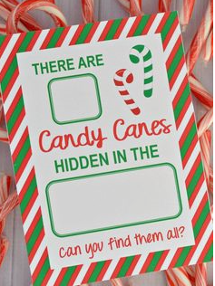  Candy Cane hide and seek game | Children will be making their very own snowstorm in a jar | Children’s Choice | Christmas Movie and popcorn  (Children will be able to choose from a selection of age appropriate Christmas movies)
Tuesday 22nd December 2020 | Christmas tree decoration making | Children’s Choice | 1 minute to win it game.  Get as many cotton wool balls (snowballs) in the cup using the spoon (shovel) within one minute |  | Skipping ropes  Bean bag races  Hopscotch | Kite  Flying
Wednesday 23rd December 2020 | Using a picture of themselves, children will make a wacky elf figure | Using oven gloves, children will have the challenge to try and open a present | Which team can stick as many christmas bows on a team mate to win | Children’s Choice | Sack races  Hoop and cone game  Inflatable Giant balls | Christmas  Colouring  Packs
Tuesday 29th December 2020 |  | Children’s Choice |  |  | Basketball shoot the hoop  Obstacle Races  Football | Bingo  With a prize to win  Number or picture bingo (age appropriate)
Wednesday 30th December 2020 | 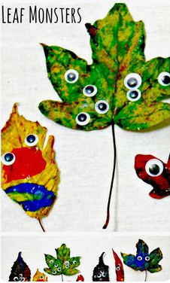 |  | Children’s Choice |  | Giant inflatable Bowling  Ring toss game  Space Hoopers | Movie and biscuits  (Children will be able to choose from a selection of age appropriate movies)

