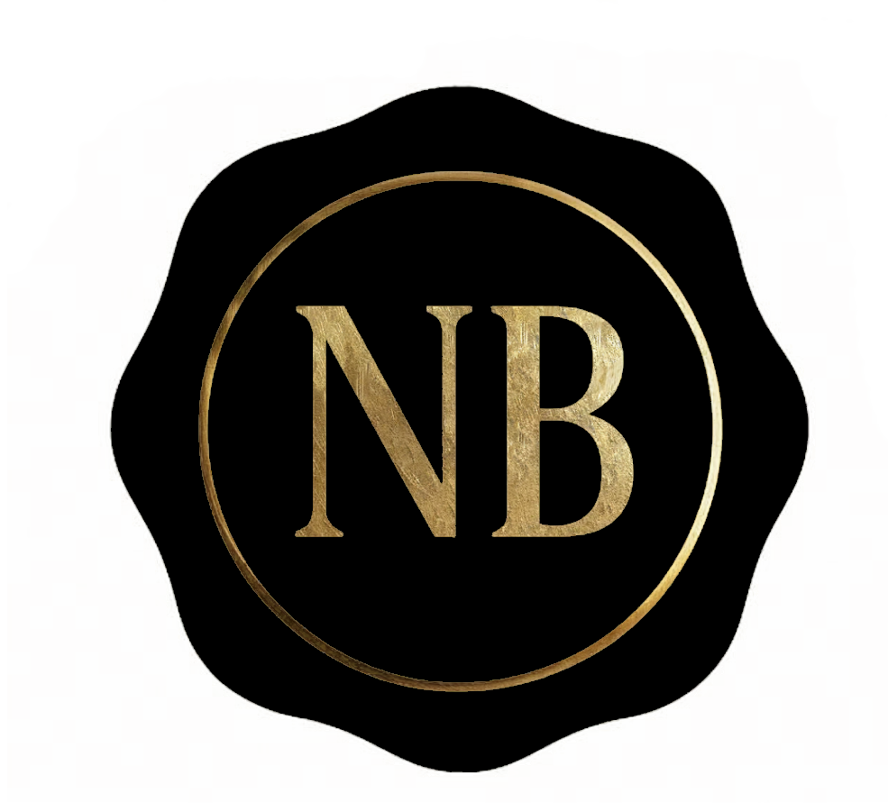

**NOTA BENE PRODUCTIONS LLC**

*Your Moment, Well Marked*

**Isaac Horvat**Phone: 240-818-1217  
Email: isaac@notabeneproductions.com  
Web: www.notabeneproductions.com

# Core Competencies

- Event Videography: Capturing corporate, nonprofit, and private events with cinematic precision.  
- Professional Editing: Seamless post-production using industry-standard tools to deliver polished final products.  
- Security-Cleared Work: Eligible for projects requiring high-level confidentiality and discretion.

# Differentiators

- Small, agile team offering personalized service and quick turnaround.  
- Proven ability to adapt to live, on-the-ground production needs.  
- Trained in television production with experience in both field and studio settings.  
- Familiarity with secure workflows for sensitive content.

# Past Performance

- Filming and editing corporate interviews, short documentaries, and live productions.  
- Capturing professional headshots and run-and-gun style coverage for organizations and individuals.  
- Livestream production for public events, video podcasts, and speaking engagements.