Miami | South Florida
Site MenuDonate
Listen Live

Lots Of Wine, Graffiti And Opera At Miami's Art Days
By MARVA HINTON • SEP 20, 2013
SHARETwitter Facebook Google+ Email
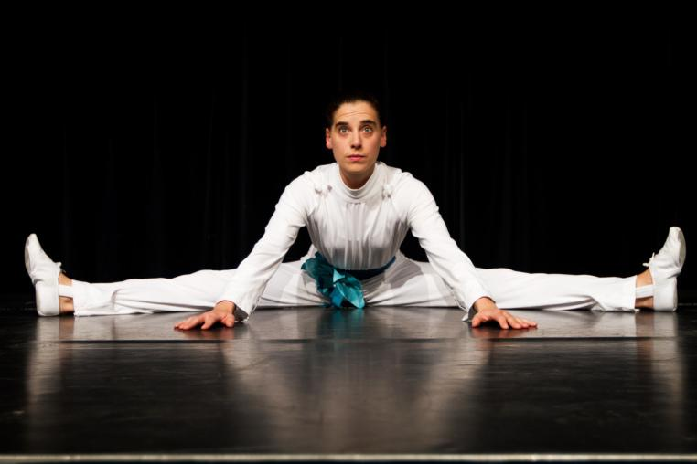
Nina Hlava is a mime artist from Vienna who is participating in DWNTWN Art Days.
CREDIT NINA HLAVA
DWNTWN Art Days kicks off Friday in Miami. The second annual celebration of arts and culture features more than 130 events with something for everyone, from wine lovers to graffiti art enthusiasts and fans of the opera.
Art Days is sponsored by the Miami Downtown Development Authority.
Alyce Robertson is the authority's executive director. She says the arts are a key component of economic development.
"We've had a lot of people move into the condos," said Robertson. "We've had almost a doubling in our population, so there's a lot to offer people who are new to downtown. And we're hoping that people see in the three days, that all year round, there's a lot to do in downtown Miami."
One of the highlights of this year's event is a huge exhibition at Bayfront Park. Giants in the City features towering structures, some as high as 45 feet, that the public is
encouraged to touch. 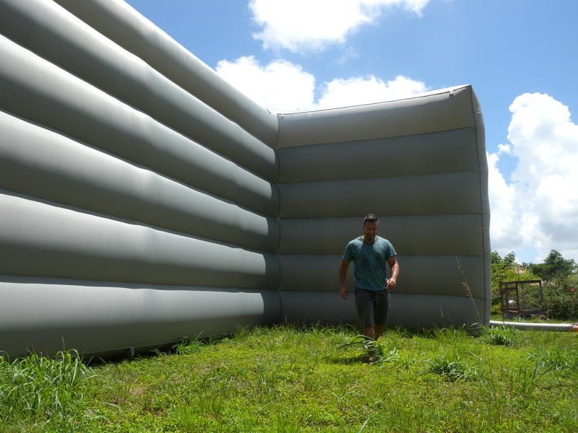

Artist Yamel Molerio stands in front of one of the large structures from the exhibition Giants in the City.
CREDIT NOOR BLAZEKOVIC
Noor Blazekovic is the exhibit's executive director. She says it provides a completely different experience than going to a gallery with stuffy rules.
"You're not supposed to touch," said Blazekovic. "You're not supposed to talk. You're not supposed to do anything other than to contemplate a marvelous piece."
But she says Giants in the City encourages interaction.
"These are marvelous pieces, very high-profile pieces," said Blazekovic. "These are artists established and well known around the world, and they will do the opposite with you. They want you to talk. They want you to touch."
The exhibition will also feature a piece that looks like a large wall that participants will be encouraged to tag with spray paint.
Other highlights of the event include:
- A Water Balloon Kickball Tournament
- The National Red Bull Flutag
- Happy Hour at the CU-1 Gallery
- Progressive Studio Tours
DWNTWN Art Days runs through Sunday evening. Free or $5 parking is available.
TAGS:
CITY OF MIAMI
ALYCE ROBERTSON
NOOR BLAZEKOVIC
NINA HLAVA
YAMEL MOLERIO
ARTS

