I'M IN MIAMI BITCH! JAM 104 Q&A
Andrew KaufmanSeptember 13, 2018
September 17, 2013.
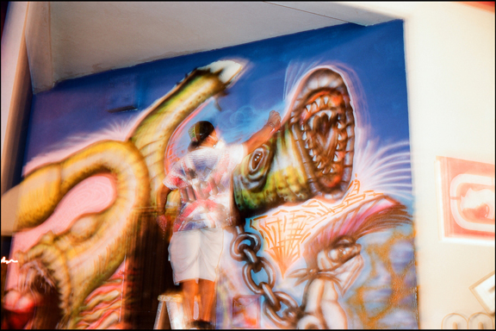
JAM 104 at work in Wynwood.
Father, Husband, Artist, Art Teacher, Street Artist, Sculptor, yeah that's a lot but for Yamel Molerio aka Jam 104 that's how he rolls. Go check him out this weekend in downtown Miami as he headlines Giants in the City during the Miami Downtown Art Days.
AK: What do you write? Are you in a crew?
YM: Jam 104 and my crew is TYT stands for Today's Youth Talent.
AK: In what city did you start painting in the streets? Do you feel your work has influenced the community in return? If so, how? Is there a relationship between the artist and the community in which they work?
YM: Miami back in the mid 80's. Back in those days graff was in it’s beginnings. So, I think our generation influenced what graff has become. I think little by little the community has seen graff for what it is a beautiful crime.
AK: Did you go to school or are you self taught?
YM: I have a Bachelors in Fine Arts(painting) from University of Florida via NWSA(New World School of the Arts) and a Masters degree in art education from Florida International University and a PHD from the streets cause it taught me a lot.
AK: How did you get started in the arts and why?
YM: I was in high school and I just saw the art and I was immediately attracted to it. I was always drawing so it was easy for me to take on graff. It was an outlet for me to express myself since my parents couldn't afford art classes and magnet art schools were not common at that time.
AK: How long have you been working in the streets?
YM: I am an artist so I have never stopped painting. I stopped doing graff in 1989. I returned to doing graff in 2009 but since then I have been doing some pieces. Including one I just finished in the school where I work. I had been out of the graff scene for a long time and Zun from the DAM crew was the one that invited me for the Art Basel 2012 piece.
AK: Who or What inspires you the most?
YM: Life, my family, my kids, my wife, and art itself.
AK: What should the general public know about street art? What stereotype about street art/graffiti do you hate the most?
YM: It’s just another form of art. Some of the artists might come across as street thugs, but people have to remember that since a lot of our work is done on the streets you have to sometimes fit the part so you are respected in the streets. Back in the days I took on that role because I was hanging out in abandoned buildings and in rough areas of our city. Today, I am a public school art teacher, I am married with two kids so I do not have the need to act like that.
AK: Are you a full time artist? Do you have a day job? Is it best to be full time artist or not worry about it and make your $$$ elsewhere, that way you can paint what and how you want, which one offers a more creative outlook?
YM: I am not a full time street artist, I am a full time artist and full time art teacher. I don't know what is best for other artists I know what is best for me. I think having a full time job actually lets me be more creative. I feel that when you are financially depending on just your art others such as gallerists tend to try to mold your work.
AK: What are you working on now?
YM: I just finished taking down work from a group show in the Bakehouse Art Complex titled "Water Rites". The pieces are inspired by street art.
AK: What do you hope to achieve or accomplish by putting your work in the street?
YM: I want people to get to know me as an artist. Art is an outlet for me. I need to express myself either on a wall or a canvas.
THANKS!
Check out Jam's work http://YamelMolerio.com

