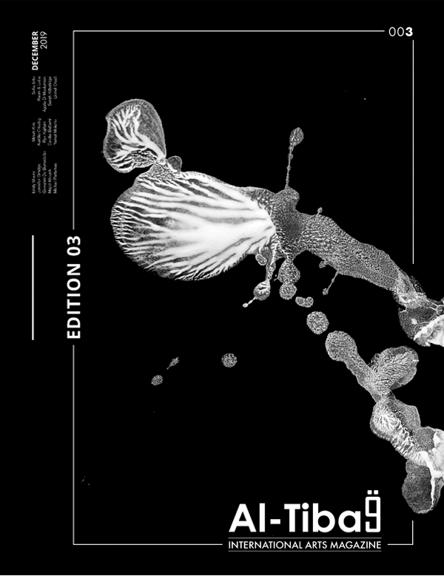

**Artists**

Emily Moore - Jennifer Orhélys - Giovanni de Benedetto - Aurélie Crisetig - Ryo Kajitani - Cecilia Battaini - Yamel Molerio - Majd Alloush - Michail Parlamas - Minah Kim - Sofia Erto - Raom & Loba - Agata di Masternak - Sarah Kitteridge - Lionel Cruet.

**Pages:** 88

**Publisher:** Al-Tiba9 (December, 2019)