

**Student Name: _____________________________________________________**

**How Credit Scores are Calculated**

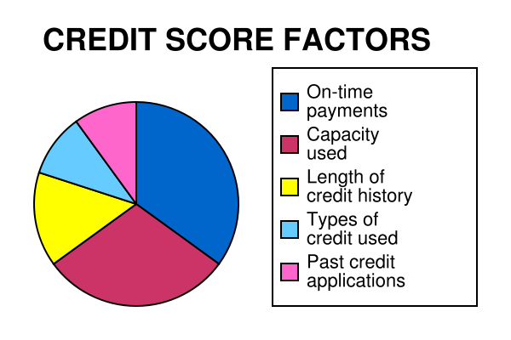

35% payment history – on time payments

30% credit utilization - current debt owed

15% length of credit history

10% types of credit

10% new credit



**____%**

**____%**

**____%**

**____%**

**____%**



**35% 30% 15% 10% 10%**

**10% Types of Credit**

_________________________________________________________________________________________________________________________________________________________________________

**10% New Credit**

_________________________________________________________________________________________________________________________________________________________________________

**15% Length of History**

_________________________________________________________________________________________________________________________________________________________________________

**30% Debt Owed**

_________________________________________________________________________________________________________________________________________________________________________

**35% Payment History**

_________________________________________________________________________________________________________________________________________________________________________