Name: ______________________________

**Smart Shopping Spree – What’s for Dinner?**

**Scenario:** You have $30 and have to purchase food at the supermarket to feed a family of four as if you were to cook the meal. Don’t worry about buying individual spices and items you may typically have at home like butter, sugar, salt/pepper, etc. Focus on the main ingredients.

Go to the ShopRite website or a food store of your choice:

<https://www.shoprite.com/sm/pickup/rsid/3000/curbsidepickup>

In the chart below, list the items you selected and the cost. Remember it should feed 4 people. If you have money left over, you can buy dessert or fruit for healthy snacking. If you choose delivery or a cost for pick-up, be sure to add that cost in your list.

|  |  |  |  |
| --- | --- | --- | --- |
| **Item** | **Quantity** | **Price per item** | **Total** |
|  |  | $ | $ |
|  |  | $ | $ |
|  |  | $ | $ |
|  |  | $ | $ |
|  |  | $ | $ |
|  |  | $ | $ |
| **Total** |  |  | $ |

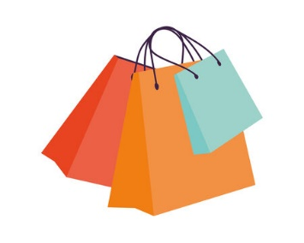Name: ______________________________

**Smart Shopping Spree – Find an outfit!**

**Scenario:** You have $30 and have to purchase an outfit. You need at least a top and a bottom (shirt & pants/skirt). If you have money left over you can buy accessories for the outfit.

Go to any retail store online to shop for your outfit.

In the chart below, list the items you selected and the cost. Then total your purchases.

|  |  |
| --- | --- |
| **Item** | **Total** |
|  | $ |
|  | $ |
|  | $ |
|  | $ |
| **Total** | $ |

**Notes for the Instructors:**

This exercise requires access to computers.

Divide the class in half and give each half one of the assignments. If you have more time and want to provide both assignments to the students, that’s a wonderful learning experience.

**Food Shopping:**

Be sure to review the students’ shopping lists to ensure a complete meal is selected. For example, a student purchased hamburger patties, and a bag of French fries but forgot to purchase the buns.

If they have money left over, encourage them to purchase healthy snacks versus ice cream or other sugary snacks.

If they purchased soda (or “pop” depending on where you live), discuss the cost. In Philadelphia, there is a soda tax which increases the price.

Be sure to talk about the expense of buying fast food instead of shopping at the supermarket. I have a presentation on “The price of convenience” explaining the mark-up associated with convenient stores.

Another discussion topic is the use of Door Dash/Uber Eats and the costs associated with delivery.

**Clothes Shopping:**

By allowing students to select their own clothing website, students typically went to the “cheap” sites. Have a discussion with them and talk about whether this is really where they do all their shopping. Especially if you see them wearing branded clothing. 😊 They asked if they could go to Thrift Shops. It’s great to see them being financially conscious with their spending, but again, is this where they do all their shopping or are they trying to stay under their budget for the sake of the exercise?

If they order online be sure to include the shipping costs. Or, see if the items can be mailed to the retail store for pick-up to eliminate shipping costs. But if they have to pay public transportation to get to the store, that may not be more cost-effective. Do the math!

We eliminated the shoes on this assignment because sneakers were going to be expensive. You can incorporate that discussion with the class. Marketing and “falling for the hype” are complimentary topics for this assignment.

**Good luck and have fun with this!**