Miss Susan

Greenacres Newsletter

Spring/Summer
2025
Edition

Dear Parents,
"Exciting Times Ahead at Greenacres”!
Please enjoy reading our next newsletter and don’t forget we love you to come and work alongside us for half a day doing ‘Nursery Officer for a day’.

As we look ahead to the coming months, I'm thrilled to share with you the many adventures and learning opportunities that await us here at Greenacres. Our dedicated teams are busy planning engaging activities and experiences that will spark curiosity, creativity, and joy in our young explorers.

From outdoor explorations to arts and crafts, we'll be embracing the changing seasons and all the wonders they bring. Our nurseries will be buzzing with excitement as we discover new things, make new friends, and create lasting memories.
I'm proud of the nurturing environment we've created at Greenacres, where every child feels valued, supported, and encouraged to grow. I'm looking forward to seeing the incredible progress your children will make, and celebrating. I still remain honoured to be part of their journey and can't wait to share the fun with you!
See you all soon

Happy Reading.

<><><><><><><><><><><><><><><><><><><><><><><><><><><><><><><><><><><><><><><><><><><><>

Nursery Officer for a Day

Why not come and witness first hand exactly what we do with our curriculums
and our days of fun and activity?

As they say,
“if you walked a mile in our shoes . . .” you’d learn so much more about what we do and why we do it.

It is often better to do this on a day or in an area when your child isn’t with you, so that you get a chance to really witness and join the activities for yourself. It’s a great way to meet staff and see how they work, maybe find out more about the next room that your child is going to move up to, or just understand some of the techniques, or behind the scenes plans.

Work with us for the morning, then finish with a relaxed lunch with Miss Susan and your keyworker to discuss your experience.

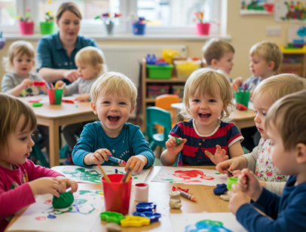
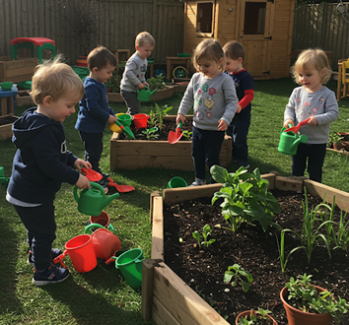

If you’d like to experience this wonderful opportunity to learn more about how your child spends their time at Greenacres, please speak to your keyworker to arrange a day to come in. We’d love to welcome you.

Encouraging Problem-Solving in Our Children at Greenacres

At Greenacres, we believe that fostering problem-solving skills in our young learners is essential for their cognitive development and future success.
Our experienced practitioners are dedicated to providing a safe and nurturing environment where children can explore, experiment, and learn through play.

What is Problem-Solving?
Problem-solving is the process of identifying a challenge or obstacle and finding a solution. For under 5s, this might mean figuring out how to stack blocks, navigating a puzzle, or finding a way to share toys with friends.
How We Encourage Problem-Solving?

Open-Ended Play: We provide opportunities for children to engage in open-ended play, where they can explore and experiment without fear of failure.
Challenging Activities: Our practitioners design activities that challenge children to think critically and come up with creative solutions.
Supportive Guidance: We offer gentle guidance and support to help children develop their problem-solving skills, without providing the answers.
Reflection and Discussion: We encourage children to reflect on their experiences and discuss their thoughts and ideas with their peers.
Benefits of Problem-Solving

Develops Critical Thinking:
Problem-solving helps children develop critical thinking skills, which are essential for future academic success.
Builds Confidence: By overcoming challenges, children build confidence in their ability to solve problems and tackle new situations.
Enhances Creativity:
Problem-solving encourages children to think creatively and come up with innovative solutions.
How You Can Support Problem-Solving at Home?
Provide Opportunities for Play: Encourage your child to engage in open-ended play at home, using materials like blocks, puzzles, and playdough.
Ask Open-Ended Questions:
Ask your child questions that encourage them to think critically and come up with their own solutions.
Praise Effort, Not Just Success: Praise your child for their effort and persistence, not just their success. This helps to develop a growth mindset and encourages them to take risks.

By working together, we can help our children develop the problem-solving skills they need to succeed in life. If you have any questions or would like to learn more about our approach to problem-solving, please don't hesitate to ask.

Recipes

Two examples of some cooking that we do here at nursery

Our Chicken Curry is prepared by our cook for lunch, and the children really love it, so we wanted to share it with you.
The Courgette Loaf is an example of something the children would cook as part of our learning through cooking when exploring different cooking skills.
We hope the recipes are making you feel hungry and keen to give them a try at home.
<><><><><><><><><><><><><><><><><><><><><><><><><><><><><>

Chicken Curry

Ingredients:
Chicken – Onions – Garlic - Veggies of your choice
Curry Powder & Cornflour

Method:
Fry the onions and garlic, and part way through cooking add the chicken. Add curry powder and garlic and allow to cook down.
Add all your chosen vegetables (we add peas, green beans, baby corn, broccoli and potatoes). Add water to just cover the ingredients cooking. If you are in a hurry, you can part boil your vegetables first whilst the onions and chicken are cooking. Continue to cook gently until the vegetables are tender and the chicken is thoroughly cooked through.
Mix a little cornflour with cold water and add to the mixture. Stir continuously until the mixture thickens nicely, then serve with a chosen accompaniment. We serve ours with rice and naan bread.
<><><><><><><><><><><><><><><><><><><><><><><><><><><><><>

Courgette Loaf

Ingredients:
3 cups of Flour 3 Eggs
1 tbsp Ground Cinnamon 2 cups of Sugar
¼ tsp Ground Nutmeg 1 cup of Vegetable Oil
1 tsp Salt 1 cup of shredded Courgette
1 tsp Baking Powder 1 tbsp Vanilla Extract
¼ tsp Baking Soda

Method:
Combine the flour, cinnamon, nutmeg, salt, baking powder and baking soda together in a bowl.
In another bowl crack the eggs, add the sugar, oil, courgette and vanilla. Add the dry ingredients in and stir well.
Pour the mixture into a bread loaf tin, and cook for around an hour.
Allow to cool in the tin for 10 minutes before removing from the tin on to a cooling rack to allow to cool completely.

We hope you enjoy making and eating this delicious loaf.




Maths is all around us

How often have you heard the phrase, “Oh no I’m rubbish at maths” or “I was always bad at maths” throughout your day?
Do we automatically think something that seems difficult is unachievable and how do we ensure we do not create barriers for our children to overcome before they have even got started?
If you have a nervousness about maths then I am going suggest to you that, in Early years, maths is everywhere!!

It’s true, maths really is everywhere, and learning about it doesn’t happen just at school or nursery. Young children have lots of important mathematical experiences every day and there are lots of ways to help them begin to develop their mathematical skills.

We all use maths many times a day. Numbers and shapes, measuring and solving problems are all needed for simple tasks like measuring out washing powder, making the right number of sandwiches for lunch or cutting a cake in equal portions.

Young children need help to understand what maths is used for and you can do this by talking about the maths you use in your day-to-day routine.

Show children how numbers, size, shape and pattern are important in your life by doing things

like:

• checking with them the bus number as it arrives
• reading aloud the quantities printed on boxes and tins of food
• pointing out the numbers on the clock
• counting out the money at the check-out
• finding the TV channel on the remote control together
• talking about how things fit and tidying away toys into boxes.

Use everyday maths words.

Children may not understand all the maths you use, but they can get to know maths words and numbers. If your family speaks several languages together, encourage the children to learn to count in all of those languages. This will help their understanding about number. Children who are confident with counting get off to a good start in maths.

How do children learn maths?
Singing songs and playing finger rhymes/games quickly grabs children’s interest. The repetition in these rhymes means that even quite young toddlers soon pick up the words and will join in the chorus with you as they begin to get a feel for a pattern.
In finger plays, where you wriggle fingers or toes, babies learn that one movement matches one sound. Babies from as young as four to five months love playing peek-a-boo.
If you count “1, 2, 3, boo!” they begin to remember the sequence of word sounds and know when the “boo!” is coming, so will laugh in anticipation.

When children start school, the games they play become more complicated, involving rules, dice and cards. And while playing these games – whether Snakes and Ladders, Snap or Happy Families – children are learning valuable maths skills such as adding up and reading numbers.

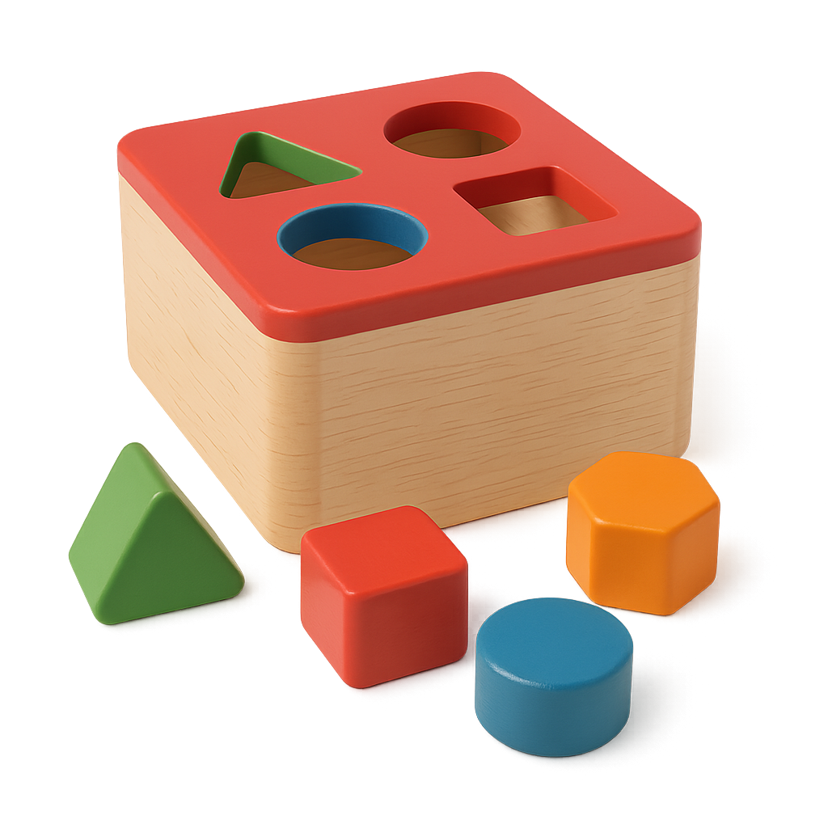
Babies learn first about the space they are in. Then they learn about the order of events and begin to predict what will happen next. They also start to hear and use number names. From 18 months onwards, most toddlers will be learning:

• some number words
• their birthday number: “I’m 2”
• pairs of shoes
• the sequence “1, 2, 3” linked to something they can see
• how to sort out similar objects
• some position words, such as “in”, “on top”, “behind”
• how to build with four to six blocks
• how to post shapes.

Children slowly understand more about numbers, shapes and measurement. They may be able to say the numbers up to nearly 10, but only be able to count a small number of objects. Children need plenty of practical experiences to link what they can see, hear and feel with the idea of using numbers. So, at this time children will be learning to:

• say “1, 2, 3, 4…” up to 10
• count up to 10 objects, put them in different patterns and count again
• recognise the written numbers 1, 2, 3, 4… up to 9
• use words to compare things, such as “more”, “less”, “greater”, “smaller”
• make simple patterns and talk about them
• name shapes such as a circle, square, triangle
• use words to describe where things are, such as “over”, “under”, “next to”.

During their first few years at primary school, children learn to count up to the hundreds, add and take away, talk about shapes and use measures. They still need to handle things so that the maths is real and makes sense to them. By about the age of seven to eight they will be learning to:


• count to, read and write numbers up to 100
• count forwards and backwards in ones or tens from two-digit numbers
• add and take away numbers less than 10 in their head
• double and halve small numbers (such as double 9 is 18, and half of 18 is 9)
• find the value of a handful of coins up to £1
• measure and weigh using metres and centimetres, kilograms and litres
• tell the time to half and quarter past or to the hour
• name and describe common shapes.

Maths around the house
Stand in front of the mirror together. Do an action like putting your finger on your nose and then say what you are doing. Ask your child to follow you. Try out lots of different actions, such as:

• Touching the top of your head or scratching behind your ear.
• Talk about which order to get dressed in, and which items to put on first, next and last.
• Sort out clothes to see which ones are the right size and which are too big or too small.
• Match pairs of things: shoes, socks, gloves, buttons and buttonholes.
• In the bath, use plastic tubs and ducks or small toys. Count how many toys will make the boat sink.
• Drop some coins in the bath and see how many the children can find.
• Have a toy clock next to a real clock. Say that the child can get up when the hands on the real clock match the hands on the toy clock. This can be a game played at any time of day or be used to help children work out whether or not it is their real getting-up time.

Maths outdoors


• Create an obstacle course outside: large boxes to climb into and through, a
board to balance along, a blanket to hide behind, and so on.
• Look for numbers as you are walking along the street together. You could
see how many of a particular number you can spy, such as the number 2
(on a bus, on advertising hoardings, on front doors); or look for numbers in
order – first 1, then 2, then 3, and so on. With older children, see who can
find the largest number.
• Give children a small bag in which to collect five interesting things, such as
a conker, a leaf, a stone, a feather and a twig, then talk about them when
the collection is complete.
• Play “I spy” using descriptions instead of an initial letter, for example, “I spy
with my little eye something that is small and very smooth” or “long and
prickly”.
• Compare two shopping bags to find out which is heavier.

Maths ideas for rainy days

These activities help children learn about numbers:


• playing with a calculator
• using their own footprints cut out from newspaper to make a trail to the front door
• counting fingers, toes, eyes and noses, socks and shoes
• making a birthday card for a friend and writing the number of their birthday on the card
• cutting out numbers in magazines and catalogues, looking for page numbers in books.
• playing card games such as Snap
• sorting out and playing a game of dominoes
• using a dice to play board games, such as Snakes and Ladders
• playing skittle games and keeping score.

These activities will help children learn about shapes and measures:

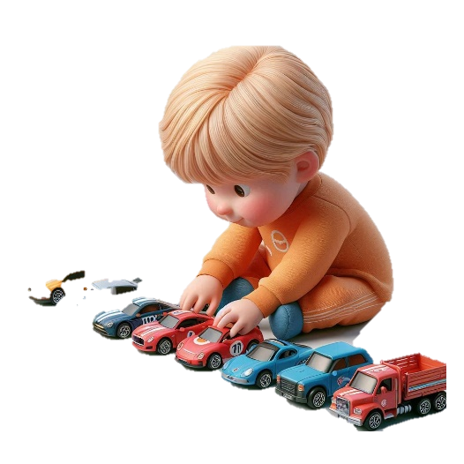
• hiding a small toy in a box of shredded paper and then finding it again
• using empty food packets and boxes to build a castle
• wrapping up pretend presents and sometimes real ones too
• sorting out and playing with a bagful of zips
• filling up small boxes with objects
• rolling out left-over dough
• reflecting things using a hand mirror
• filling up cups with small spoonful’s of whisked-up bubble-bath liquid
• playing making shapes with a light from a torch
• lining up small cars or plastic figures across the table
• dropping small stones in a plastic water jug to make the water level rise
• helping to read a recipe and weighing out the ingredients.

Maths can be judging the distance when crossing the road, deciding if left over dinner will fit in a container without overflowing, packing a suitcase, or even fitting everything into the fridge.

Maths really is all around us .

Water Safety Reminder

With the warmer weather here again, there are likely to be a lot more water activities taking place.
Here is a little safety reminder from Child Accident Prevention Trust. Stay safe and enjoy your summer.
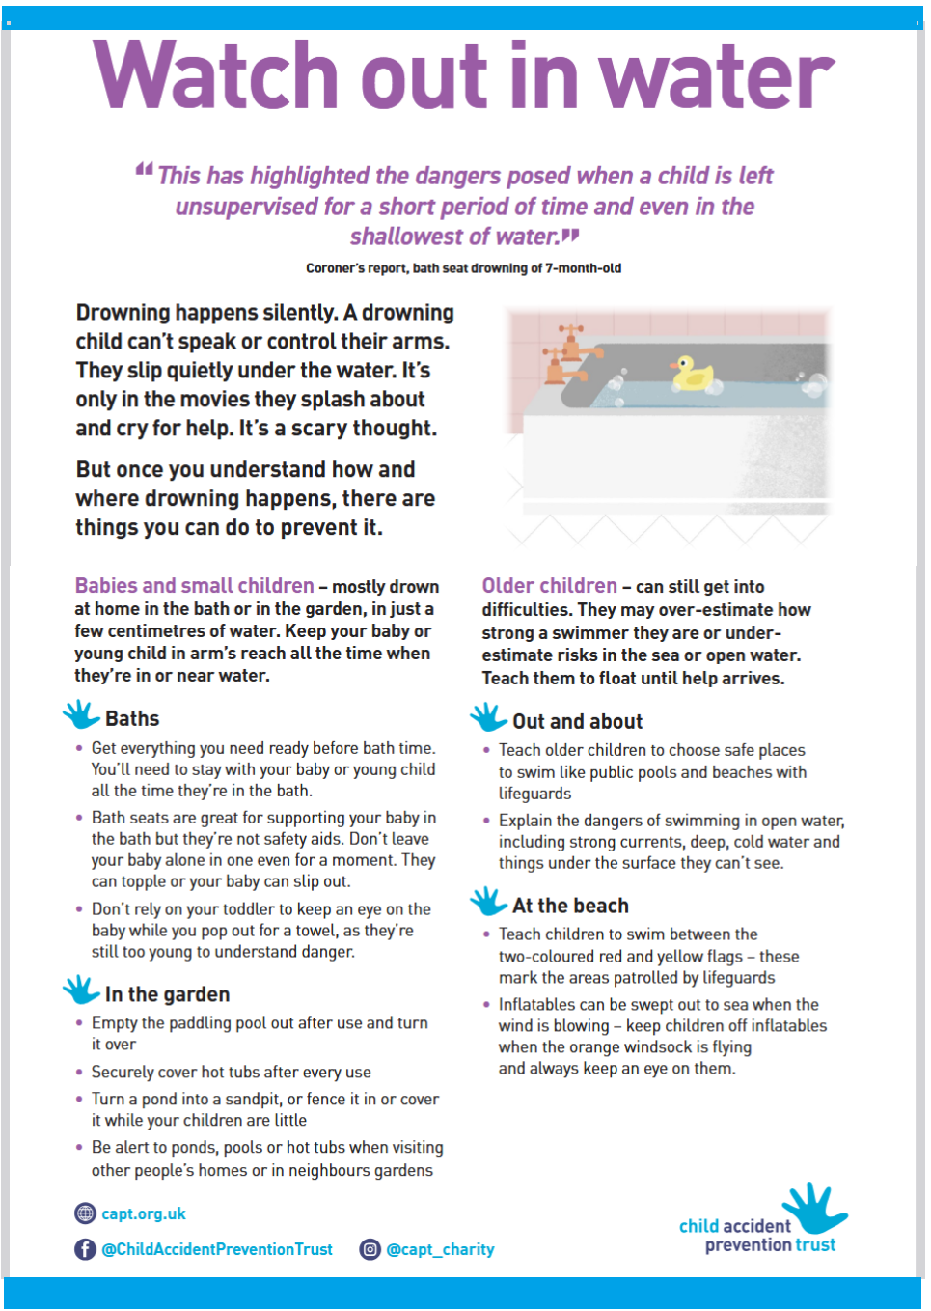

A note from Miss Michelle - (Area Manager)

FUNDING IN OUR SETTINGS

There are various types of funding that we claim, the most common is known as entitlement (Early education entitlement) this is universal and extended.
Universal (15hrs) entitlement is for all three and four year olds and extended (30hrs) entitlement is for working families with 2,3 and 4 year olds that meet the criteria. The criteria for working entitlements are; each parent must be working for at least 16hours per week, earning between the national minimum and not exceeding £100.000.
Parents should apply for a childcare code on the childcare choice’s website www.childcarechoices.gov.uk . From September this entitlement will also be for eligible 9 month- 2 year olds.
There is another type of entitlement known as ‘FRAS’ (families in receipt of additional government support) Parents that are entitled to this funding will be given a code, which will need to be given to the nursery.
All entitlements are from the term after the child’s eligible age. The way in which Greenacres delivers the entitlement is, the 38 weeks claimed, is stretched over 52 weeks per year, which gives 11hrs or 22hrs funded hours per week and not 15hrs or 30hrs term time only. Any fees are then calculated for additional hours. Parents often ask, “when will I get my full 15 hours”? In a day nursery, they already are, as it covers 12 months instead of just the school dates (term time)
Parents are required to complete a parent authorisation form, prove their child’s age and sign a contract, this will have an invoice attached, which will show your free hours and any additional hours. A new form only needs to be done if there is a change to the entitlement of a new academic year. Entitlements can be used with other providers and must be shown on the from.
When applying for working entitlement code, please be aware that eligibility codes must be applied for, before the cut off dates to be able to be used for the following term.
The cut off dates are 31st March, 31st August and 31st December.
Codes must be revalidated regularly to be able to be used. If a parent falls out of eligibility, they can use their grace period to help them to become eligible.
Other types of funding are;
DAF - disability access fund - this is given to the setting for any child that receives disability living allowance.
EYPP - Early years pupil premium - this is for the setting for children from families that are receiving additional support from the government.
EYSIF - for children with additional needs for the setting.
All of these types of funding are to be used in the setting to benefit the individual child, such as new resources, staff training courses and outings.
If you have any questions, please email Tanya or myself on info.greenacres@gmail.com or ask a member of staff.

Please read on for more news and info from your setting.
We hope you find your newsletter interesting and informative.
Don’t forget to let a staff member know if there is something that you would like to add or have covered in a future edition.

Spring/Summer

2025
Edition
Greenacres
Newsletter

Thameside


Thameside - Manager’s Message

What amazing weather we have been having so far!

Mr Steve has been revamping our garden for us, and so far we have a new slide, mud kitchen and water feature!

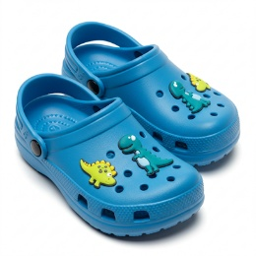

The children love playing with the water each time we visit the garden, so if you could provide a pair of crocs or similar for the children to keep at the nursery to use, we can make sure shoes aren't going home wet.

Dates for your Diaries.

Thameside's Parent Forum is coming up on Tuesday 24th June in the evening.

Book your babysitters and make sure you're free to come and have a look around. It is the perfect opportunity to see what's happening around the nursery, speak to the staff in a more relaxed environment and maybe visit the room that your child will transition into next.

We can't wait to see you there.


Our annual Graduation & Celebration BBQ will be taking place on Saturday 12th July. More details will be available closer to the time but be sure to save the date.

Miss Ellen




Fun in Bears


Messy Play

What do we think about when we hear the word 'messy'?

The word messy is often given negative meanings and calling an important aspect of
play 'messy' can lead to it being undervalued.

Messy play involves:

children using all their senses in the process of exploration, especially the sense of touch offering children plenty of opportunity to mould and manipulate materials, not having a focus on making or producing something.
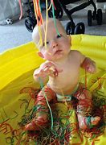
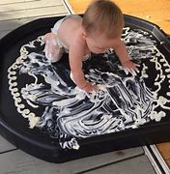
What is messy play for babies?

Messy play describes a group of specific play activities that involve messy materials. These activities encourage babies and children to use their hands, feet, whole bodies and/or certain equipment in order to make a mess (hence the term ‘messy play’!).

8 Messy Play Ideas For Babies For You To Try Out At Home

1. Edible Finger Painting Let’s face it—babies put everything in their mouths! ...
2. Spaghetti Sensory Play Cooked spaghetti is a wonderfully squishy material that babies love to grab,
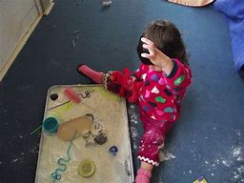
squeeze, and throw! ...
3. Jelly Treasure Hunt ...
4. Cloud Dough Play ...
5. Mud Kitchen Fun (Edible Version!) ...
6. Water Play with Cornflour Goo ...
7. Ice Cube Sensory Play ...
8. Rice or Cereal Digging ...
Your keyworker can give you more info or recipes for cloud dough etc.



Explorers & Discoverers Chat

TRANSITIONS

Transitions are such a big part of nursery life and it’s important that they are managed with care and consistency. At Greenacres the children experience a range of different transitions including the move from downstairs to upstairs, from Explorers into Discoverers, and Discoverers onto school. Each of these different transitions will be unique and handled according to each individual child.

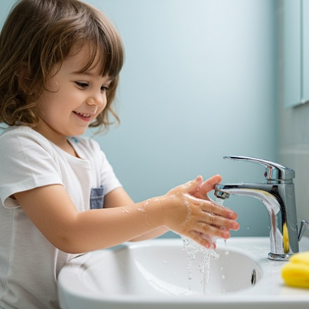
When moving into Explorers from Bears it is important that the younger children are familiar with their new staff members, so we make sure to make regular visits to the Bears room and interact with the children, so that when they come upstairs to their new room, they are already comfortable with their staff members, ensuring a more successful transition period. On the lead up to the transition the Bears staff will start to make changes which will promote the children’s independence, such as drinking from an open top cup, introducing forks for eating, and promoting some more self-care practices such as hand washing and attempting to put on and take off shoes.

Moving to school is a highly significant change for children. It is not just a physical change from one place to another. Children will need to develop attachments and relationships with new adults and peers. At school, there are more children and adults and it is usually a larger space. The new environment will look and operate differently - children will need to adapt to a new daily routine and a shift in focus as more formal teaching and learning is steadily introduced. The move to school can cause some children anxiety and may be stressful for both children and parents. Children’s behaviour and how they relate to others may be affected. They may lose their appetite, lose concentration, become withdrawn or upset/tearful and clingy towards parents/carers. Good communication and development of positive relationships between nursery/pre-school and school is excellent preparation for this transition and can help to ease some of these concerns. In Discoverers we endeavour to make the transition to school as smooth and exciting for the children as possible. We introduce different school uniforms into our role play areas to allow the children to explore their new school clothing. We take the children to visit the school and their new teacher. This allows the children to explore their new school and teachers in a relaxed environment, and allows the nursery key workers to liaise with the teacher about the children’s specific needs. We will also organise lots of activities and events around moving to school in order to make it a fun and exciting transition rather than one filled with anxiety and fear.


It is important to remember that to an adult, some of these transitions may not seem disruptive, but to a child they can cause a lot of anxiety and often changes in behaviour. Speaking to your child about changes regularly in a positive way can help to reduce some of this anxiety. Make sure to liaise with your key worker about any concerns you may have, and speak about what the transition means for your child specifically. Your key worker and other nursery staff will help you in any way to make sure the transition is smooth and effective for both the child and their families.

