2025
Edition
Autumn/Winter
Miss Susan

Greenacres Newsletter

A Note From Miss Susan


Dear Parents,

A Note from Miss Susan . . .
As some of you may have heard, I'm excited to share that we're merging the Hampton Hill nursery children with our Oldfield Road and Thameside sites. I'd like to take a moment to explain the reasoning behind this decision.
The nursery industry is facing challenges in finding quality staff who not only excel in their roles, but also bring passion and enthusiasm to their work. As a result, I've made the difficult decision to consolidate our efforts into two strong settings, rather than spreading ourselves too thin across three locations.
By combining our teams and resources, we'll be able to create two exceptional nurseries that function at the highest level. The close proximity of the Oldfield Road and Thameside sites will allow our teams to work together seamlessly, support each other, and engage in exciting activities and projects.
As we move into the next term, you'll see some of the fantastic plans we've put in place. We'll be sharing extracurricular plans and updates in your newsletters, so stay tuned!
If you'd like to discuss this decision further or learn more about what it means for Greenacres, please don't hesitate to reach out. You can call/text me, send an email, or set up a time for a coffee. Alternatively, you can participate in our "Nursery Officer for a Day" program, where you'll get to work alongside our team and gain a deeper understanding of our work.
I'm looking forward to keeping you all updated as we embark on this new chapter together.

<><><><><><><><><><><><><><><><><><><><><><><><><><><><><><><><><><><><><><><><><><><><>

Nursery Officer For A Day

Why not come and witness first hand, exactly what we do with our curriculums and our days of fun and activity.
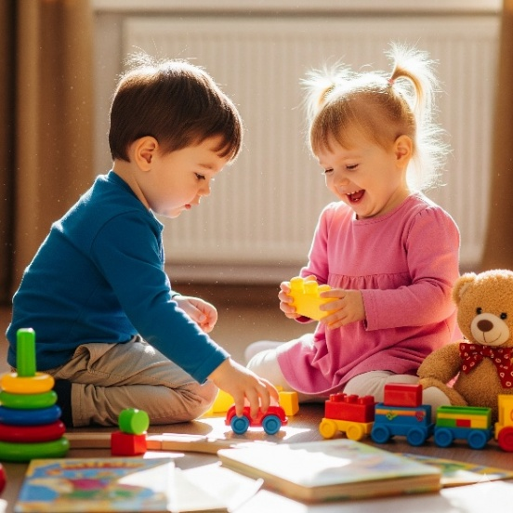
As they say, “If you walked a mile in our shoes” . . . ,
you’d learn so much more about what we do and why we do it.

It is often better to do this on a day or in area when your child isn’t with you, so that you get a chance to really witness and join the activities for yourself.

It’s a great way to meet staff and see how they work, maybe find out
more about the next room that your child is going to move up to, or just understand some of the techniques or behind the scene plans.

Work with us for the morning, then finish with a relaxed lunch with
Miss Susan and your keyworker to discuss your experience.

Forest School

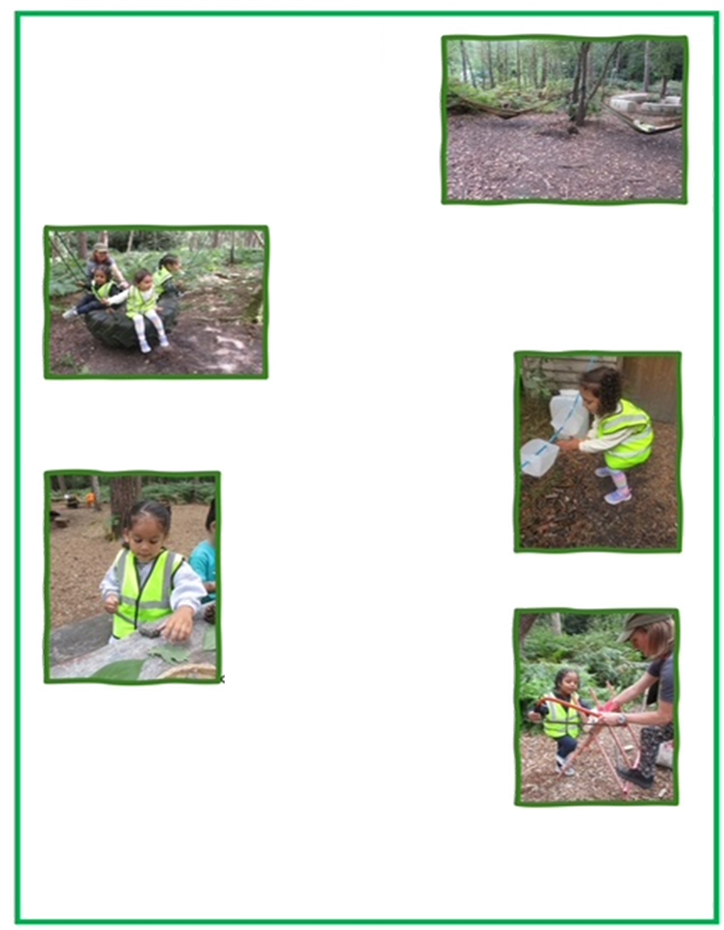
This term all of Greenacres preschoolers will be offered Forest school as an extra-curricular.
We run in 6 week projects and only take small groups so we can maximise their experience. Therefore, please get your forms in quickly so we can make plans.
Lions Preschool have trialled the sessions so we could get a taster of what’s in store. Here’s how they did . . .
Last term Lions took part in a Forest School program initiative that aimed to promote outdoor learning, exploration and adventure.

Through a variety of activities & experiences, our goal was to foster a deeper connection with nature, develop teamwork & problem-solving skills, & encourage creativity and imagination.

We participated in:

- Nature walks, scavenger hunts and exploration.

- Outdoor games and challenges: Building dens, creating obstacle courses and engaging in team-building activities that promote physical activity
and social interaction.

- Crafts and creativity: Using natural materials like leaves, sticks, and rocks to create art, crafts, and storytelling.

- Environmental education:
Learning about weather, growing,
mini-beasts and looking after our
world.

- Team building and collaborating with peers, developing communication skills and building confidence through shared
experiences.

Our Forest School program was
designed to be a fun and an engaging
way for children to learn and grow.
We believe that this experience not only enhanced their learning,
but also promoted their physical and emotional well-being.

We had a lot of fun and laughter through the sessions, in pouring
rain and basking sunshine, learning skills we brought back & used
at nursery, lighting fires, seeing the Monkey tree and collecting as many pinecones as we could hold in our hands.

A huge thanks to Tess from Bushy Tails Forest School for supporting us in this adventure.





How Music Affects Your Child’s Brain

Early brain development is all about building connections through input from the outside world, and music provides a rich and supplementary source of input as young brains develop.
Exposure to music allows young brains to soak in the range of notes, tones, and words they will later use, essentially introducing them to the key elements of music they will build upon, and in doing so, build neural pathways that can influence and enhance cognitive ability for a lifetime.
This process underscores the vital link between music and brain development from the earliest stages.

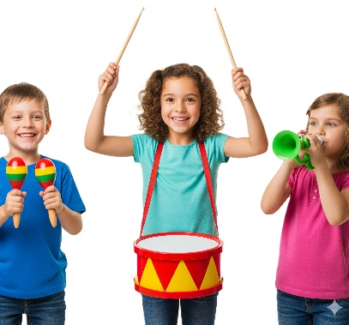
Music builds neural pathways throughout the brain, but especially in the corpus callosum, a band of tissue that connects the two hemispheres of the brain. This, neurologists believe, conveys a whole range of benefits, including increased problem-solving ability and greater emotional resilience.
One theory is that music, particularly playing music, strengthens the connection between a child’s sense of hearing and the brain’s ability to process sounds.
There’s no specific child-development music that will make your children smarter, but there is evidence that learning music has a positive effect on brain development in children.

Music is important in the early years, as it affects children’s intelligence and emotions, and helps them develop their skills, including:

• Early language development
• An increased ability to learn foreign languages
• Improved mood and emotional regulation
• Physical endurance
• Patience and discipline
• Gross and fine motor skills
• Ability to recognize small differences between sounds (auditory discrimination)
• Cooperation and cross-cultural awareness
• Improved memory and concentration
• Self-confidence, self-esteem, and self-expression

There is almost no aspect of human cognition and development that can’t be improved by listening to and learning to play music.
These benefits last well into adulthood and even old age because when a brain builds more neural pathways early on, that brain is better able to retain new information and resist the deterioration of memory.
Exposure to music may influence your child’s behaviour, but perhaps not how you think, because the style of the music may not matter. Exposure to music strengthens the corpus callosum, the tissue that connects the two hemispheres of the brain.
With that connection strengthened, a child will be better equipped to regulate their mood, emotions, and behaviour.


It is important not to underestimate the power of singing to children.
Studies have shown that singing to children prepares their ears, voice, and brain for language. Lullabies, songs and rhymes carry the ‘signature’ melodies and inflexions of a mother tongue. This applies across all cultures and languages, and this prepares a child’s ear, voice and brain for language.

Why is music in the early years important?

By being exposed to music, it improves a child’s cognitive functioning. This is important as it regulates pathways in the brain developed through musical activities that lead to development of language, reading and mathematical skill due to the beat, timing and rhythm. Vocabulary is also developed through music, as music teaches children new word meanings and how words work together to be used in a sentence. This will help with communication skills as children begin to understand the words and sentences, they are exposed to.

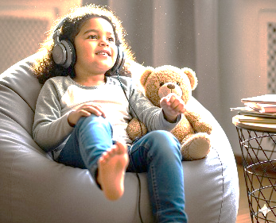
Through listening to music, children can develop both their fine motor skills and gross motor skills, which develops both the smaller and larger muscles.
Playing with different sized instruments, making their own instruments and action rhymes are not only effective for learning, but also for co-ordination, as it develops a child’s sensory skills. Co-ordination is especially important in learning with younger children, as it allows children to have the best possible control over their bodies and develop a strong motor planning of movement.

Communication skills are important for children to develop to prepare them for later life. Exposing babies to music such as singing is an extremely effective way of starting the children’s
learning from the youngest possible age, as it begins to teach them about inflections of the language they will go on to speak.
As a child begins to grow and develop, singing then benefits them in different ways. When singing, it strengthens a child’s lips & therefore encourages clear elocution, whilst continuing
to build their vocabulary. Memory skills are also progressed through the repetitive nature of songs and are important to develop as this gives children information stored long enough to use it and put it into practice.

The structure of songs or rhymes alongside the tune and rhythm make them easy to memorise
and teaches skills that will be relied on during school and their future. Sound patterns are learned through rhyme, poem and song. Sound patterns when heard by a child, teaches them to distinguish various noises from each other, as well as joining and breaking sounds apart.
Sound patterns are practiced by children when rhyming, playing with instruments, singing and practicing syllables. All these features effectively contribute to learning how to read and spell and eventually will benefit a child academically in their writing and mathematics skill.
Overall, exposing a child to music from a young age in all its forms is a recognisable beneficial in supporting their learning and development of academic skill, which will benefit them in later life .

Safety Awareness – Slushies Unsafe for Children Under 7?

Hollie Cole
BBC News - Published 17 July 2025

Children under seven years old should not have shop-bought slushies over health concerns about a chemical they contain, the Food Standards Agency (FSA) has said.

The government watchdog said slushed ice drinks containing glycerol - a type of sweetener - were unsafe for young children, and consumption of them should be limited for children aged between seven and 10.

Most slushies contain naturally occurring glycerol instead of sugar to stop them freezing solid, giving them the slushy effect.

The FSA said consuming large amounts of it can cause side-effects, including headaches and sickness, low blood sugar levels, shock, and loss of consciousness in children.

Prof Robin May, the FSA's chief scientific advisor, said: "While these drinks may seem harmless and side effects are generally mild, they can, especially when consumed in large quantities over a short time, pose serious health risks to young children."

The fresh FSA guidance comes following research indicating children under eight should completely avoid drinking slushies.
It studied the cases of 21 two- to seven-year-olds in the UK and Ireland who needed A&E treatment after becoming acutely ill within an hour of having the drinks, mostly between 2018 and 2024.
The children all recovered and were discharged from hospital.

Dr Duane Mellor from the British Dietetic Association told the BBC that it was "relatively rare" for children to suffer ill side-effects after drinking slushies containing glycerol.

The registered dietician said the "heat of the day", dehydration and a child being excited could "exacerbate" symptoms linked to consuming the drink.
He recommended that children have water or cold milk as alternatives to slushies - or if they want a sweet drink, fruit flavoured water with ice cubes, a diet drink or a low-sugar ice lolly.

The FSA's updated guidance is stricter than its previous advice, which said that under-fives should avoid slushies.

It now also says children aged seven to 10 should have no more than one 350ml slushy drink - "roughly the size of a fizzy drink can" - a day.
"We are asking parents and carers to take extra care when buying drinks for young children, particularly during warmer months when consumption of 'slushies' typically increases," said Prof May.
This guidance also applies to ready-to-drink slushy pouches and make-at-home kits of slushy concentrates.

Please read on for more news and info from your setting.
We hope you find your newsletter interesting and informative.
Don’t forget to let a staff member know if there is something that you would like to add or have covered in a future edition.

Thameside

Greenacres
Newsletter

2025
Edition
Autumn/Winter

A note from Miss Michelle - (Area Manager)

Why are visuals so important in a nursery setting?


At Greenacres we believe that supporting children’s learning with visuals can improve their learning outcomes. Over the years we have worked with many professionals and have put support into place for individual children.

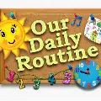
We have seen the benefit of using visuals for all children, not just children with additional needs, as this helps children to know what is coming next and to be able to anticipate changes with less anxiety. We ensure that all visuals are clear and relates to the Childs room and activity. We have various ways in which we support the children’s learning, these are:

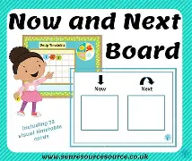
- Visual timetables, our routine in photos.
- Now and next boards, we involve the children in changing these, as the activity changes.
- Visuals on lanyards or keyrings.
- Transition books
- ALD boards (Aided language display)
- Photos in different areas to show children what happens there, or what to do with the resources.
- Children’s name cards with photos on, to help at self-registration time.
- Photos on pegs, to give a sense of belonging
- Use real objects (object of reference)
- We use Makaton to support the children’s language development. This supports the language that we use with signing, some children sign and speak, some sign before they speak.

We always have a move around session before we get the children to sit down, as this helps with their attention.
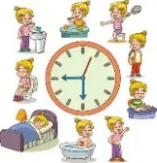

Visuals serve as powerful tools in early childhood education because they align naturally with how young brains develop & process information. They enhance comprehension, language development memory, critical thinking skills, as well as inquisitively, Visual learning enriches experiences for young children, making education not only more accessible but also more engaging & fun.

Early childhood is a critical period for cognitive, social & emotional development. During these years, children absorb vast amounts of information about the world around them. One of the most effective ways to enhance learning during this stage is through the use of visuals, they play a crucial role in improving learning outcomes for young children. But why exactly do visuals have such a powerful impact?

Thameside Manager’s Message

I hope you have all had a lovely summer and enjoyed the events we had recently such as the Graduation. What a lovely way to say goodbye to our school leavers.
We are looking forward to welcoming all the new children over the next few weeks and saying 'Hello' to a few familiar faces too.
As we head towards the last few months of the year, we will be celebrating lots of festivities such as Diwali, Bonfire Night and Christmas. Please let us know if there's anything you can contribute or any others you will be celebrating at home that we can join in with.




Miss Ellen



Christmas Dates for your Diary
At Thameside

Explorers Concert | Discoverers Play | Thameside Parties
Tuesday 9th Dec | Thursday 11th Dec | Wednesday 17th Dec




Fun in Bears
Sensory play

From the moment they're born, children use their senses to discover the world around them.

What is sensory play?
Sensory play is any activity that stimulates our senses – touch, sight, hearing, smell and taste. It helps children interact with and make sense of the world that surrounds them.

When can you start sensory play?
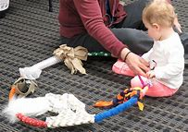
From birth, children are ready for sensory play. Children are natural explorers – they’re constantly learning and taking in what’s around them.
Sensory activities can be adapted for different ages, needs and abilities.
You can easily adapt a simple sensory activity like blowing bubbles for different children at different stages and abilities, for example:
Babies might enjoy feeling the bubbles pop on their skin.
Toddlers can chase after bubbles and pop them on themselves, the floor, and surfaces around them.

Why is sensory play important?
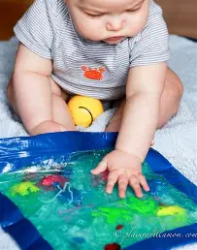
Sensory play plays an important role in a child’s learning and development. Much of our learning comes through our ability to use our senses to retain information.
Sensory play is a lot of fun. It also offers many benefits for child development, including:
Helping children understand how their actions affect what’s around them.
Supporting brain development, enhancing memory, complex tasks and problem solving.
Developing fine motor skills through tactile play (useful when children want to hold a pen or use scissors for example).
Supporting language development, communication and social skills.
Enhancing memory and observational skills.
Encouraging creative and independent thinking.
Emotional regulation by providing a calming effect on children’s angry or anxious feelings.

What sensory play activities can parents do at home?
Sensory play activities can be as simple or complex as you’d like. They can often be set up with items you already have at home. There’s something to explore and wonder at in every home.
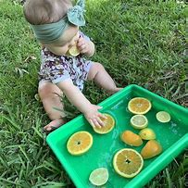
Here are some activities to try:

Playing with food
Encourage play through squishing, smearing, and tasting food.
This allows children to become comfortable with a variety of textures and flavours.

Sensory bottles
Fill a bottle with water, oil and food colouring for an exciting visual effect.

Sensory bin
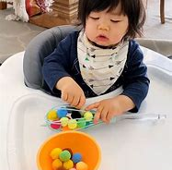
In a box, or container, place various objects with a variety of textures for a hands-on experience for children. This could be beads, paper, kinetic sand and water or leaves, rocks and sand.

Homemade musical instruments
Create a variety of sounds and songs using pots/pans/spoons.
You could fill a bottle with rice or dried pasta/beans to create maracas.


Explorers Chat

Building positive relationships in early childhood

A massive welcome to the children who have transitioned into Explorers room from Bears and also Hampton Hill branch.

The children have enjoyed exploring their new environment and also meeting their new peers.

Building positive relationships in early childhood is crucial for children's social and emotional development

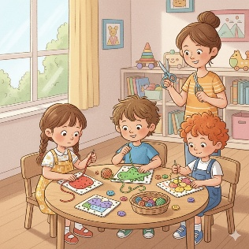
and also the child’s communication skills.

Here are a few tips on developing your child’s social skills –

· Small group activities based on your child’s interests

· Planning play dates outside of nursery setting

· Supporting children in working as a team to achieve a task together

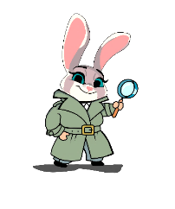
<><><><><><><><><><><><><><><><><><><><><><><><><><><><><><><><><><><><><><><><><><><><>
Discoverers Chat

Forest School Fun!

This term a lot more of our pre-school children have taken part in our Forest School extracurricular.

This is a great opportunity for them to learn new skills and have experiences they may not have access to in a normal nursery setting. Skills such as sawing, working together, crafting, hammering, fire building and so much more helps to teach the children how to take safe risks, and adopt skills for life in a calming and natural environment.

Forest school aids young children’s development in a variety of ways for example…

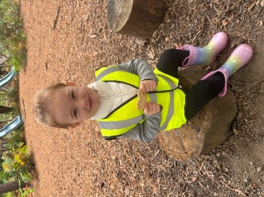
Physical Development: Outdoor environments provide endless opportunities for movement, climbing, balance, and building, which are crucial for gross and fine motor skills development.

Emotional Well-being and Confidence: Spending time in nature has been linked to reduced stress and anxiety, fostering emotional resilience and self-esteem.

Social Skills and Teamwork: Children learn to work together during Forest School activities, developing communication, negotiation, and teamwork skills.
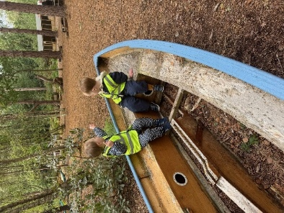
Creativity and Imagination: Natural objects used in Forest School settings encourage children to use their creativity, such as making a magic wand or dragon's nest. These benefits contribute to a holistic development of children, preparing them for future challenges and fostering a love for the natural world.

Forest school is an amazing opportunity for all to experience, and all of the children have thoroughly enjoyed their experiences so far, so look out for the extracurricular forms for the upcoming terms!

