**Student Budget Worksheet**

As a student, it’s important to manage your money. Paying close attention to where your money is going will help you identify places to cut back or make smarter choices

**5 Money Management Tips**

Managing money can seem overwhelming. Especially when you’re in college, and the thought of even checking in on your funds might make you cringe. But effective money-management isn’t difficult, and it can seriously reduce the amount of stress you have when it comes to your finances.

**Check out these tips to keep your finances in check:**

**1.** **Create a Savings Goal and Track Your Progress.** Saving money, in general, might not sound exciting, but what if you had a goal in mind to motivate you? Let’s say you want to buy a new laptop. Figure out how much money you want to put aside each month until you’re able to make this purchase, and make sure to track your progress along the way. Forming healthy savings habits like this will help you stay away from wasteful spending, and it gives you a good reason to keep track of your funds.

**2. Wait 48 Hours Before Making a Purchase**. Do you ever go into a store with one thing on your shopping list, only to leave with a full cart? Those impulse purchases can really get the best of you. Next time you eye something new that you want, wait 48 hours before you actually make the purchase. If the impulse passes, so should you.

**3. Check For Student Discounts and Promo Codes Before Swiping Your Card**. You waited 48 hours instead of impulse buying, but this purchase is still at the front of your mind. Is it time to swipe your card? Not yet. First, check and see if the retailer offers any student discounts. Many businesses offer lower prices if you’re able to present a valid student ID. You should also check out if there are any valid coupons or promo codes you can redeem. Sites like RetailMeNot and Rakuten, or Chrome extensions like Honey, can help you find the best deals.

**4. Look at Your Banking Statements and See Where You’re Spending Money**. Food? Coffee? Late fees? New clothes? One of the easiest ways to manage your money is to first recognize where you’re doing most of your spending. Then, you can consciously make an effort to cut down on these expenses.

**5. Start an Emergency Fund.** Let’s say you finally purchased that laptop you created a savings goal for. The very next day, your car breaks down, and it’s going to cost you a big sum of money for repairs. Ouch! Unexpected expenses like this happen, but it’ll lessen the blow a bit if you’ve prepared for these situations ahead of time. Start putting aside a little bit of money each month that you’ll only touch when situations like these arise. You’ll rest easily knowing you always have this fund as a safety net.

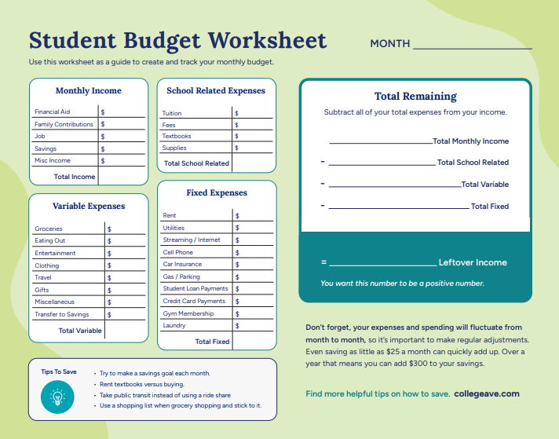 **Do You Have a Credit Report?**

**Under The Age of 18, with a Few Exceptions, GENERALLY Do Not Have Credit Reports**

[Credit reporting companies](https://www.consumerfinance.gov/ask-cfpb/what-is-a-credit-reporting-company-en-1251/) create and maintain credit files with information about consumers, including experiences with credit.  This information includes how often you make your payments on time, how much credit you have, how much credit you have available, how much credit you are using, and whether a debt or bill collector is collecting on money you owe.

It is rare for these companies to maintain a credit file about a child. However, sometimes a minor child can have a file if:

* A consumer with a similar name as your minor child obtained credit and a credit reporting company erroneously created a credit file for your minor child.
* An identity thief obtained a loan in your minor child’s name and a credit reporting company created a credit file with information about payment experience on the loan.
* Your minor child is an authorized user of your credit card, or someone else’s.

Credit reporting companies will not generate a credit report when they know that the information concerns a child.  In other words, if a file about your child exists then a credit report should not be created or provided to anyone requesting the information until your child turns 18. However, you may request all the information in your child’s credit files from the credit reporting companies if you provide documents showing you are the child’s legal guardian. It’s important to review and correct errors in the file now. The information in the file could become visible when your child turns 18 or could be visible now if a credit reporting company has an incorrect date of birth associated with the information.

If you notice specific red flags such as receiving bills, credit card offers, or debt collection calls in your child’s name, you may want to check if your minor child has a credit file because of an error or identity theft. Identity thieves may attempt, for example, to take out loans using children’s Social Security numbers because children have no credit blemishes and because the thief’s fraudulent activity may go undetected for years.

**How To Protect My Financial Future: Free Security Freezes**

Under a federal law effective September 21, 2018, you can freeze and unfreeze your credit record for free at the three nationwide credit reporting companies – Experian, TransUnion, and Equifax. The federal law requiring free security freezes does not apply to someone who requests your credit report for employment, tenant-screening, or insurance purposes. You can place a "freeze" on your credit file at any time, but you must contact each credit reporting company. For more information, visit the nationwide credit reporting companies' websites or call the numbers below:

* Equifax: [Take control of your Equifax® credit report](https://www.equifax.com/personal/credit-report-services/credit-freeze/), (800) 685-1111
* Experian: [Security Freeze](http://www.experian.com/consumer/security_freeze.html), (888) 397-3742
* TransUnion: [Credit Help,](https://www.transunion.com/credit-help)(888) 909-8872

**Q & A For Federal Trade Commission:** <https://www.consumerfinance.gov/ask-cfpb/what-does-it-mean-to-put-a-security-freeze-on-my-credit->