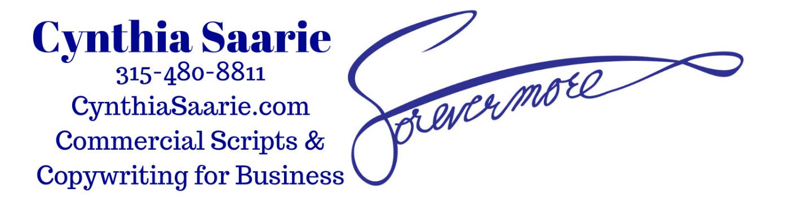

Cynthia JE Saarie, owner - ForevermoreOnline, LLC.
Professional Copywriting Services
Phoenix, NY 13135
https://CynthiaSaarie.com
Cynthia@CynthiaSaarie.com
315-480-8811
NYS, WBE, SBA, Gov’t. SAM, and UN certified, registered, vetted, insured
Dun’s #: 117179089
NAICS #: 711510
CAGE #: 8DSQ0
Accepting Credit Cards, certified checks, and PayPal

Specializing in Commercial Script Copywriting for Businesses.
Copy designed to get and keep your customer's attention.

• Short and to the point copy
• The Most Bang for your buck

Other written forms of copy for your business:

• White paper case studies and client or company testimonials
• E-booklets (5+ - 20+ pages) including colorful 3D book covers
• Video production, and Video sales letter scripts
• Articles, newsletters, blogs, tag lines
• Banners, Content material for websites
• PowerPoint presentations, converted
into videos with music, animations, voiceover, and text
• Scripts and text for videos showcasing your company
• Webinars, sermons, and podcasts
• B2B / B2C Sales Copy

A working professional Voiceover Artist, Author, Soprano Vocalist;

- Understanding rhythmic cadence of words and the phrasing of sentences
- Published award-winning author - knowing the power words create
- Certified practicing Lay Speaker for the United Methodist Church
(A Substitute for pastors that are out sick or on vacation)
- Decades of experience speaking and singing to an audience

First Steps: Businesses that want to be seen must have a planned strategy of supplying information – one promotion at a time to the customer audience they want to reach;

• A Scripted campaign that builds from ONE idea to the next
• Keeping the momentum going for your whole product's campaign
• Time and cooperation with your design, video team, production crew, voiceover artists, and my time as your copywriter
• Details must be mapped out and a timeframe set up
• Making all deadlines with completed work

A Smile is a Universal Hello. (Original slogan/tagline)
Let's Chat and bring Your Company into the Spotlight.

Cynthia Saarie
315-480-8811
Cynthia@CynthiaSaarie.com

The Details:

Certified/Vetted Business - Women-Owned Business Enterprise (WBE)
Certified/Vetted through NYS, United Nations, SAM- Government Contracts
Certified/Vetted through the Small Business Administration Service
ForevermoreOnline, LLC. is a registered/trademarked business in the USA.
Insured and Authorized to work in the US for any employer
No sponsorship required, US citizen
Not a Veteran
Not Disabled
Female
White

Work History-

ForevermoreOnline, LLC.
Professional Copywriting Services
Licensed/Vetted/Insured
Owner (1989- present)
Copywriting, Voiceover, Vocals, Videos, Lay Speaking for Churches
315-480-8811

Phoenix, New York - United States Postal Service.
Sales and Service Senior Window Clerk, retired (30 years: 1/87 to 1/17)
Steve McAllister, Postmaster (315)6953261
99 Jefferson St. Phoenix, NY 13135-9998

The United Methodist Church
District Superintendent, Rev. Nola Anderson
7481 Henry Clay Blvd. Liverpool, NY 13088
315-8982029 – Anne Hutchins, secretary for Rev. Anderson
Lay Speaker (2013- present)
Certified to lead churches in the USA

Education:

- American Writers and Artists - verified Professional Copywriter (2016)
certified: B2B, B2C, Video Script Writing, Sales Letters, Commercial Copy
- Osteo Bone Builder Instructor- Tufts Medical University (2017)
Instructor of Senior citizen weight training
Pat Thayer - senior instructor, (315)6953944
- Oswego SUNY – Psychology (2011)
- Cayuga Community College – English (2012)
- Voice Coaches of Albany, NY – Certified Voice Actor (2014)
- Syracuse Oratorio Society, Syracuse University- Certified Soprano Vocalist (2017)
- The United Methodist Church (2013) Certified Lay Speaker
Upper NY District Superintendent, Rev. Nola Anderson (607)2671995

Organization Memberships:

Writing member:
Circle of Success, Titanides, Infinity,
Professional Writer's Alliance, AdHub

Vocal:
VoiceBox1, American Music Channel

Testimonials:

- Tali Icepack Jackson, Producer, Drummer, Promoter:
"Cynthia is a talented vocalist, voiceover artist, and copywriter of scripts for tv and radio commercials.
As a professional performer myself, I look for other talents in this world to connect with and find a way to bring these other talents along. Cynthia has my recommendation to write copy for all commercial needs. She is a pleasure to work with."

- Noah St. John, I teach The Power Habits® that improve productivity, reduce costs, and build a stronger company culture.
If you’re ready to take your life and business to higher levels and sustain continuous growth, then you must work with my friend, Cynthia. She has the unique ability to connect on a level that instantly changes people’s lives. And, the best thing is that Cynthia comes from the heart and truly cares about making a positive difference in the lives of others! Do yourself a favor and work with Cynthia today! You’ll be grateful you did!

- Angelina Hilton, founder of Christian Marketing Company E-Zine:
"I was in search of guest bloggers who share similar values and Cynthia reached out. I really
appreciated her thoroughness, her quick turnaround time, and the blog she wrote on SEO. I
recommend her services for anyone seeking a high level of professionalism."

- Betty Glaz - Betty Glaz Copywriting Services:
"Very creative and gets the job done, usually before the deadline. I am glad to recommend Cynthia"

- Walker Bennett - Cydonia Publishing:
"Innovative and highly creative operation."

- Peter Clegg, President/CEO - JustRight International Inc.:
"Highly Recommended, 'EXCELLENT'"

Cynthia Saarie's Samples:

My samples are on my website under the Samples page.

