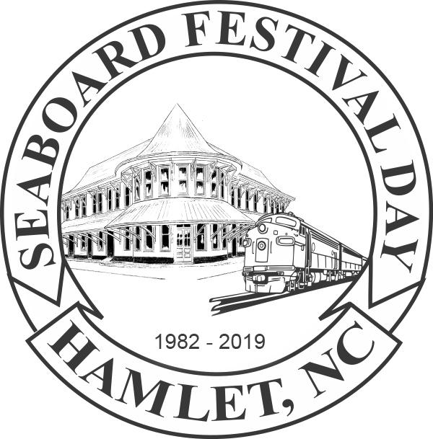**2021 Seaboard Festival Day Application**

**Commercial & Non-Profit Food Vendors**

Saturday, October 30, 2021, 9am-5pm

P.O. Box 132 Hamlet, NC 28345

(910)557-5570 (Leave Message)

Website: [www.seaboardfestival.com](http://www.seaboardfestival.com) Email:[info@seaboardfestival.com](mailto:info@seaboardfestival.com)

Name of Organization/Business: ___________________________________________________________

Contact Person: _______________________________________ Phone: ___________________________

Address: ______________________________________________________________________________

City: __________________________________________State: __________ Zip: ____________________

Email: ________________________________________________________________________________

Web Page: _________________________________________ Facebook: __________________________

Booth size is 16’ wide x 12’ deep

* Commercial Food Booth (limit 2 spaces) $200 # of spaces ____ $____________
* Non-Profit Food Booth (limit 1 space) $ 100 # of spaces _1__ $ ____________

Electricity (110/15 amp service) $25 $ ____________

Water (limited availability) Total $ ____________

**Make checks payable to: Seaboard Festival Day, Inc. ($30 returned check fee)**

**Include late fee of $25 if postmarked after June 1, 2021**

Please list your general menu including prices or submit a menu.

______________________________________________________________________________________________________________________________________________________________________________________________________________________________________________________________________________

Special requests: (We will try to accommodate requests)

____________________________________________________________________________________________________________________________________________________________________________________

**__________________________________________________________________________________________**

**Festival Use Only:**

**Date Received: __________________ Space #: _______________ Check #: ______________________**