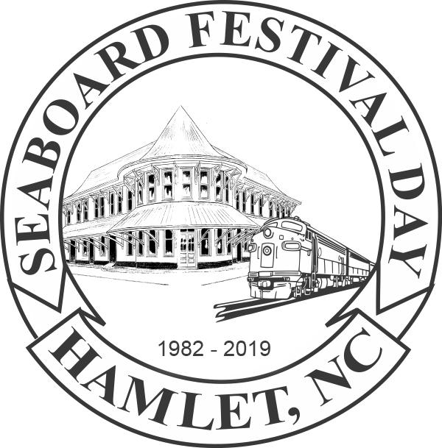
Seaboard Festival Day Craft Vendor Rules and Information
Saturday, October 30, 2021, 9am to 5pm
Main Street, Hamlet, NC 28345
(910)557-5570 (Leave Message)
Website: www.seaboardfestival.com Email: info@seaboardfestival.com

Booth Information: Booths are 16’w x 12’d. Booth set up begins at 6am. Festival Directors will be on each block to assist vendors with space location. All vehicles must be off the street and vendors unpacked by 8:30am. Booths must be in operation from 9am until 5pm and the street cleared as soon as possible. Any vendor on the street after 6:30 will incur fines starting at $100 per 15 minutes and/or be rejected from future festivals.
The above policy will be strictly enforced.
Festival Space Assignments: We do our best to accommodate every space assignment request but we never guarantee the same space or a particular space from year to year. Most often, the decision to move a vendor or deny a request is out of necessity for safety reasons, better exposure, or a change in traffic flow. Craft vendor assignments are based on paid application date and proximity to a similar product. Hint: Don’t wait. Register early for the best spot.
As a Courtesy to Others: We are excited to have you join us. Our festival is a free, family friendly event. Please help us keep that spirit alive by treating all of those around you with honor, dignity and respect. We also expect you to be treated well while at our Festival. All rulings by the Seaboard Festival Board are final.
When Unforeseen Issues Arise: In case of rain, unfortunately we all get wet together. The Seaboard Festival is a rain or shine event.
Space Assignment Information: You will receive your space assignment and street map in the mail prior to the festival at some point in October.
Vendor Responsibility: Vendors are responsible for their own tent, tables, chairs, signage and personal garbage receptacle. If you purchased power hook up, you are responsible for your own power cords. We do not provide power cords. All drop cords must have ground strips and must meet approval on-site.
We are excited to have you with us and welcome to the 39th Annual Seaboard Festival!

Seaboard Festival FAQ
What type of vendor am I?
Craft Booths feature products that are made by or partially made by hand. You must make the item, decorate the item, or otherwise improve the item. While there are many different levels of crafters, taking a product out of a box or purchasing “hand make items” does not qualify as crafting. If you did not make it or make it better, you are not eligible for a craft space.
If you are a new craft vendor, please provide photos so that we may make a proper determination regarding your craft. For our new vendors, photos will also allow us to place you away from a similar product. You have the option to mail or email your photos.
Commercial Sales Booths feature merchandise that is not hand made by the person who owns, operates or reserves the booth. These booths sell products that are commercially made. Any commercial product requesting a craft booth will be denied. Past attendance does not guarantee automatic acceptance into the upcoming festival.
Information Only Booths are reserved for civic groups, clubs, churches and non-profits who will provide information about their group or organization. You may not sell crafts or foods. Information only booths may give out informational literature or gifts.
Food Booths: The only food vendors that will be allowed non-profit status MUST possess a 501c
In general, a commercial business will not qualify as an Information only applicant. Business vendors that sell a product or service to residential or commercial customers are considered commercial vendors. Examples of commercial services would include but are not limited to construction or home improvement services, health/fitness/medical related services and real estate services.
The Seaboard Festival celebrates heritage/handcrafts/cultural arts. Craft vendors occupy the largest majority of our vendor spaces. Information spaces are limited and in high demand.
Additional Information
The deadline for all craft, commercial, and information booth applications is Sep 1, 2021.
The deadline for all commercial and non-profit food vendor applications is June 1, 2021.
The Seaboard Festival reserves the right to ask a vendor to discontinue the sale of an inappropriate item on Festival Day.
The Seaboard Festival reserves the right to take immediate action in any situation where equipment, including electrical appliances and extension cords, appear to be substandard or unsafe. The action ranges from asking the vendor to discontinue using the problem equipment to shutting down a vendor’s operations for the remainder of the day. A refund will not be issued if this occurs.

