4Legs4Justice
Animal Advocate and Rescue

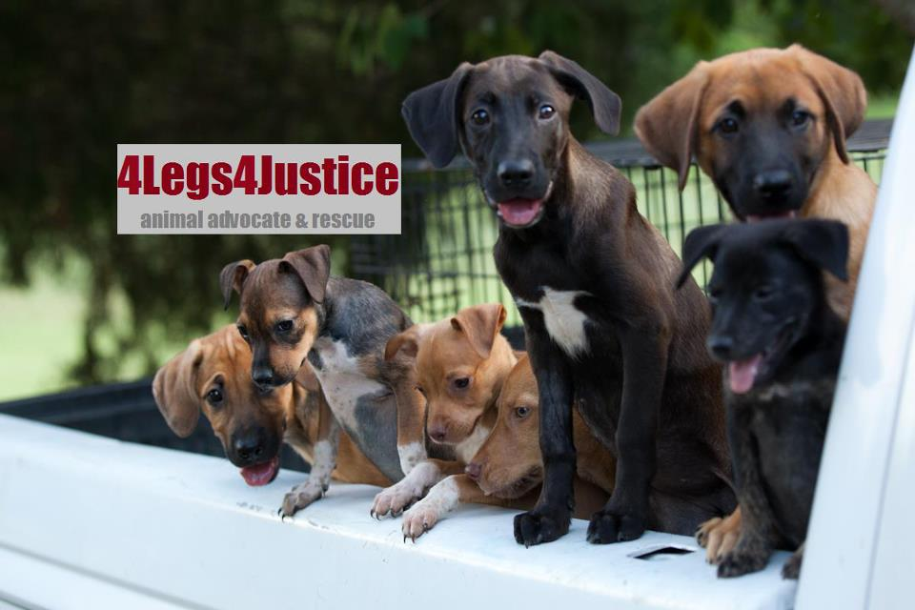
Website: www.4Legs4Justice.org
Facebook Page: www.facebook.com/4Legs4Justice
Email: 4Legs4Justice@gmail.com
Contact persons: Lindsay Ghee, Taylor Freeman, Brenda Ghee,& Cally Donahue
Location: Anniston, Alabama, USA

DOG ADOPTION CONTRACT/AGREEMENT
4Legs4Justice Animal Advocate and Rescue, (the “Charity/Rescue/we/us”), an Alabama 501 (c) (3) non-profit corporation, and the undersigned (the “Adopter” or “you”), in consideration of the mutual covenants in this Agreement and other good and valuable consideration, intending to be legally bound by this Agreement, agree to the following:

1. The Dog: We are placing the following described dog/puppy with you, the Adopter, for the adoption by you as a companion dog and family member:
Name________________ M__ F__ (Hereinafter ADOPTEE or Dog)
Breed/Mix/Color/Markings______________________________________
Date:__________________

2. Adoption Donation: To assist us in continuing our rescue work, Adopter agrees to make a non-refundable donation of at least $300.00 and if the dog is a graduate from our dog training program a non-refundable donation of $500.00. The adopter understands that if they had to pay out of pocket for of this dog training outside our rescue work it would have cost them $2100.00. We do not distinguish between adult dogs and puppies, or between pure breeds and mixes. This donation is immediately used to pay the ongoing costs of rescuing stray and shelter animals, including food, veterinary care, kenneling costs, behavior training, etc.

3. Spay/Neuter: If this Dog has not been sterilized prior to this adoption due to age or physical condition, you agree to enter into a Sterilization Agreement with us to have the Dog spayed or neutered in accordance with the Sterilization Agreement.

4. Care of the Dog: You agree that this Dog is being adopted as a family member and will be given extensive house privileges; i.e. sleep inside the house, be allowed freedom of the house when the family is home, and will NOT be restricted to the yard at any time. You agree to provide the Dog with fresh water, wholesome dog food, adequate outdoor exercise, affection and shelter. You also agree that the Dog will not be used as a guard animal, or for any purpose other than as a companion and friend to you and your family. No alteration to the animal’s appearance is permitted (i.e. docking of tails, ears).

5. Veterinary Care: The Dog will be examined by your licensed veterinarian within 10 days after adoption and will be provided with medical treatment as needed. You agree to keep all vaccinations current including but not limited to Rabies, Distemper/Parvo (DHLPP), Bordetella, AND to ensure the Dog receives preventative medication to protect against heartworm if necessary. You agree to provide the best available care to the Dog in a timely manner. Any veterinary problems that may arise, including serious illness requiring emergency care or surgery is your responsibility and you are responsible for all related costs.
NOTE:::We follow a THREE year protocol for Rabies nad DHLLP(Parvo) vaccines. Which means that one year after their first adult booster, they’ll have rabies & DHLLP in a “3 year” which lasts for THREE years, so every shots after will be administered every THREE years. Not annually.
The “1 year” and the “3 year” dosage is the EXACT same. It’s just up to your vet’s protocol’s documentation ☺

6. Behavioral Issues (i.e. biting, destruction, escapism, fearfulness, dominance) that might lead to abandonment of the animal: Adopter agrees to contact the obedience trainer as well as 4Legs4Justice to follow the recommendation in resolving any issues as an effort to maintain custody of the adopted animal.

7. Safe Environment: Where applicable, adopter will provide a secure fenced yard, with ample room for outdoor exercise. If fencing needs repair or modification in order to ensure the safety and well-being of the Dog, you agree to make any necessary repairs prior to allowing Adoptee access to the yard. You agree to maintain the security of the fencing in the future to further secure the Dog. Adopter understands that gardeners, pool men, contractors and utility workers are not responsible for the safety of the Dog, therefore adoptee must be kept indoors when workmen have access to the yard.
NOTE: Many dogs are sensitive and scared of loud noises, and you hereby agree to keep the adoptee indoors or in a safe and secure environment on holidays such as July 4th and New Years Eve.

8. Identification: You agree that the Dog WILL ALWAYS be wearing an identification tag with two current telephone numbers plus the 4Legs4Justice ID tag.

9. Leash/Collar Etc: You will walk the dog on a leash when on public streets or in parks or other unfenced areas, and will never allow the Dog to roam free unsupervised. The Dog will be walked using a slip or choke collar, pinch collar or harness, and will not be walked with the leash attached to the Dog’s identification tag. Adopter understands that the identification tag is not a secure restraint. Also, the Dog will NEVER be tied up on your property or elsewhere. Adopter understands that restraining a dog by tying it to a fixed post or wire run is unsafe and may cause theft of the Dog, unpredictable behavior and random aggression. You will not leave the dog crated and/or otherwise confined for extended periods of time (more than 5 hours).

10. Transportation: The Dog will be properly position and/or restrained, preferably using either a secured crate or seat harness when transported in any vehicle. Adoptee will NEVER be transported in the back of an open vehicle or pick-up truck. Adoptee will not be allowed to ride with his/her head outside the window of a moving vehicle without being secured.

11. Lost Dog: You agree to make an immediate and serious effort to find the Dog if it becomes lost, by (a) filing lost reports with the local police, animal control authorities (at least within 30 miles radius), animal shelters (at least within 30 miles radius), and local veterinarians and pet stores, (b) post lost dog signs (c) place lost dog ads in your local paper (d) contact us for additional support and advice. Preferred optional effort: to register the dog on www.fidofinder.com and/or www.lostfoundpets.us and/or www.petamberalert.com and/or similar website. Furthermore, Adopter understands that if the loss was the result of negligence or failure to comply with the covenants of this Agreement, 4Legs4Justice reserves the right not to return the Dog and to place adoptee into a new home. You must report to us that the dog is missing, so that we may help find him/her too.

12. No Right to Transfer: If at any time in the future you cannot continue to provide proper care for the Dog, you will not abandon, give or sell the Dog to another person, company, organization, medical research, pound or animal shelter. You agree to do one or more of the following:
A. Obtain approval from 4Legs4Justice to transfer the ownership of the Dog to a friend or relative. Rescue must approve the new adopter who will be required to sign an agreement similar to this one.

B. Agree to cover the costs to board Adoptee for an agreed-upon time, allowing Rescue to actively seek a new home and then relinquish the Dog to Rescue when a home is found. Note: Boarding costs are $25 to $30 per day.

C. Return Adoptee to Rescue.

13. Return Policy: If Adopter decided to not keep the Dog, Adopter hereby agrees to return the Adoptee to Rescue. Importantly, Adopter agrees to give Rescue a minimum of 5 working days to secure a kennel, and will provide safe and loving care of the Dog until it is returned. _____(Adopter Initial). Adopter agrees to safely transport the Dog to the determined kennel or veterinarian facility, and will return any/all paperwork and supplies provided by Rescue at that time.

14. Euthanasia: You agree that you may not euthanize the Dog except in the case of the Dog’s terminal illness or injury, or old age accompanied by pain and suffering and in that case, the euthanasia must be performed by a licensed veterinarian.

15. Change of Contact Info: You will notify 4Legs4Justice of all changes of address and/or telephone within 30 days after the change. Communications should be mailed to: 4Legs4Justice, P.O. Box 848, Anniston, AL 36202. And to our email: 4Legs4Justice@gmail.com

16. Estate Provisions: Adopter agrees to provide for care of the Dog in their will or estate if by no other means than specifying in writing to personal representative that Adoptee is to be returned to 4Legs4Justice Animal Advocate and Rescue in the event of Adopter’s death.

17. Follow Up: Adopter understands and agrees that 4Legs4Justice is fully entitled to make follow-up visits or phone calls to ascertain that all of the covenants and clauses of this agreement are being satisfied. Adopter is obligated to cooperate with Rescue.

18. Certified Trained Dogs: If adopted dog has been through dog training provided by the Rescue, the Adopter understands that this dog has been completely obedience trained by certified/qualified persons. In order to maintain the training, I/We understand that we must return to K9s only for a minimum of 3 follow-up sessions within 3 months of the adoption date. Follow-up sessions for learned commands are given free of charge at an authorized location for as long as the owner has the dog(s), once required follow-ups have been completed.

Right to Reclaim: Adopter understands and agrees that Rescue reserves the right to reclaim adoptee if any of the above conditions are not met to the satisfaction of Rescue. Adopter further understands and agrees that any expenses incurred by Rescue in exercising its rights under this provision will be paid by Adopter in addition to any liquidated damages required by other provisions of this Agreement.

No Warrantee: Rescue makes no warranty as to the temperament or physical condition of the Adoptee. The Adoptee is being adopted as is.

Special Disclaimer: All warranties with regard to Adoptee, including any implied
warranty of merchantability and fitness for a particular purpose, where they are
applicable, are hereby specifically disclaimed.

Release & Indemnification/No Liability: Adopter hereby releases 4Legs4Justice Animal Advocate and Rescue (the “Charity/Rescue/we/us,” Lindsay Ghee, Taylor Freeman, Brenda Ghee, and Cally Donahue, and all affiliates, volunteers, veterinarians, &/or board/team members of 4Legs4Justice), from any and all liability for personal injury, property damage, legal fees, or veterinary care, or any other expense or liability incurred by Adopter as a result of this adoption. Adopter agrees to indemnify 4Legs4Justice from any and all such claims and to pay, without limitation, any costs related to such injury, damage, or liability, including, in the case of litigation, any attorney’s fees incurred by 4Legs4Justice in its defense.

Breach of Agreement/Liquidated Damages. In the event that you do not comply with the terms of this Agreement, or the Dog is abused or neglected, we hold the right to recover the Dog from you upon demand, and the Dog will be surrendered to us immediately. In addition, without waiving any of our rights under this Agreement, if you do not surrender the Dog to us, you will owe us a payment in the amount of $2,500 agreed between us as just and reasonable liquidated damages to compensate us for our costs and expenses in connection with your breach of this Agreement and we reserve our rights to reacquire the Dog.

Entire Agreement/Modification/Binding Effect: This Agreement (including the
attached Voluntary Release/Waiver of Liability) is the entire agreement between you and us, and supersedes any prior understandings between you and us with respect to the subject matter of this agreement. No modification of this Agreement will be valid unless in writing duly signed by both you and us. This Agreement is binding upon you and your heirs, assigns, successors, personal representatives and executors.

Dated:________________

BY ADOPTER: | By 4Legs4Justice:
Signed & Agreed: | Signed:
Print Name: | Print Name:
Drivers License # | Title:
Street Address: | Contact #:
City/State/Zip:

Home Phone:

Work and/or Cell #s:

E-Mail:

Emergency Contact/Friend or Relative that does NOT live with you:
Name and number:_________________________________________________

4Legs4Justice Optional Care Provision

In effect if checked, Adoptee please read and initial:

Special Behavioral Needs: Adopter understands that if the Dog has special behavioral issues that have been described to them by Rescue and agrees to complete obedience training class ______(initial)

Unenclosed Pools/Spas: Adopter understands that their unenclosed pool or spa may represent a deadly hazard to the Dog and agrees not to give the Adoptee unaccompanied access to the pool or spa until after Adoptee has been trained to safely exit the pool or spa _____(initial)

Supervision with Children: Adopter understands that the Dog may not be kept or left home alone with children and hereby states that the dog will never be left unsupervised with a child of any age under the age of 14 _____(initial)

Predators: Adopter understands that the Dog is a small dog, especially vulnerable to predators, such as hawks, owls, coyotes, etc., therefore agrees that the Dog will never be left outdoors unaccompanied by you or a member of your family _____(initial)

Sensitive to Loud Sounds: This dog is sensitive and scared of loud noises, and you hereby agree to keep the Adoptee indoors or in a safe and secure environment on holidays such as July 4th , New Year’s Eve, etc. _____(initial)

(circled if applicable) Escape Artist: This dog has proved to Rescue that it can jump a ____foot fence. It will never be left alone in a yard unsupervised _____(initial)

(circled if applicable) Possessive of Food: This dog has exhibited behavior of protecting its food. The adoptee agrees to feed it separate from all other animals in the home and be careful of taking food away from dog while eating_____(initial)

VOLUNTARY RELEASE / WAIVER OF LIABILITY

This Voluntary Release/Waiver of Liability (the “Release”) is made and entered between this undersigned and 4Legs4Justice Animal Advocate and Rescue (“the “Charity/Rescue/we/us”) effective as of the below-indicated date. The undersigned desires to adopt an animal from Charity, and as an inducement to Charity to agree to the adoption, the undersigned hereby represents, acknowledges and agrees as follows:

1. I acknowledge that, due to the unpredictable nature of animals, certain risks and dangers may occur while caring for an animal, including risks of injury to person and property, and that I have voluntarily agreed to make the adoption contemplated herein with full knowledge of such risks and hereby voluntarily assume all of such risks.

2. I agree that I will not make any claims against, sue or attach any property of Charity, its directors, officers, agents, employees and/or volunteers for any injury or damage caused by any animal(s) adopted from Charity.

3. I hereby voluntarily release, discharge, waive and relinquish any and all actions or causes of action for personal injury, property damage or wrongful death occurring to me or third parties as a result of any action or activity of any animal(s) adopted by me from Charity. It is my intention by this instrument to exempt and relieve charity from ALL liability for personal injury, property damage or wrongful death caused by negligence or otherwise.

4. I hereby agree to hold Charity and its directors, officers, agents and/or employees harmless and indemnify them from and against any liability, claims, judgments or expenses I may incur arising out of my adoption of an animal from Charity and/or my ownership or care of any such animal thereafter.

5. I HAVE CAREFULLY READ THE FOREGOING, AND I UNDERSTAND THAT TOGETHER THEY CONSTITUTE A DISCLAIMER OF LIABILITY BY CHARITY AND A RELEASE OF ALL CLAIMS BY ME. I UNDERSTAND THAT I ASSUME ALL RISKS INHERENT IN MY DECISION TO ADOPT AN ANIMAL FROM CHARITY AND ANY RELATED ACTIVITIES. I VOLUNTARILY SIGN BELOW TO EVIDENCE MY ACCEPTANCE OF THE ABOVE PROVISIONS.

6. If any portion of this Release is held invalid, it is agreed that the balance hereof shall continue in full legal force and effect.

7. This Release is governed by the laws of the State of Alabama applicable to agreements entered into and fully performed therein, and waives jurisdiction furthermore agreeing to the jurisdiction of Calhoun County.
Dated:___________ 20__. Executed at _Calhoun County, Anniston, Alabama.
Signature of Pet Adopter_________________Print Name___________________

