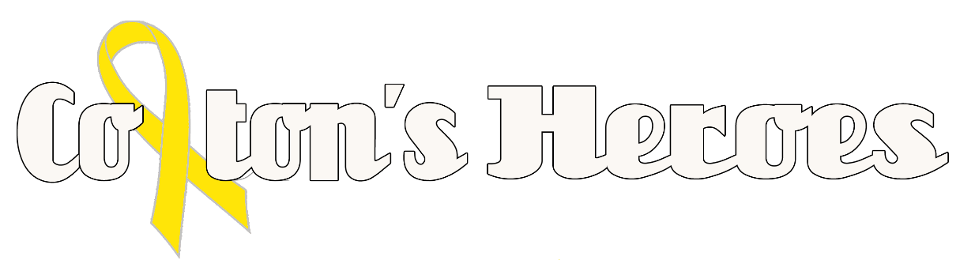
“Because Families Shouldn’t Fight Alone”

On August 25,2015, we were given news that would forever change our lives. At 2 1/2 years old, our son, Colton Graham, was initially diagnosed with a Wilm’s Tumor, which is cancerous. The tumor was removed along with Colton’s left kidney. On September 8th, 2015, the pathology report came back that the tumor was Renal Cell Carcinoma, and it had metastasized to his lungs. This is an adult cancer that is very rare for a young child and there is no cure. Since then Colton has had 3 lung surgeries to remove cancerous nodules. He now has a spot on the T-9 vertebrae, which is stable and new nodules on his lungs.

Due to our experiences, passion, drive and most of all, Colton’s love of life; My husband and I, along with team of family and friends have made it a goal to help families deal with the unthinkable; a child with cancer. We as the organization have planned to bring childhood cancer into the spotlight through Colton’s Walk for Childhood Cancer Awareness. This walk is dedicated to help those families during their time of need; not only through support; but ensuring families have the funds to eat meals during their hospital stay, while being by their children’s side. We as a family and as a team know far too well what it is like to be worried about finances; food for your family, basic household expenses; when a traumatic event like this can take one if not both parents away from their jobs. These are basic things that no parent should have to worry about when they are confronted with this obstacle.

Through Colton’s Heroes we will help families who are dealing with the unthinkable, a child with cancer. Thank you for your time and consideration in helping us help others.

Janele and Bradley Graham

