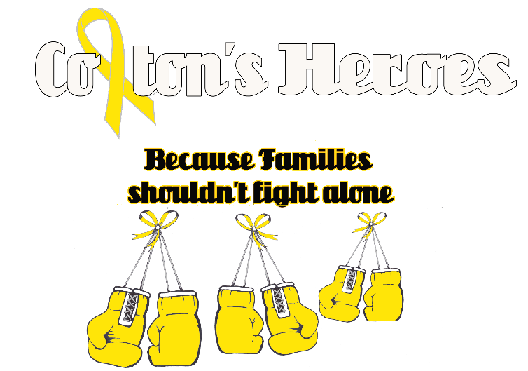

**Colton’s Heroes**

**PO BOX 6965**

**Pueblo West, CO 81007**

**coltonsheroes.org**

[**janelegraham@coltonshereos.org**](mailto:janelegraham@coltonshereos.org)

[**lhockaday@coltonsheroes.org**](mailto:lhockaday@coltonsheroes.org)

Dear Potential Sponsor:

On September 15, 2018, Colton’s Heroes will be hosting our Third Annual Colton’s Walk for Childhood Cancer Awareness…Because Kids Can’t Fight Alone, at Lovell Park, in Pueblo West, CO.

In order to make our mission successful, we will be relying on the generosity of businesses and individuals for support.

Colton’s Heroes would like to invite you to be one of our 2018 sponsors. As a sponsor your company will receive thanks and recognition for your association with Colton’s Heroes, a 501(c)(3) non-profit.

With the help from our sponsors we will provide families with gift cards to restaurants that either deliver or that are in walking distance from the hospital. We will also provide gift cards to local grocery stores and gas stations, help with everyday household expenses or any other need that may arise from having a child who is dealing with cancer. Also, the last two years we have sent a child (who’s outlook is not the best) and their family on the Santa Express, as a fun get away from the stresses that they are going through. We have also donated to benefits and funeral expense. Please help us, help those who are dealing with the unthinkable, a child with cancer.

Sincerely,

**Mission:**

Colton’s Heroes is dedicated to raising awareness of childhood cancer and funds to help families who are dealing with the unthinkable, a child with cancer.

**Vision:**

To help ease the financial burden for families dealing with the unthinkable, a child with cancer.