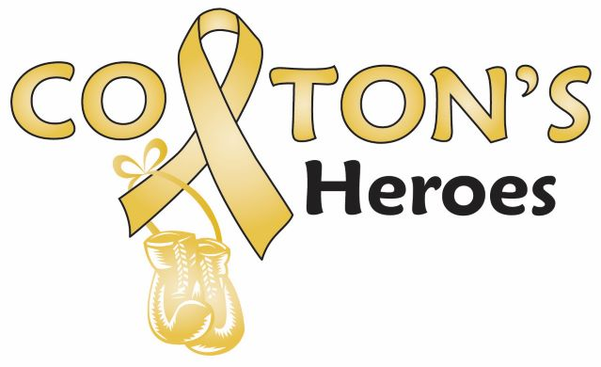

Registration and Liability Waiver

On this ____day of __________, 2019, the undersigned hereby releases Colton’s Heroes, a Colorado non-profit corporation, and the Pueblo West Parks and Recreation (collectively, the “District”) from liability and agrees to indemnify both Colton’s Heroes and the district and hold harmless Colton’s Heroes’ representatives and agents and the Metro’s employees, representatives and agents for any personal injuries, loss or damage to property arising from any and all activities prior to, during and after the event held by Colton’s Heroes at Lovell Park in Pueblo West, Colorado on September 7, 2019.
As of the date first written above, the undersigned executes this Liability Waiver and agrees to comply with the rules and regulations set by Colton’s Heroes and the Pueblo West Metro District, and the safety provisions established for the mentioned activity.
Participant’s Name:____________________________________________________________Age:_______________
Participant’s Name:____________________________________________________________Age:_______________
Participant’s Name:____________________________________________________________Age:_______________
Participant’s Name:____________________________________________________________Age:_______________
Parent/Guardian Name: ___________________________________________________________________________
Participant/Parent/Guardian Address: ________________________________________________________________
Participant/Parent/Guardian Phone: ____________________________Email: ________________________________
Participant/Parent/Guardian Signature: ___________________________________________Date________________

Paid on_______________ CASH / CHECK / CREDIT CARD / PAYPAL Received by: __________________________

T-Shirt Size: Youth: SM MED LG XLG Adult: SM MED LG XLG XXLG XXXLG

